Table of Contents

# 1 Real-world use-phase energy and electric driving share of EU plug-in hybrid electric vehicles

Markos A. Ktistakis a, …, Georgios Fontaras b,*

a Laboratory of Applied Thermodynamics, Mechanical Engineering Department, Aristotle University of Thessaloniki, 54124, Thessaloniki, Greece  
ORCiD: 0000-0001-5648-2764

b European Commission, Joint Research Centre, Via Enrico Fermi 2749, 21027, Ispra (VA), Italy

*Corresponding author: georgios.fontaras@ec.europa.eu

☆The views expressed in this paper are purely those of the authors and shall not be interpreted as an official position of the European Commission under any circumstance.

**Keywords:** Plug-in hybrid vehicles, Energy consumption, Electric driving share, OBFCM, Real-world performance, Variable importance, Explainable machine learning, SHAP

## 1 Abstract

Plug-in hybrid electric vehicles (PHEVs) represent a significant share of the European vehicle market, with real-world performance analysis increasingly important for policy and consumer information. This study quantifies the real-world use-phase supplied energy demand and electric driving share (EDS) of EU PHEVs at fleet scale using On-Board Fuel Consumption Monitoring (OBFCM) data from 2021–2023, covering 900,525 unflagged PHEV records across 29 countries. We use EDSen_mech (mechanical energy-based EDS) as the primary operational electrification metric and report supplied energies (EnTot_final100km, EnICE_final100km, EnEl_final100km) for use-phase energy analysis. Our results show substantial heterogeneity in both EDS and energy consumption, with regional and vehicle-level factors explaining significant variation. Explainable machine learning (boosted trees with SHAP) reveals key drivers of EDS and energy outcomes, with overall models achieving 21.1% R² for EDS prediction and 82.3% R² for energy prediction. Segmented models for homogeneous vehicle groups (e.g., heavy vehicles ≥2000 kg) achieve modestly higher R² (23.1-23.6%), demonstrating that more homogeneous groups can achieve better predictions, though the improvement remains modest. The analysis framework is designed to extend findings to EU-fleet representativeness via EEA registrations and to incorporate mechanistic evidence from targeted sub-fleet and campaign analyses when data become available. These findings translate into robust, policy-relevant metrics without centring utility factor/gap politics, focusing instead on understanding what drives real-world PHEV performance.

**Keywords:** Plug-in hybrid vehicles, Energy consumption, Electric driving share, OBFCM, Real-world performance, Variable importance, Explainable machine learning, SHAP

## 2 Highlights

* 0.9 million 2021-2023 PHEVs lifetime real-world and 9 with detailed trip level data
* PHEVs require % and % less energy in real-world compared to HEVs and ICEVs when EDS > %
* Energy most explained by EDS; EDS weakly explained by vehicle characteristics alone
* Northern countries highest EDS and lowest energy spent
* Total energy of new PHEVs in Europe from … in 2021 to … in 2024

## 3 Abstract

Plug-in hybrid electric vehicles (PHEVs) can reduce in-use fuel consumption, but real-world outcomes depend strongly on how frequently they are charged and driven electrically. This study quantifies EU PHEV use-phase supplied energy demand and the electric driving share (EDS) using the European on-board fuel and energy consumption monitoring (OBFCM) dataset for 2021–2023 as well as high-resolution trip-level campaign data. Fleet-scale results show substantial heterogeneity in both EDS and energy consumption, with regional and vehicle-level factors explaining significant variation. A country-level comparison indicates systematic differences across European regions. Feature-importance analysis highlights that energy demand is most strongly associated with EDS, while EDS itself is only weakly explained by observable vehicle characteristics alone, reflecting the importance of charging behavior that is not directly observed in aggregated fleet monitoring.

**Keywords:** Plug-in hybrid (PHEV); real-world energy consumption; electric driving share; EU fleet monitoring; On-board fuel consumption monitoring (OBFCM); passenger cars; SHAP

## 4 Introduction

### 4.1 Global decarbonisation context, the role of road transport, and why electrification is central—using the EU as a policy-relevant case

Transport is a major contributor to greenhouse gas emissions and remains a central focus of climate strategies worldwide (34). Across regions, road vehicles account for a large share of transport-related emissions, making the decarbonisation of the light-duty fleet a priority for both climate and air-quality objectives. Electrification is widely viewed as a key pathway because it can reduce reliance on fossil fuels in the use phase while enabling efficiency gains at the powertrain level (24, 28, 29). Within this global context, the European Union provides a particularly policy-relevant case: it combines ambitious fleet decarbonisation targets (36) with a large and diverse market, and it has introduced harmonised monitoring mechanisms (1; 35, 37, 38) intended to track whether certified progress translates into real-world benefits (25, 26, 27, 39, 40).

### 4.2 Electrified vehicles and the role of PHEVs: why they are deployed, why they persist, and why their outcomes are inherently more usage-dependent

Electrified vehicles span multiple technology routes, including battery electric vehicles (BEVs) and fuel-cell electric vehicles (FCEVs), which eliminate tailpipe emissions during operation, as well as hybrid powertrains that improve efficiency without necessarily relying on external charging (24, 28, 29, 30). Plug-in hybrid electric vehicles (PHEVs) sit between these approaches: they can deliver electrically propelled driving when charged, while retaining the flexibility of a liquid-fuel powertrain when charging is not available or when driving patterns require it (22, 23). This dual-energy capability can be attractive under uneven charging access, heterogeneous user needs, and cost or infrastructure constraints (24), and it implies that PHEVs may remain relevant through the 2020s and into the 2030s as they continue to enter—and remain within—the active fleet. However, the same feature that makes PHEVs attractive also makes their real-world outcomes unusually sensitive to how the vehicle is used (3, 18, 20, 21, 44).

### 4.3 Why PHEVs are under scrutiny: real-world variability, documented gaps, and the need for operational indicators beyond certified values

PHEVs have been subject to increasing scrutiny because real-world outcomes can diverge substantially from type-approval expectations when charging frequency is low or when trip patterns favour engine operation (3, 26, 39, 44). This has been reflected in a growing body of evidence documenting large dispersion in real-world performance and, in many cases, sizable gaps between certified and in-use fuel/CO₂ outcomes (25, 26, 27, 31, 39, 40, 41); these observations have also motivated revisions of official accounting approaches (including utility-factor frameworks) and renewed attention to how PHEVs are operated in practice (42). Importantly, while gaps between certified and real-world values provide important context (25, 26, 27, 31, 39, 40, 41), this study does not centre on utility-factor debates or regulatory accounting frameworks as its primary focus. Instead, we focus on a deeper issue: PHEVs do not have a single representative use-phase performance, and understanding this variability requires operational indicators that quantify how much propulsion is actually delivered electrically in the field, and how that translates into the real-world split between electric and ICE energy use.

### 4.4 How PHEVs are usually assessed and why energy-based accounting matters: connecting real-world datasets, electrified operation, and broader impact perspectives

PHEV performance is commonly examined through a combination of laboratory testing, on-road measurement campaigns, modelling, and observational datasets, each with trade-offs between control, interpretability, representativeness, and behavioural realism (22, 23, 4). Many real-world studies focus on fuel consumption and tailpipe CO₂ (31, 32, 43), while broader climate assessments often use well-to-wheel or life-cycle frameworks that incorporate upstream electricity and fuel pathways. Within these broader perspectives, a clear tank-to-wheel accounting of supplied energy remains an essential building block: it provides a technology-agnostic description of what the vehicle consumes in use and how propulsion is supplied (20). In particular, decomposing total supplied energy into electric and ICE components directly captures the degree to which electricity substitutes fuel in real operation, complementing CO₂-centric perspectives (31, 32, 43) without requiring this study to perform a full LCA.

### 4.5 What this study adds: fleet-scale EU evidence on energy and electric driving share, mechanisms from trip-level data, and translation to EU-fleet metrics

This study quantifies the real-world use-phase supplied energy demand and electric driving share (EDS) of EU PHEVs using approximately 0.9 million OBFCM PHEV records from 2021–2023, complemented by trip-level telemetry from 9 detailed campaign PHEVs to interpret underlying mechanisms. The analysis provides fleet distributions of total, electric and ICE supplied energy per distance and of EDS; it documents heterogeneity across vehicle mass classes and across countries/regions while explicitly addressing the role of vehicle-mix composition in cross-country comparisons. It then uses model-based feature-importance analysis to quantify how observed vehicle characteristics and usage proxies relate to energy demand and to the variability in EDS, while recognising that charging behaviour is only partially observable in aggregated fleet monitoring. Finally, the results are translated into EU-fleet representative metrics and trends using European registration monitoring data, providing a consistent, policy-relevant picture of real-world PHEV energy use and electrified operation.

## 5 Background

### 5.1 What the real-world PHEV literature agrees on: large dispersion driven by charging opportunity, trip structure, environment, and vehicle design

Real-world studies consistently show that PHEV use-phase outcomes vary widely across vehicles and users (3, 18, 20, 21, 44). Reported fuel/energy consumption and tailpipe CO₂ can range from near-zero in predominantly electric propulsion to values comparable with conventional powertrains when the vehicle operates mainly with the combustion engine (25, 26, 31, 39, 40). This dispersion is typically linked to a combination of (i) charging opportunity and charging frequency (22, 23, 24), (ii) trip length and daily distance distributions (4), (iii) ambient temperature and auxiliary loads (28, 29, 30), and (iv) vehicle design attributes such as mass, powertrain architecture, and nominal electric range (17). The implication is that PHEV performance cannot be summarised meaningfully without describing how much propulsion is delivered electrically in real-world operation (3, 18, 20, 21, 44).

### 5.2 How PHEVs are typically assessed and why evidence often fragments: controlled testing, simulations, self-reported data, and observational datasets each capture different parts of the problem

PHEV performance is examined using several data and method families, each with strengths and limitations. Laboratory testing and test-bench studies provide controlled comparisons and enable detailed mode-specific measurements (31, 42), but they cannot fully reproduce real-world variability in charging behaviour and trip patterns (25, 26, 27, 31, 39, 40, 41). Simulation approaches can explore counterfactual scenarios and isolate factors, but depend on assumptions about usage, charging, and driving conditions that may not generalise across regions and users (24, 28, 29). Self-reported datasets can provide large samples and long time horizons, but may introduce selection and reporting biases. Observational datasets collected from vehicles in operation provide direct evidence of in-use consumption (1, 19, 20, 21), but often trade behavioural detail for sample size and harmonisation (4, 18). This fragmentation motivates approaches that combine fleet-scale monitoring (breadth and representativeness) with targeted high-resolution datasets (mechanistic interpretability) (4, 19, 20, 21).

### 5.3 Why OBFCM is important and unique in the EU context and what it can and cannot tell about PHEVs

The EU’s on-board fuel and energy consumption monitoring (OBFCM) framework provides a harmonised basis for collecting fuel and energy consumption information from large numbers of vehicles operating under real-world conditions (1, 19, 21). This enables multi-country, multi-year fleet-scale analysis that would be difficult to achieve with campaigns alone (18, 19, 20, 21). However, OBFCM readouts are typically aggregated over reporting periods and do not directly observe key behavioural determinants such as charging events, charging regularity, or trip-level structure (4, 19). For PHEVs, this limitation is consequential: the central mechanism governing electrified operation is user charging behaviour interacting with trip patterns, which may only be weakly proxied through aggregated usage variables (4, 17). As a result, OBFCM is well-suited to quantifying fleet distributions and heterogeneity (18, 19, 20, 21), but it must be complemented by higher-resolution evidence to interpret the behavioural mechanisms behind the observed patterns (4, 19).

### 5.4 The “detail vs scale” trade-off: why this study uses OBFCM for fleet patterns and campaigns for mechanisms, rather than treating one dataset as a complete solution

A key methodological choice in PHEV assessment is how to balance sample size, representativeness, and behavioural detail. Fleet monitoring data provide a broad picture of how vehicles are used across countries and years, supporting robust distributional statements and the identification of systematic heterogeneity. By contrast, trip-level telemetry data can directly represent charging, daily distance, and trip length distributions, making it possible to interpret why the same vehicle can operate in very different parts of the fleet distribution. This study adopts OBFCM as the primary evidence base for fleet-scale energy and electric driving share outcomes, and uses high-resolution campaigns to provide mechanistic consistency checks and to explain residual variability that aggregated fleet records cannot fully resolve.

### 5.5 Energy and boundary framing: tank-to-wheel energy split as an operational building block that complements CO₂ and connects to broader assessments without becoming a full LCA study

Many PHEV debates are framed around tailpipe CO₂ and differences between certified and in-use values (25, 26, 27, 31, 39, 40, 41), while broader environmental assessments rely on well-to-wheel or life-cycle metrics expressed in CO₂-equivalent terms. The present study focuses on the use phase (tank-to-wheel) and characterises performance through supplied energy accounting, decomposed into electric and ICE-supplied components (20, 21). This energy split provides a clear operational description of propulsion supply and directly captures the extent to which electricity substitutes fuel in practice (20, 28, 29). While upstream pathways determine the climate intensity of electricity and fuels, a transparent use-phase energy decomposition remains a necessary input for operational carbon assessments and for integration into well-to-wheel and life-cycle frameworks—without requiring this paper to quantify upstream emissions or claim full LCA coverage.

### 5.6 Why electric driving share (EDS) is central: an operational metric of electrified propulsion that links behaviour to the energy split

To represent operational electrification explicitly, electric driving share (EDS) is used to quantify the fraction of propulsion delivered electrically. EDS is conceptually distinct from electrical energy share expressed on a supplied-energy basis because it is intended to capture electrified propulsion rather than energy conversion efficiencies. In this study, EDS is defined using propulsion (mechanical) energy where available, and it is analysed jointly with the supplied-energy split (total, electric, and ICE supplied energy per distance). This pairing supports two complementary perspectives: EDS captures the extent of electrified propulsion in real-world use, and the supplied-energy split captures the corresponding use-phase energy demand and the degree of fuel substitution.

### 5.7 What prior multivariate/ML evidence suggests about determinants: PHEVs vs non-PHEVs, and why importance patterns differ by outcome (energy and EDS) and level of aggregation

Across the broader real-world literature, multivariate statistical models and machine-learning approaches have been used to rank or quantify the association of observable factors with fuel/energy consumption and, for PHEVs specifically, electrified operation (19, 20, 33). For conventional powertrains (ICEVs and HEVs), the most consistently influential factors tend to be vehicle attributes linked to road load and powertrain efficiency (e.g., mass, engine power, vehicle class/segment) together with usage and environment proxies (e.g., speed regime, temperature, driving dynamics, traffic context and road grade where available) (31, 32, 41, 43). For BEVs, energy demand is similarly shaped by vehicle mass/aerodynamics and by operating conditions, with particularly strong sensitivity to ambient temperature and auxiliary loads (28, 29, 30). For PHEVs, the picture is more complex because two distinct mechanisms coexist: (i) the determinants of total energy demand (which overlap with conventional vehicles through road load and efficiency effects) (31, 32, 41, 43), and (ii) the determinants of electrified operation (charging opportunity, charging frequency, and trip structure), which are often only weakly observable in fleet-scale aggregated datasets (17, 19). As a result, studies that attempt to predict or explain PHEV outcomes often find that energy demand is more explainable from vehicle characteristics and coarse usage proxies than metrics of electric operation (utility factor, electric kilometres, or EDS), unless direct charging/trip-structure information is available (4, 17). This motivates a dual interpretation in the present work: fleet monitoring can robustly quantify distributions and heterogeneity of energy and EDS (18, 19, 20, 21), while campaigns and trip-level telemetry provide the behavioural variables needed to explain the variability in electrified operation more directly (4, 19).

### 5.8 Why model-based feature importance is used (and what it is not): separating co-variation in fleet data while avoiding causal overclaiming

Fleet-scale datasets contain many correlated factors—vehicle attributes, usage proxies, geography, and year effects—making simple one-factor explanations unreliable. Model-based feature-importance methods provide a transparent way to summarise which observable variables are most associated with outcomes such as total supplied energy and EDS under multivariate co-variation (Chen & Guestrin, 2016; Lundberg & Lee, 2017; Suarez et al., 2025). In this study, the purpose is interpretability and prioritisation, not causal identification: the results are used to quantify association patterns, highlight which factors stratify the fleet distribution, and motivate where behavioural variables (charging and trip structure) are likely to dominate but are not directly observed in aggregated monitoring. Campaign datasets are then used to interpret these behavioural mechanisms more directly.

### 5.9 Short recap of where this study fits: fleet-scale quantification plus mechanism-aware interpretation

Taken together, the literature indicates that PHEV outcomes are strongly usage-dependent and that evidence tends to split between detailed but small samples and large but behaviourally sparse monitoring datasets. This motivates a framework that (i) quantifies fleet-scale distributions of energy demand and EDS from OBFCM, (ii) documents heterogeneity across mass classes and across countries/regions with explicit caveats on vehicle-mix composition, (iii) uses campaigns to interpret the behavioural mechanisms behind the fleet patterns, and (iv) applies model-based feature importance to summarise how observable characteristics relate to energy demand and EDS.

## 6 Materials & Methods

### 6.1 Materials

#### 6.1.1 OBFCM dataset and EEA monitoring (fleet data)

The main dataset comprises vehicle-level real-world lifetime fuel, energy, and mileage data from the EU OBFCM framework for EU-27 plus Norway and Iceland (EU27+). Passenger cars first registered in 2021–2023 are analysed. When vehicles are reported in multiple years, the most recent entry is retained. Data quality checks and filtering steps are applied as described in Appendix A. Three powertrain groups: PHEVs (900,516), HEVs (2,295,746), and ICEVs (4,441,005) (Table 1). Within the PHEV sample which is the main focus of this study, registrations are distributed across 2021, 2022 and 2023 with portions of 49.7%, 36.1% and 14.2%, respectively. Overall coverage is X% of EU27+ PHEV new registrations in 2021–2023.

**Table 1:** Summary statistics for OBFCM dataset by powertrain type and registration year. Values show median (interquartile range) for continuous variables. P = PHEV, H = HEV, M = ICEV (conventional). Energy values are in kWh/100 km (supplied energy). Electric range and electric driving share are only applicable to PHEVs.

| Powertrain | Reg year | Vehicles | Lifetime mileage (km) | Mass (kg) | Electric range (km) | Electric driving share (%) | Energy (kWh/100km) | Energy (kWh/100km) | Energy (kWh/100km) |
| --- | --- | --- | --- | --- | --- | --- | --- | --- | --- |
|  |  |  |  |  |  |  | Electric | ICE | Total |
| P | 2021 | 447,663 | 28,826 (16,793–44,992) | 1,997 (1,879–2,261) | 56 (50–68) | 26.9 (11.4–44.0) | 7.9 (3.5–12.7) | 49.7 (35.9–63.4) | 57.6 (47.3–69.0) |
| P | 2022 | 325,067 | 19,047 (11,638–30,224) | 2,048 (1,925–2,282) | 63 (51–72) | 26.7 (10.0–44.5) | 8.0 (3.1–13.2) | 50.8 (36.8–64.7) | 58.7 (48.5–69.8) |
| P | 2023 | 127,786 | 8,596 (4,003–15,334) | 2,242 (1,926–2,349) | 65 (59–87) | 28.5 (11.7–46.5) | 8.8 (3.7–14.2) | 50.4 (36.2–64.8) | 58.6 (48.3–71.4) |
| P | Overall | 900,516 | 21,387 (11,572–34,608) | 2,033 (1,911–2,280) | 61 (50–71) | 27.0 (11.0–44.5) | 8.1 (3.4–13.1) | 50.2 (36.2–64.1) | 58.1 (47.9–69.6) |
| H | 2021 | 950,328 | 22,616 (10,791–38,886) | 1,551 (1,384–1,878) | – | – | – | 56.6 (48.5–66.9) | 56.6 (48.5–66.9) |
| H | 2022 | 888,625 | 15,833 (9,359–28,270) | 1,574 (1,406–1,872) | – | – | – | 55.7 (47.6–67.0) | 55.7 (47.6–67.0) |
| H | 2023 | 456,793 | 7,700 (3,644–14,597) | 1,608 (1,479–1,836) | – | – | – | 57.0 (49.8–66.7) | 57.0 (49.8–66.7) |
| H | Overall | 2,295,746 | 15,600 (7,746–29,616) | 1,574 (1,408–1,867) | – | – | – | 56.4 (48.4–66.9) | 56.4 (48.4–66.9) |
| M | 2021 | 2,352,363 | 25,875 (14,727–41,780) | 1,549 (1,385–1,729) | – | – | – | 61.4 (55.0–69.7) | 61.4 (55.0–69.7) |
| M | 2022 | 1,496,420 | 18,914 (10,146–30,052) | 1,559 (1,385–1,739) | – | – | – | 61.2 (55.0–69.7) | 61.2 (55.0–69.7) |
| M | 2023 | 592,222 | 6,984 (3,259–13,698) | 1,426 (1,270–1,714) | – | – | – | 60.9 (55.2–69.2) | 60.9 (55.2–69.2) |
| M | Overall | 4,441,005 | 20,462 (10,173–32,747) | 1,541 (1,368–1,731) | – | – | – | 61.3 (55.0–69.6) | 61.3 (55.0–69.6) |

OBFCM provides cumulative/lifetime quantities for each vehicle, of the total distance, fuel consumed (with PHEV mileage/fuel splits by operating state), and for PHEVs cumulative energy charged into the battery. This study quantifies use-phase supplied energy to the vehicle as the sum of grid electricity demand at plug and fuel chemical energy, and reports distance-normalised intensities (/100 km) using the lifetime total distance.

**Supplied energy (kWh):**

[E_{supplied} = E_{fuel} + E_{el,grid}]

Where (E_{fuel} = LHV V_{fuel}), with the fuel density () and the lower heating value (LHV) (see CLIMA report) and (E_{el,grid} = E_{el,charged} / *{charge}), where (*{charge}) is the assumed average charging efficiency from grid electricity at plug to energy charged into the battery.

**Supplied energy (kWh/100km):**

[E_{supplied,100km} = ]

**Conditional (mode-specific) energy intensities**

In addition to reporting supplied energy normalised by total lifetime distance, the analysis also reports conditional (mode-specific) energy intensities as supporting indicators. OBFCM provides splits of total mileage across several PHEV operating states. Here, we use two conditional quantities that are directly interpretable and closely linked to PHEV operation: (i) the fuel-energy intensity while the vehicle is operating in charge-sustaining (CS) mode, and (ii) the electric-energy intensity over pure-electric (engine-off) distance. Where Charge-Depleting (CD) operation refers to driving where the battery energy is predominantly used for propulsion, whereas Charge-Sustaining (CS) operation refers to driving where propulsion relies primarily on the ICE while maintaining the battery state of charge around a target level. Using the corresponding OBFCM distance splits, we define:

[E_{ICE,conditional} = ]

[E_{El,conditional} = ]

Where (D_{CD,EngOff}) is the lifetime mileage driven in CD mode with the engine off and (D_{CS}) is the lifetime mileage driven in CS mode, calculated as the difference of the total distance and the sum of the rest of the distances found in the OBFCM dataset.

**Electric driving share**

Charging behaviour is not directly observed at fleet scale, instead the analysis uses EDS as an operational electrification indicator, defined on a propulsion/traction-proxy boundary using fixed pathway efficiencies:

[EDS = ]

Where (E_{ICE,prop} = E_{fuel} / *{fuel}) is an assumed average efficiency mapping fuel chemical energy (different for petrol and diesel) to a traction-energy proxy and (E*{el,prop} = E_{el,charged} / _{el}) is an efficiency mapping battery-in electric energy to the same propulsion-energy proxy (ref CLIMA report).

Unless stated otherwise, electric, fuel and total energy refer to supplied-energy intensities (E_{el,100km}), (E_{ICE,100km}) and (E_{tot,100km}), and EDS refers to the traction-proxy definition above. A country-level assessment is conducted by grouping countries into four regions (Northern, Southern, Western and Central & Eastern) based on the EU EuroVoc classification. To link OBFCM findings to EU new-registration fleet composition and extend registration-fleet trends to 2024, the analysis also uses the official EEA CO₂ monitoring registration data for 2021–2024. The EEA dataset provides registration totals and type-approval vehicle characteristics for the EU fleet of new passenger cars and is treated as the reference for fleet composition and aggregation in the extrapolation step (Section 3.3).

#### 6.1.2 EEA Monitoring 2021-2024

EEA monitoring data (PHEV registrations + characteristics) for EU-fleet scaling. Used to extrapolate OBFCM findings to the broader European fleet.

#### 6.1.3 Tested vehicles (trip-level data)

An ad-hoc testing campaign was conducted using a C-segment petrol PHEV with a 1,400 cm³ engine, 70 km electric range and WLTP fuel consumption of 0.9 l/100 km. The vehicle was driven by 18 volunteers, primarily in North Italy, with each participant driving for approximately three weeks. Data collection spanned from September 2021 to February 2023, resulting in 1,127 trips covering 27,148 km, with a minimum trip distance of 1 km (Table 1B). A custom data-logging system recorded over 50 parameters from the On-Board Diagnostics (OBD) and Unified Diagnostics Services (UDS) systems at a frequency of 1 Hz. The 18 drivers used the vehicle between 23 and 117 times, driving a minimum of 229 km. The EDS among drivers ranged from 16% to 89%, showcasing varied charging and driving behaviors. Battery State Of Charge (SOC) changes were analyzed to quantify charging events, resulting in 164.3 equivalent full charges across 282 sessions.

**Table 1B:** Campaign vehicle characteristics and summary statistics.

| Parameter | Value |
| --- | --- |
| Vehicle type | C-segment petrol PHEV |
| Engine displacement | 1,400 cm³ |
| Electric range (WLTP) | 70 km |
| WLTP fuel consumption | 0.9 l/100 km |
| Number of drivers | 18 volunteers |
| Location | North Italy |
| Data collection period | September 2021 – February 2023 |
| Total trips | 1,127 |
| Total distance | 27,148 km |
| Minimum trip distance | 1 km |
| Driver usage range | 23–117 trips per driver |
| Distance per driver | 229–[max] km |
| EDS range | 16%–89% |
| Equivalent full charges | 164.3 |
| Charging sessions | 282 |
| Data logging frequency | 1 Hz |
| Parameters logged | >50 (OBD/UDS) |

If we use more vehicles; vehicle characteristics table go to Appendix; a short summary table can stay in Materials.

### 6.2 Feature importance analysis

#### 6.2.1 Objective and modelling targets

This study uses supervised modelling primarily as an interpretability tool to quantify which observed variables are most associated with variability in supplied energy demand ((E_{tot,100km})) and EDS. The modelling is not presented as a forecasting exercise. For the fleet-scale analysis, the fitted OBFCM models are used secondarily to enable extrapolation of outcomes to the full EU registration fleet (Section 3.4). Two parallel modelling streams are considered:

* **Fleet-scale models (OBFCM):** trained on the OBFCM sample where outcomes are observed; used for feature-importance analysis and for fleet extrapolation.
* **Campaign models (trip-level / tested vehicles):** trained on the high-resolution campaign dataset(s) to explore the importance of behavioural and trip-structure variables that are not available in OBFCM. These models are used for interpretation only and are not used for extrapolation.

A separate model may also be fitted for lifetime distance of OBFCM dataset only if needed to harmonise predictors between OBFCM and the EEA fleet dataset (Section 3.4).

#### 6.2.2 Candidate predictors, feature screening and handling of leakage

Predictors are drawn from the variables available in each dataset and grouped conceptually into: (i) vehicle technical descriptors, (ii) usage descriptors available at readout or derived consistently, and (iii) contextual descriptors (e.g., country/region). For campaign models, additional behavioural/trip descriptors may be included (e.g., charging frequency proxies, trip-length structure), reflecting the higher temporal resolution. To maintain interpretability and avoid circularity, predictors that are directly constructed from the target or otherwise encode it by definition are excluded (leakage control). A transparent feature screening step is applied before modelling to remove redundant/unstable predictors (e.g., near-duplicates or highly collinear variants). The final predictor lists used for each target and dataset are documented, with full details (candidate list, exclusions, and rationale) provided in Appendix B.

#### 6.2.3 Model class, training protocol, and performance assessment

A tree-based gradient boosting model is used as the primary model family due to its ability to capture nonlinearities and interactions common in real-world vehicle data, while remaining compatible with established importance methods. The model is trained and evaluated using K-fold cross-validation (and/or year-wise splits as a robustness check) to quantify generalisation performance. Model performance is reported using standard regression metrics for each target, such as (R^2), MAE and RMSE for (E_{tot}), and analogous error metrics for EDS. Hyperparameter tuning is performed using a limited search within cross-validation to avoid overfitting and to ensure reproducible choices.

#### 6.2.4 Feature-importance method and robustness

Feature importance is quantified using a model-agnostic approach compatible with non-linear models. The main importance metric is based on Shapley additive explanations (SHAP) (global importance via mean absolute SHAP values), optionally complemented by partial dependence / accumulated local effects plots for a small number of top predictors to support interpretation. Because importance rankings can vary with resampling, importance stability is assessed through repeated cross-validation and/or bootstrap resampling, reporting variability (e.g., interquartile ranges of ranks or importance values) for the top predictors. Importance is reported as associational (not causal), and interpretation is limited to plausible mechanisms consistent with PHEV operation and known confounders. Given space constraints, only the main importance results are shown in the main text, while additional robustness diagnostics and sensitivity checks are reported in Appendix B. Together with comparisons with other models: regression and bagging.

### 6.3 EU fleet extrapolation

To translate the OBFCM findings into metrics representative of the EU new-registration fleet, this study extrapolates modelled outcomes to the EEA CO₂ monitoring dataset, which provides an exhaustive record of passenger cars newly registered in Europe for each year considered (2021–2024), together with harmonised vehicle characteristics.

The extrapolation follows three steps. First, models for total supplied energy demand and electric driving share are trained on the OBFCM sample where the corresponding outcomes are observed (Section 3.2). Second, the trained models are applied to each vehicle record in the EEA dataset to obtain predicted outcomes (_{tot,100km}) and (). Third, EU-fleet results are obtained by summarising these predicted outcomes across all registered vehicles for each registration year and, where relevant, across stratifications such as mass class, segment proxies and country/region. The resulting EU-fleet estimates should therefore be interpreted as model-based projections of real-world outcomes conditioned on the observable fleet composition, and are used to quantify year-to-year trends and composition-aware differences in energy demand and EDS across the EU new-registration fleet. Uncertainty in EU-fleet summaries is primarily driven by model error and is assessed through cross-validation and/or resampling of the OBFCM training step, with sensitivity and robustness details reported in the Appendix.

We use explainable machine learning to identify which factors most strongly influence EDS and energy consumption, following best practices established in recent PHEV research (Suarez et al., 2025).

**Targets:** - Primary: EDSen_mech (electric driving share based on mechanical energy) - Secondary: EnTot_final100km (total energy consumption per 100 km)

**Modeling approach:** We employ boosted trees (XGBoost) as the primary modeling framework. Model selection was based on comparison with simpler alternatives and other machine learning approaches: linear regression achieved test R² of 12.7% for EDS and 44.9% for energy, while XGBoost achieved 21.1% for EDS (with 5-fold cross-validation) and 82.3% for energy, representing substantial improvements. XGBoost is chosen for its ability to capture non-linear relationships and interactions while maintaining interpretability through SHAP values, providing a clear advantage over linear models for this application. Hyperparameters are tuned using cross-validation (max_depth=6, learning_rate=0.1, nrounds=100) to optimize model performance while avoiding overfitting. Model performance is evaluated using 5-fold cross-validation on all 891,693 records with complete predictor information to ensure robust estimates.

**Explainability method:** SHAP (SHapley Additive exPlanations) values are used to quantify feature importance, providing a game-theoretic approach that accounts for interactions and non-linear relationships. SHAP values are computed for all predictors and summarized to identify the most important factors driving EDS and energy consumption.

**Robustness assessment:** Model stability is assessed through: - Cross-validation with multiple folds to quantify uncertainty in performance metrics - Stability across years (comparing models trained on different year subsets) - Bootstrap resampling to quantify uncertainty in feature importance rankings

**Predictor Selection:** Predictors were selected following a logical, reviewer-proof approach with clear rationale:

1. **Core vehicle specifications** (4 variables): Mass, Electric_range, Engine_power, drive_battery_capacity_kwh. Rationale: Fundamental physical properties that directly affect energy consumption and EDS.
2. **Engineered efficiency ratios** (3 variables): AER-to-mass ratio, power-to-mass ratio, battery-to-mass ratio. Rationale: Capture design efficiency rather than absolute values, reducing multicollinearity with mass while maintaining physical interpretability.
3. **Usage variable** (1 variable): Mileage_Tot (total mileage). Rationale: Captures vehicle utilization patterns affecting EDS. Note: Log-transformed versions were tested but excluded as they showed near-zero importance and did not improve model performance.
4. **Contextual variables** (5 variables): Country, Region, Year, segment, Fuel_type. Rationale: Capture infrastructure, climate, policy context, and vehicle segment effects.

**Pre-screening:** Removed variables directly constructed from targets to avoid leakage (e.g., EnICE_final100km and EnEl_final100km from EnTot_final100km, Mileage_CD_Eng_Off from EDSen_mech). Removed highly intercorrelated variables that do not provide additional information beyond what is captured by efficiency ratios. Excluded log-transformed versions of variables that showed near-zero importance. Ensured all predictors are available for extrapolation to EEA fleet.

**Final feature sets:** - **EDSen_mech model:** 13 variables (4 core specs + 3 efficiency ratios + 1 usage + 5 contextual) - **EnTot_final100km model:** 14 variables (same as EDS model + EDSen_mech as predictor)

**Special consideration for energy model:** For the EnTot_final100km model, we include EDSen_mech as an additional predictor. This is justified because EDS is a key driver of energy consumption: higher electric driving share directly reduces total energy consumption through the more efficient electric propulsion system. The strong negative correlation (r = -0.61) between EDS and energy confirms this relationship. Including EDS as a predictor for energy is not circular because EDS reflects operational electrification patterns (charging behavior, trip structure) that causally influence energy outcomes, rather than being derived from energy values.

**Model results:** - Feature importance (SHAP summary) for both EDSen_mech (primary target) and EnTot_final100km (secondary target) - Dependence plots for top features showing relationships between predictors and targets - Key predictors include: electric range (AER), total mileage (Mileage_Tot), AER-to-mass ratio, mass, country, region, year - Robustness: stability across years (train-by-year vs pooled with year feature), cross-validation for performance evaluation, uncertainty quantification on importance ranks

**Language:** Call it feature importance (not driver ranking).

#### 6.3.1 EU-Fleet Representativeness / Extrapolation

Use EEA registrations and characteristics to compute EU-fleet metrics for 2021-2024. Models are used to predict EDS and/or energy outcomes for the whole fleet, then aggregate with fleet weights.

**Approach:** - Fit models (from 3.2.2) on OBFCM where target is observed - Apply to EEA fleet records to predict: EDSen_mech (primary), EnTot_final100km (secondary) - Aggregate to EU-fleet weighted metrics: distribution summaries by reg-year, segment, OEM group (careful), country - Uncertainty bands (e.g., via model CV / bootstrap) if feasible

#### 6.3.2 Subfleet Isolation + Micro Evidence

**Select subfleets strategically:** - Golf family / popular VFNs (for comparability with campaign) - Prius (if/when ready) - Another popular high-volume model group (to show generality)

**What we do with subfleets:** - Repeat the flagship relationship (energy split vs EDS) within the subfleet - Compare subfleet vs overall fleet distribution (where it sits) - Show whether feature importance shifts when vehicle design is held approximately constant

**Campaign mechanistic illustration (Golf now):** - Trip-level EDS proxy / electrified share vs charging events / trip length distribution - Show how the same vehicle can sit in different parts of fleet distribution depending on usage - Use this to explain tails (low EDS users vs high EDS users) - Framing: Not “validation,” but “mechanistic consistency and interpretation”

## 7 Results

### 7.1 Fleet-Scale Distributions and Heterogeneity of EDS and Energy (OBFCM)

This section presents the core findings from OBFCM data, establishing the fundamental relationships between energy consumption and electric driving share, and documenting the substantial heterogeneity in real-world PHEV performance.

#### 7.1.1 Headline EU Distributions

Our analysis covers 900,525 unflagged PHEV records from 29 European countries, representing the largest fleet-scale analysis of real-world PHEV performance to date. The distribution of electric driving share (EDSen_mech) shows substantial heterogeneity: the median EDSen_mech is 27.05%, with an interquartile range (IQR) of 10.98% to 44.52% (Figure 1). The mean EDSen_mech is 29.37%, indicating a right-skewed distribution where a subset of vehicles achieves high electrification rates. The 5th and 95th percentiles span from 0.73% to 67.96%, demonstrating the wide range of real-world electric driving behavior.

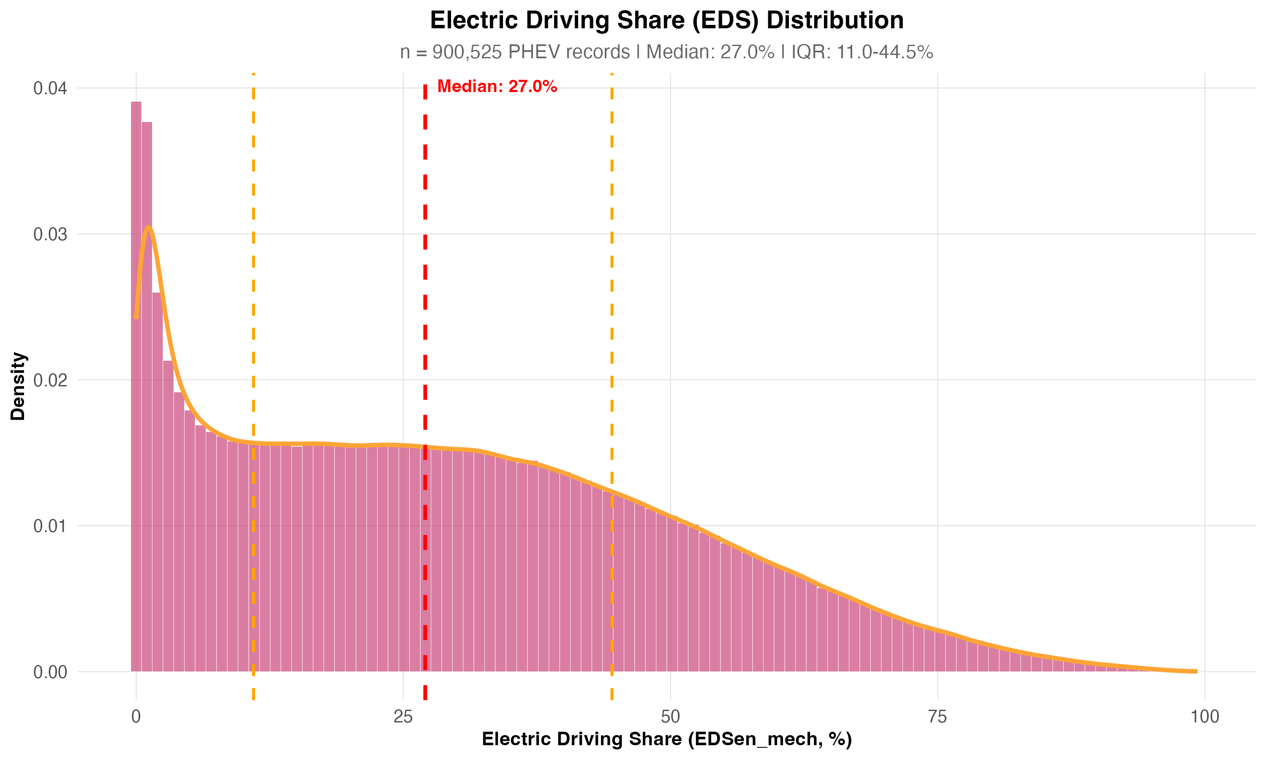

Figure 1

**Figure 1:** Distribution of Electric Driving Share (EDS) across all PHEV records. The histogram shows the density of EDS values, with the red dashed line indicating the median (27.05%) and orange dashed lines showing the first and third quartiles (10.98% and 44.52%). The distribution shows substantial heterogeneity, with a right-skewed pattern indicating that while most vehicles achieve moderate EDS values, a subset achieves high electrification rates.

For total energy consumption (EnTot_final100km), the median is 58.13 kWh/100 km (IQR: 47.89 to 69.62 kWh/100 km), with a mean of 59.82 kWh/100 km. This energy is split between ICE and electric sources: median EnICE_final100km is 50.20 kWh/100 km (IQR: 36.24 to 64.08), while median EnEl_final100km is 8.08 kWh/100 km (IQR: 3.37 to 13.09). The dominance of ICE energy over electric energy (approximately 6:1 ratio) indicates that despite having electric capability, PHEVs in our sample rely more heavily on their internal combustion engines in real-world operation.

#### 7.1.2 EDS Distribution Over Time

Figure 3 presents the temporal evolution of EDS distribution, combining density plots by period with a timeline of median values. This information-dense visualization (recreating Markos’s Screenshot 1 with improved quality) shows how EDS distributions have evolved over the 2021-2023 period, revealing whether there are trends in electric driving behavior over time.

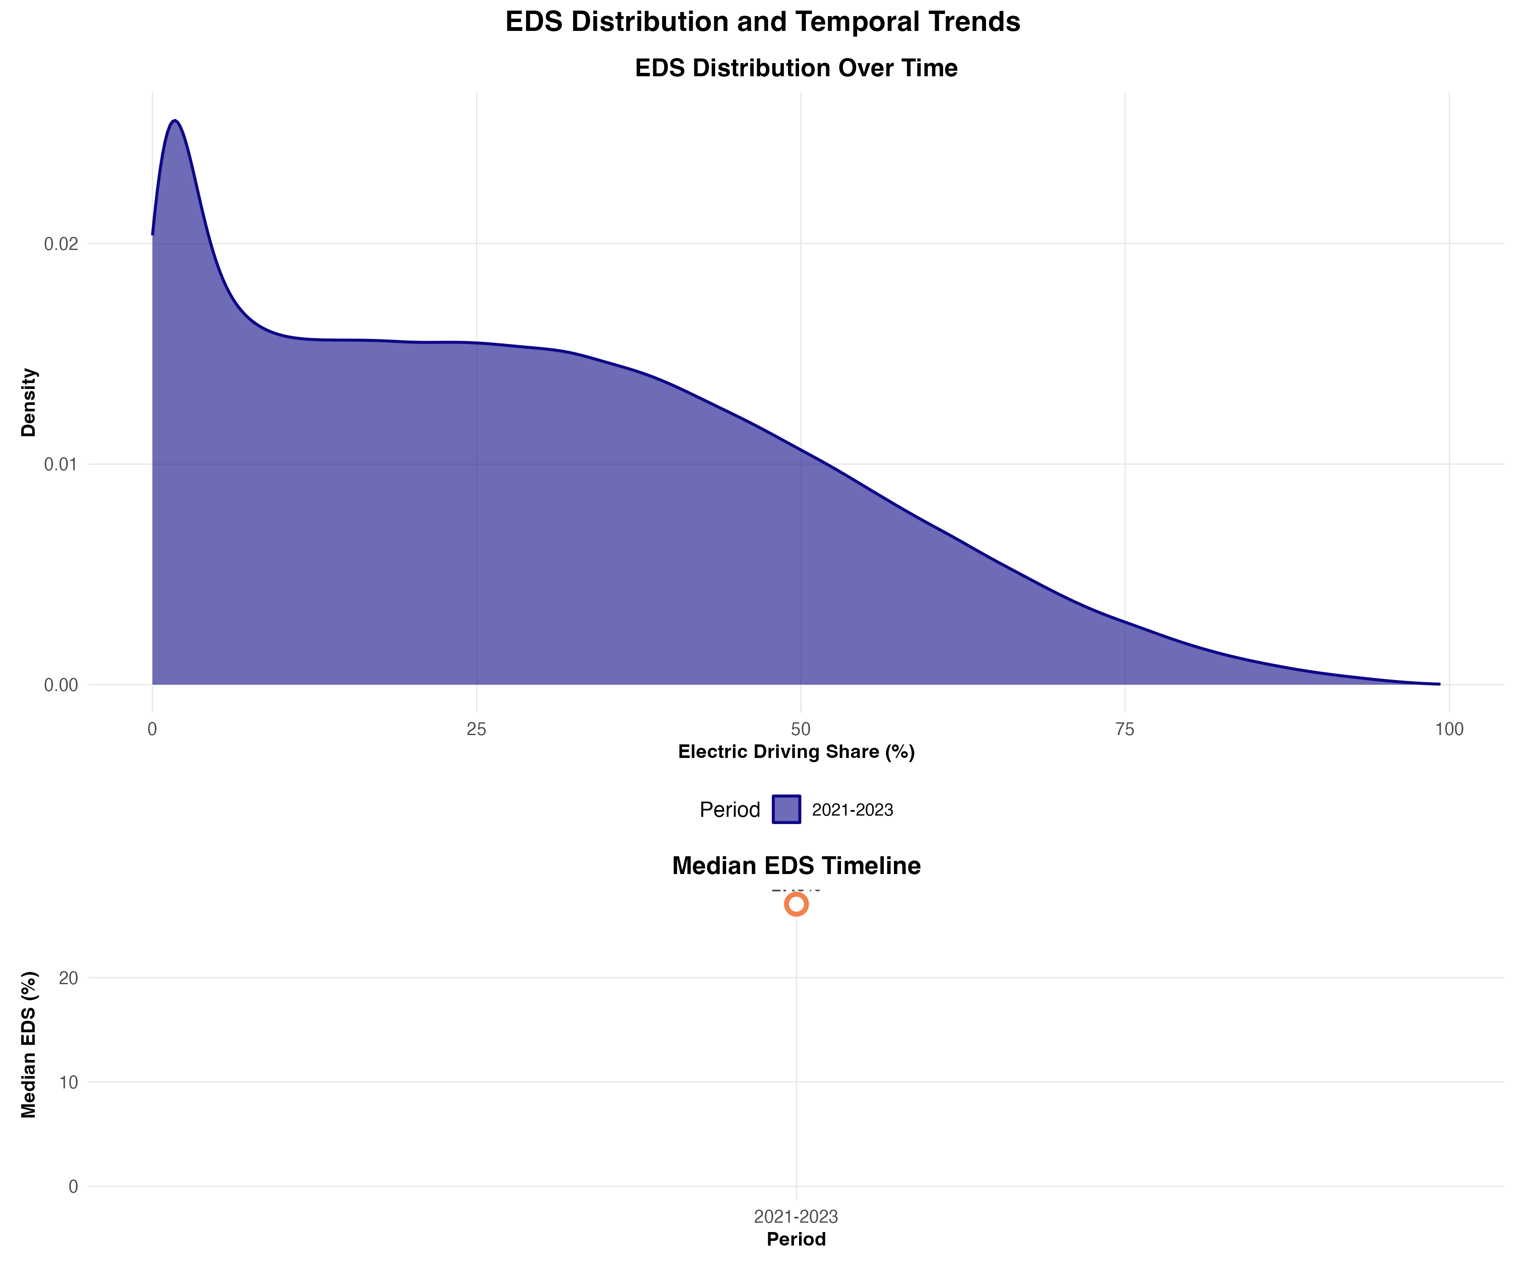

Figure 3

**Figure 3:** EDS distribution over time (top panel) and median EDS timeline (bottom panel). The density plots show the distribution of EDS values across different reporting periods, with distinct colors for each period. The timeline panel shows the evolution of median EDS, allowing identification of temporal trends in electric driving behavior.

#### 7.1.3 Descriptive correlates of EDS: electric range and mileage

Figure 3 shows how median electric driving share (EDS) varies jointly with type-approval electric range and vehicle mileage. Two patterns stand out. First, at low mileage, EDS increases markedly with electric range, consistent with larger usable electric capability translating into more electric operation when trips are shorter and charging is easier to exploit. Second, for any given electric-range band, EDS tends to decline with mileage, indicating that higher-mileage vehicles are disproportionately used in driving patterns that reduce electric operation (e.g., longer-distance use, less charging opportunity, or more sustained high-speed driving).

The interaction is substantial in magnitude. For vehicles with 40–50 km electric range, median EDS is about 25–27% at very low mileage (≤2,000 km), but falls to ~9% by 100,000–120,000 km. Even at 70–75 km electric range, median EDS drops from 42% at ≤2,000 km to 12% at 80,000–100,000 km. At the highest electric ranges in the data (e.g., ~125–130 km), median EDS remains comparatively high at low mileage (peaking around 56% at ≤2,000 km), but still decreases steadily with mileage (e.g., 38% around 20,000–30,000 km). Importantly, the marginal density plots show that most observations lie in the mid-field of the grid (moderate ranges and mileages), where estimates are most stable; tiles in the far tails are informative but should be interpreted cautiously due to lower sample sizes.

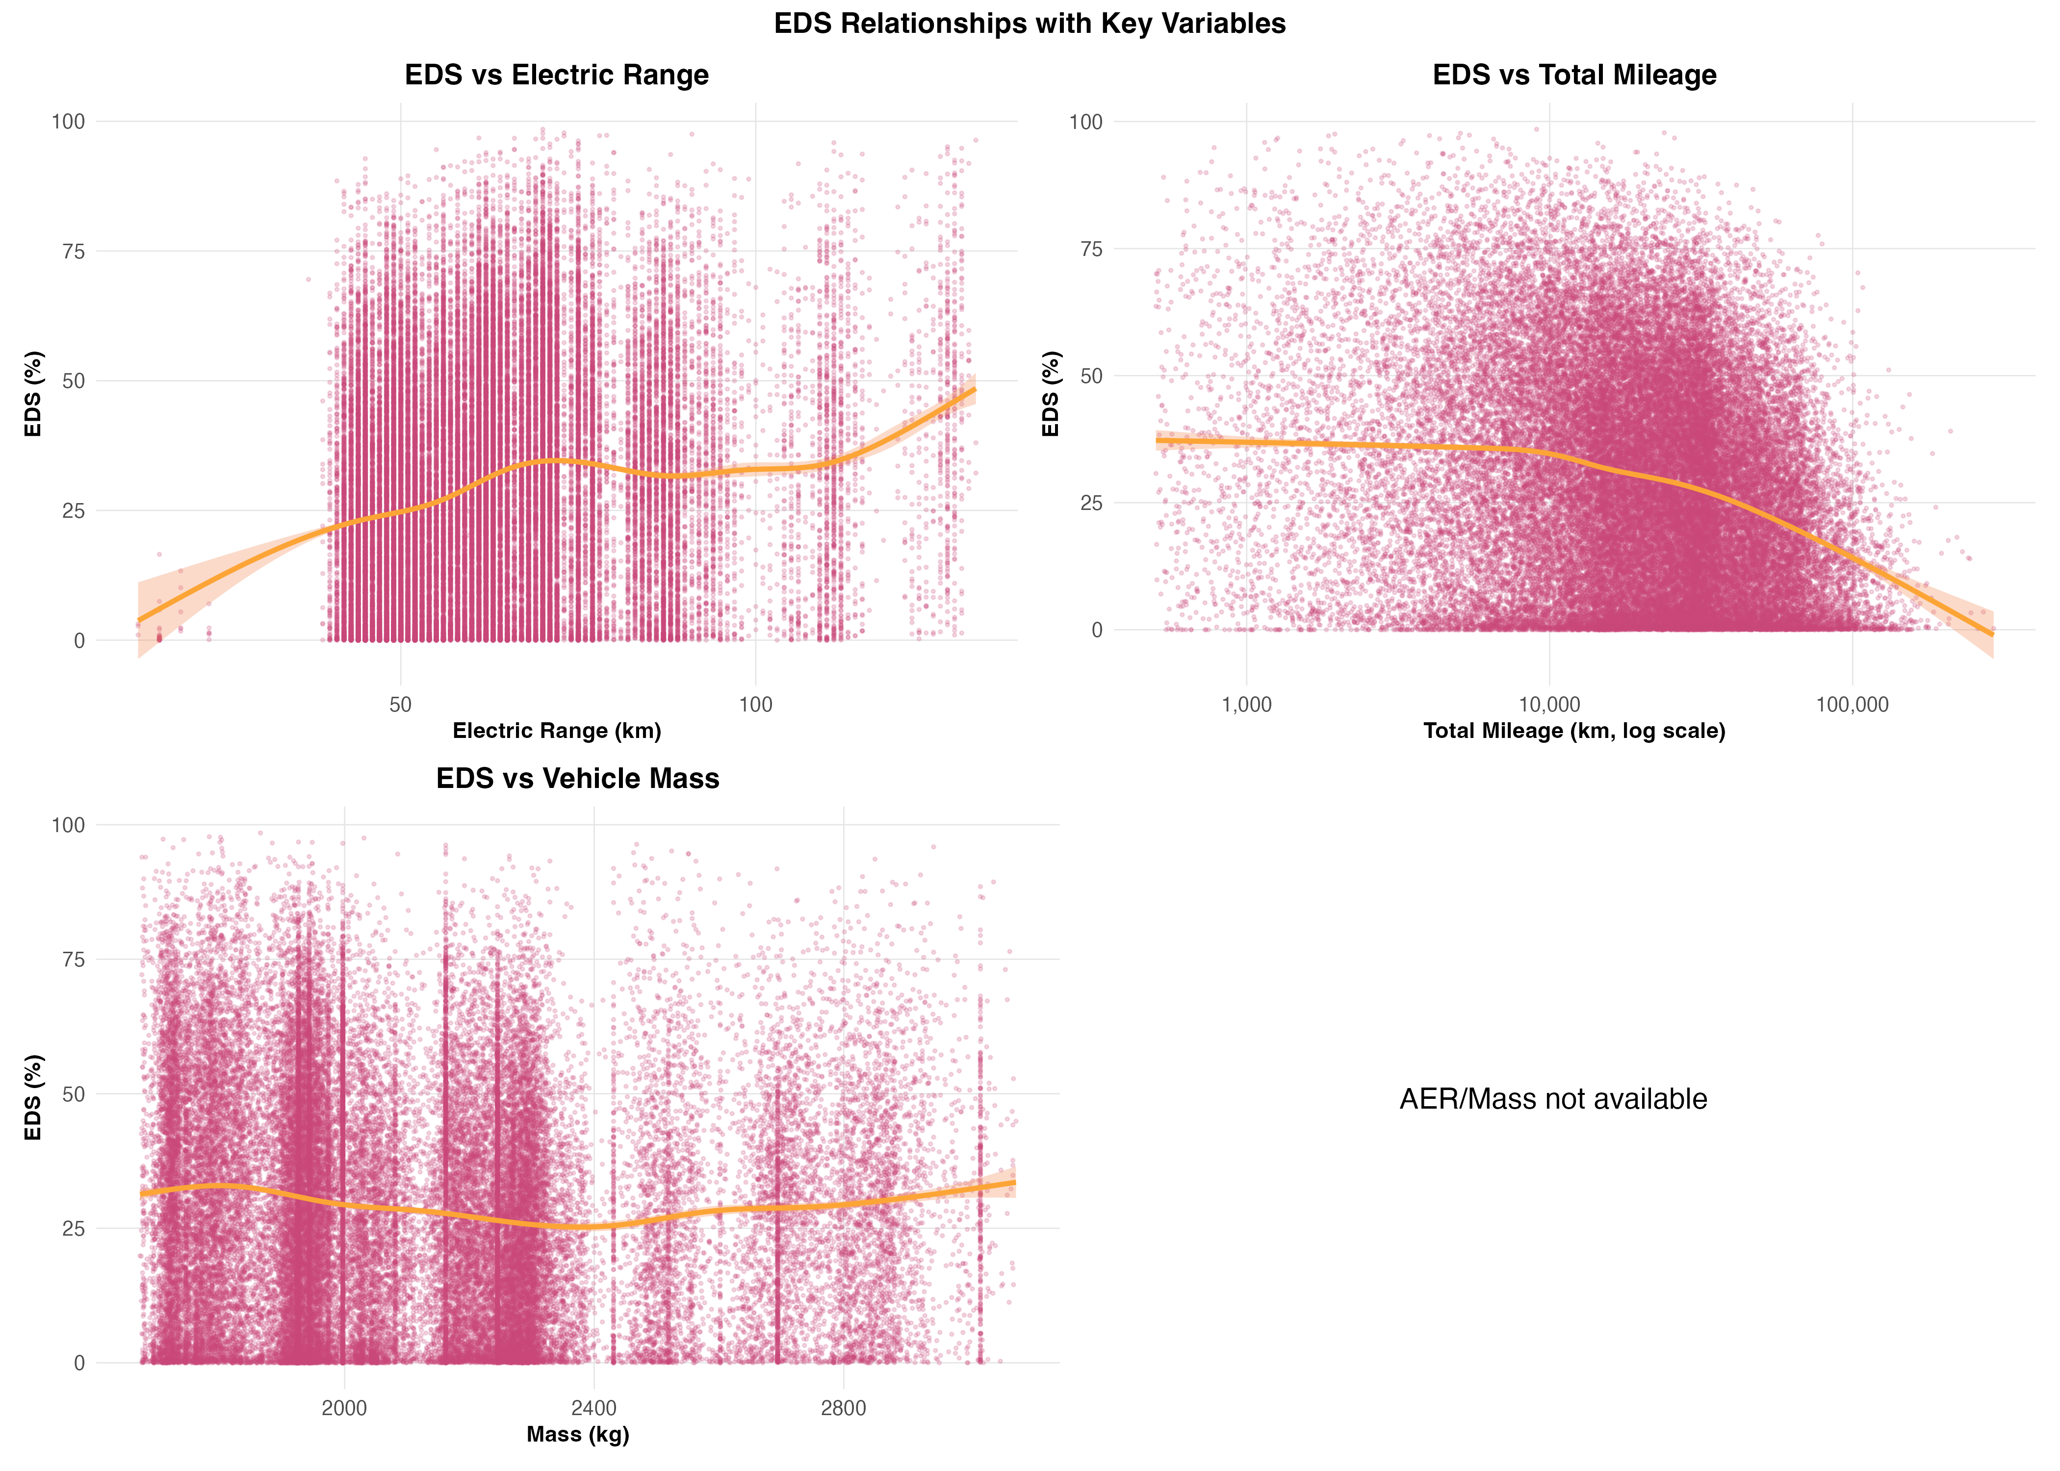

Figure 3



**Figure 3:** Median electric driving share (EDS, %) across joint bins of type-approval electric range and lifetime vehicle mileage. Each tile reports the median EDS within a range–mileage bin. Marginal density plots show the distributions of electric range and mileage in the sample. Dashed reference lines mark the 1st and 99th percentiles of the plotted axes.

#### 7.1.4 Flagship relationship: energy split vs EDS (OBFCM)

Figure 1 shows a near-monotonic shift in the supplied-energy split with increasing EDS: ICE energy declines, electric energy rises, and total supplied energy decreases. The EDS distribution is strongly skewed toward very low values (peak at EDS ≈0.1%), where supplied energy is almost entirely ICE-based. Over the central operating range, higher EDS corresponds to substantial reductions in total energy: between EDS ≈10% and ≈50%, EnTot decreases by ~5 kWh/100 km per +10 pp EDS. This net reduction reflects a rapid decline in EnICE (≈−7.8 kWh/100 km per +10 pp) that is only partly offset by increasing EnEl (≈+2.8). At higher electrification levels, the decline in EnTot becomes less steep (≈−3.9 kWh/100 km per +10% from ~50% to ~95%), consistent with a shrinking remaining ICE contribution.

Mass stratification indicates that vehicle mass primarily shifts the relationship upward while preserving the overall pattern. Across bins up to ~90% EDS where all mass groups are represented, heavy vehicles (≥2.25 t) exhibit a systematically higher EnTot than light vehicles (<1.95 t), with a heavy–light median gap of 16.7 kWh/100 km (range 8.9–22.4), and this gap narrows with EDS by roughly 1.3 kWh/100 km per +10 pp EDS. The EDS gradient is also steeper for heavier vehicles in the central range (10–50%: −5.0 kWh/100 km per +10 pp for heavy vs −4.0 for light), indicating that electrification delivers larger absolute energy reductions where baseline demand is higher.

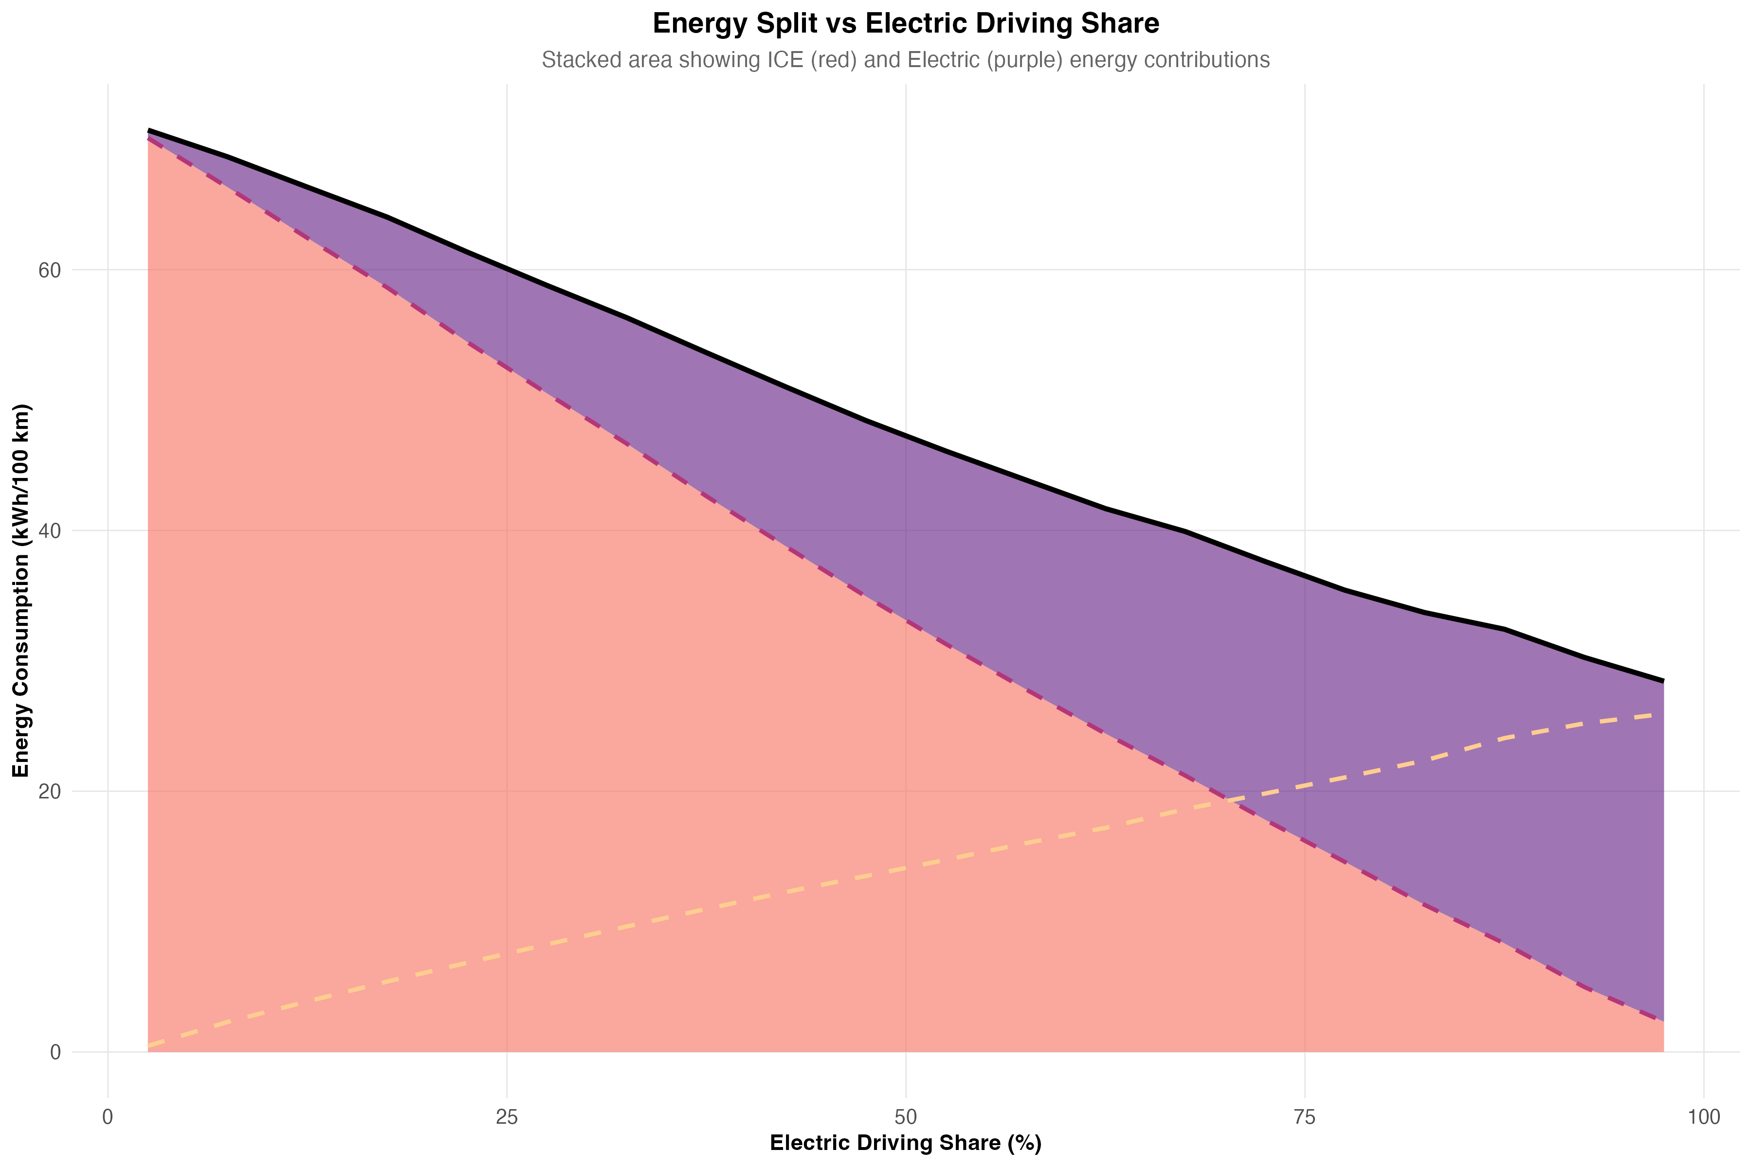

Figure 5



**Figure 1:** Final (supplied) energy intensities of PHEVs binned by electric driving share (EDS). The stacked areas show the median split of total energy (EnTot) into ICE-derived energy (EnICE) and electricity (EnEl) across EDS bins; the overlaid curves show the EDS distribution of the observed fleet by registration year. Panels below stratify the same relationship by mass group.

#### 7.1.5 Regional and country heterogeneity

Northern countries show systematically lower median total supplied energy, while Central and Eastern Europe sits at the upper end. At the regional level, median total supplied energy ranges from 54.3 kWh/100 km in the North to 63.8 kWh/100 km in Central and Eastern Europe, with Southern and Western regions in between (56.8 and 59.3 kWh/100 km, respectively). This contrast is driven primarily by differences in the ICE energy component: regional median ICE energy spans 44.9–53.7 kWh/100 km, whereas median electric energy varies much less (7.7–9.4 kWh/100 km). In other words, regions differ mainly in how much ICE energy is avoided, not in how much electric energy is taken from the grid. Fleet composition helps explain part of the pattern: the regional median mass is lowest in the South (~2.0 t) and highest in Central and Eastern Europe (~2.2 t), consistent with higher energy demand in heavier fleets; Western Europe (which contains the bulk of the vehicles shown, driven by large markets such as Germany and France) also combines relatively high total energy with mid-range median mass, suggesting that composition alone is not sufficient to explain regional differences.

At country level, the spread in total energy is again mostly a ICE-energy story. Within Northern Europe, Denmark (52.3 kWh/100 km) and Norway (51.8) sit at the low end, while Finland combines one of the highest median electric driving share (39.9%) with low total energy (53.4), consistent with higher electric operation. In Central and Eastern Europe, Romania (65.5) and Poland (64.9) are at the high end, with high median masses (≈2.16–2.20 t) and high ICE energy, while their electric energy remains within the broader European band. Western countries cluster around total energy ≈59–60 kWh/100 km (e.g., Germany 59.6, France 58.8), while Ireland stands out with relatively high electric driving share (38.1%) and lower total energy (57.1), similar to Northern countries. These patterns are consistent with a mix of (i) fleet composition (mass/segment mix) and (ii) charging opportunity and usage context: earlier electrified-vehicle uptake and better charging access in several Northern (and some Western) markets plausibly supports higher operational electrification, which appears primarily as reduced ICE energy. Finally, two small island markets excluded from the plot due to sample size: Cyprus and Malta show very high median electric driving share (46–51%) and low total energy (~47–49 kWh/100 km), plausibly reflecting shorter typical driving distances and trip patterns that favour electric operation.

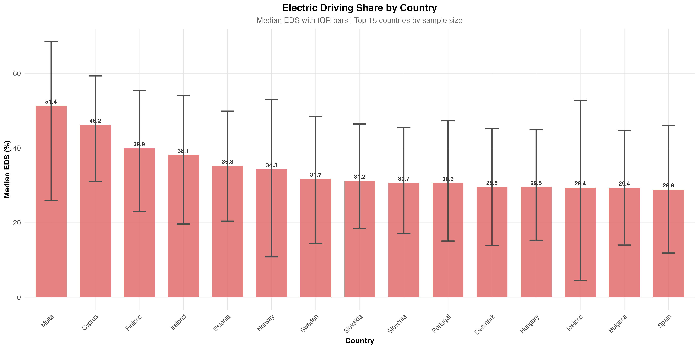

Figure 2



**Figure 2:** Country-level PHEV medians (OBFCM 2021–2023), restricted to countries with at least 2,000 vehicles. Top panels report median electric driving share (EDS) and median vehicle mass by country. Bottom panel shows median supplied-energy intensities (EnTot, EnICE, EnEl; kWh/100 km). Horizontal markers indicate region-level medians for all countries (EU27+).

#### 7.1.6 “What Drives EDS” — Descriptive Before Modelling

Descriptive analysis reveals several factors associated with EDS variation. **Electric range (AER, Electric_range)** shows a strong positive association with EDS: vehicles in the lowest AER quartile (13-50 km) have a median EDSen_mech of 20.38%, while vehicles in the highest quartile (71-131 km) achieve 32.72% median EDS. This suggests that greater electric range enables more electric driving, though the relationship is not linear and plateaus at higher ranges. The distribution of electric range across the fleet shows substantial variation, with median AER of 58 km (IQR: 50-71 km), indicating that PHEVs in the fleet span a wide range of electric capabilities.

**Total mileage (Mileage_Tot)** shows a strong inverse relationship with EDS: vehicles in the lowest mileage quartile (500-11,600 km) have a median EDSen_mech of 34.4%, while those in the highest quartile (34,600-300,000 km) show only 19.0% median EDS. This pattern likely reflects that high-mileage vehicles are used for longer trips that exceed electric range, reducing the proportion of electric driving. The relationship between total mileage and EDS is particularly important for understanding usage patterns, as it captures how vehicle utilization affects electric driving share.

Vehicle segment, mass, and other design characteristics also show variation, with smaller segments generally achieving higher EDS values. These descriptive relationships demonstrate that multiple factors co-vary with EDS, making it difficult to isolate individual contributions. We therefore use explainable machine learning modeling (Section 4.2) to separate the relative importance of these factors while accounting for their interactions.

#### 7.1.7 Energy-Mass Relationships: Design and Usage Interactions

To understand how vehicle design (mass) and usage patterns (EDS) interact to determine energy consumption, we examine energy-mass relationships stratified by EDS.

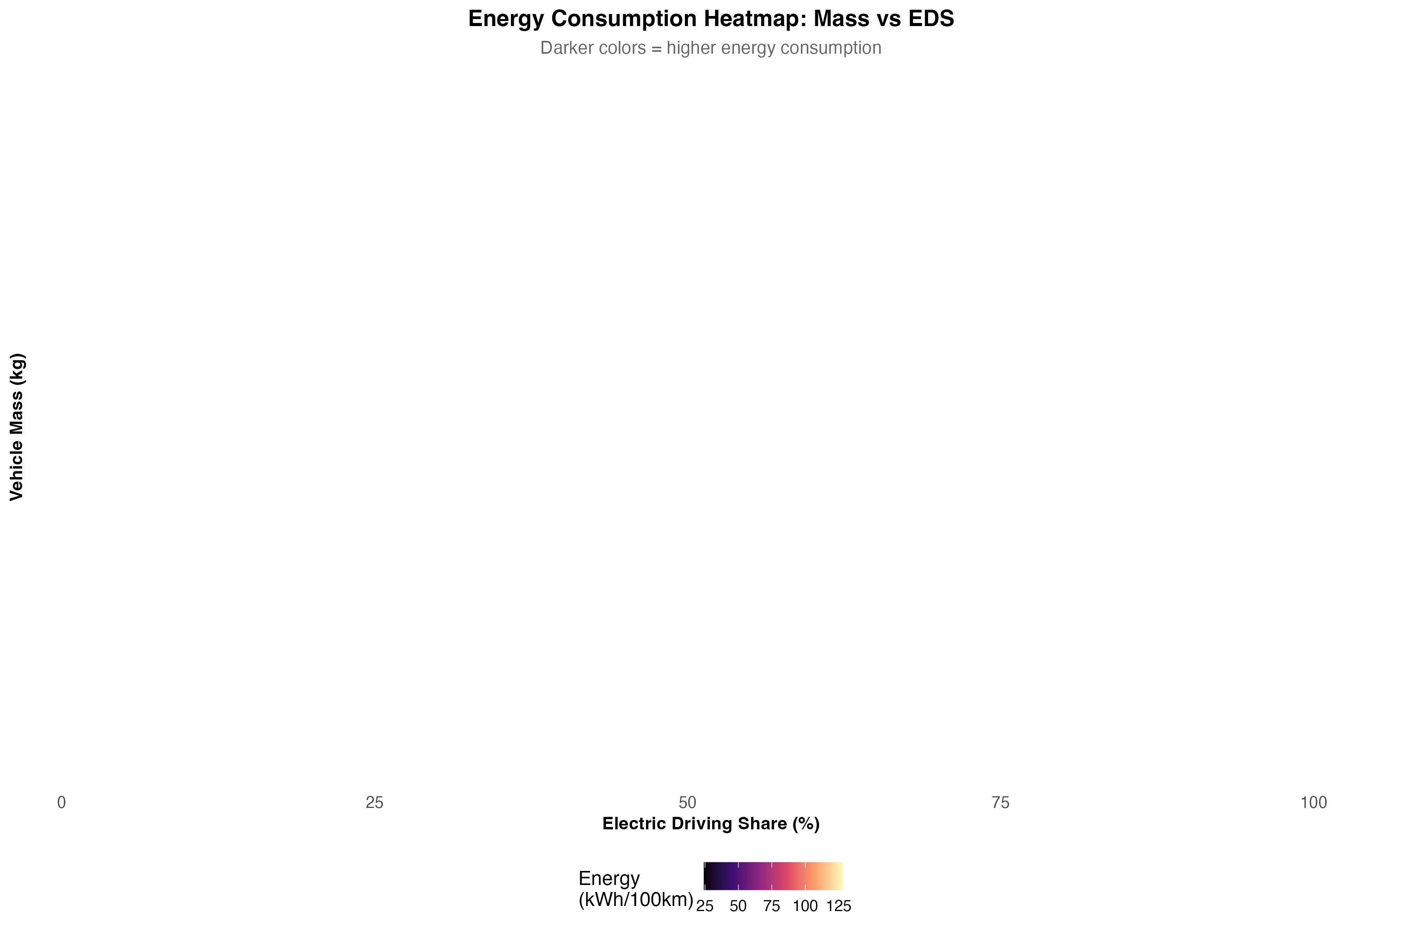

Figure 7

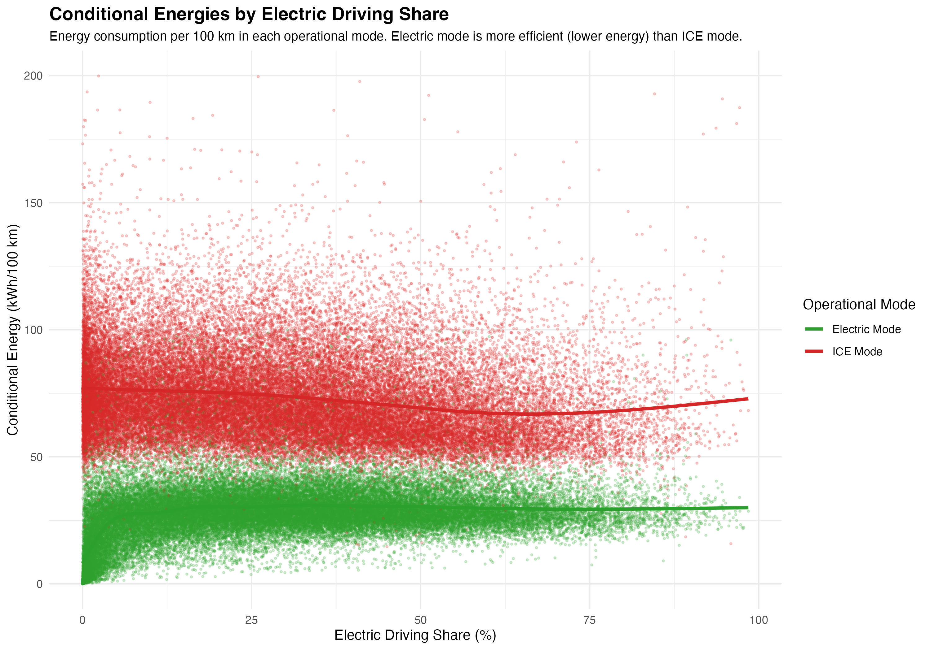

**Figure 7:** Heatmap showing median energy consumption across EDS and mass combinations. Energy consumption increases with mass (vertical axis) and decreases with EDS (horizontal axis). The color gradient (darker colors = higher energy consumption) provides a comprehensive view of how these two key factors interact to determine energy consumption. The lowest energy consumption occurs for light vehicles with high EDS, and the highest for heavy vehicles with low EDS.

#### 7.1.8 Regional Patterns

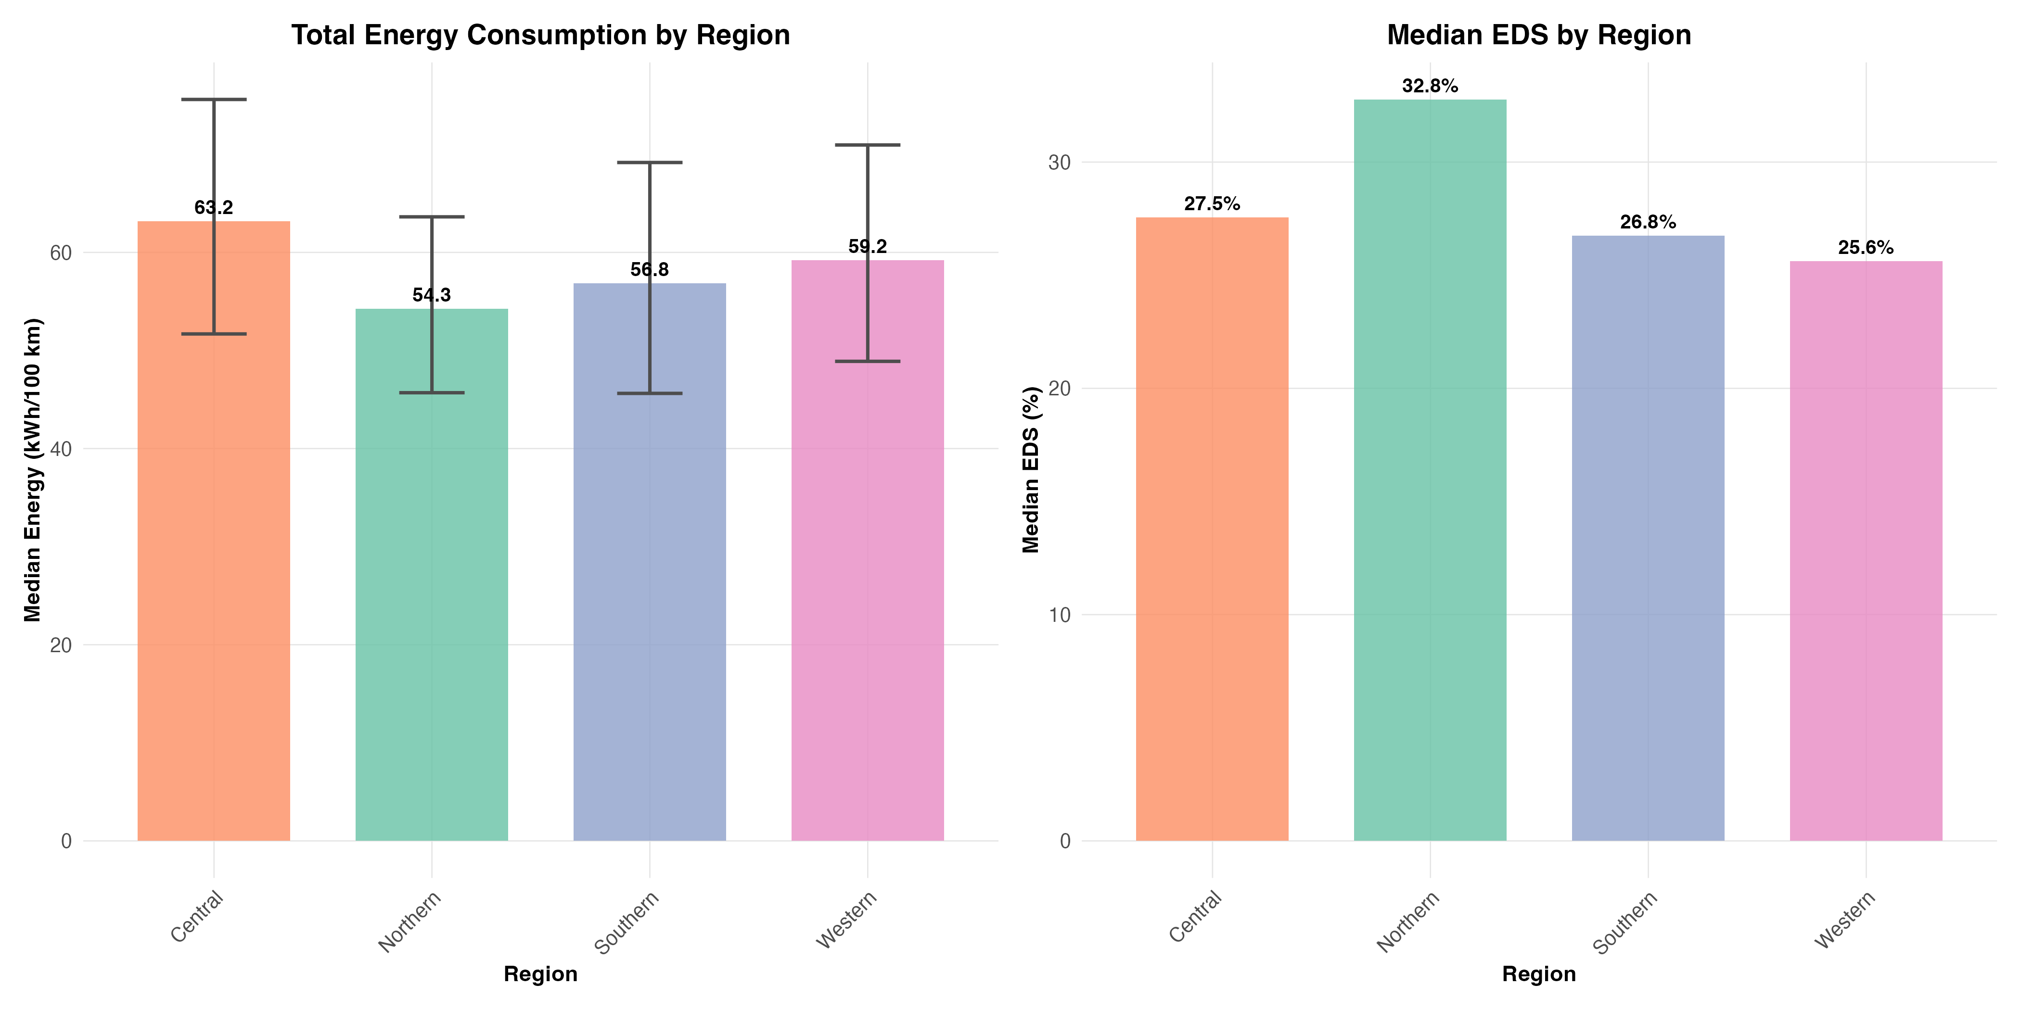

Figure 8

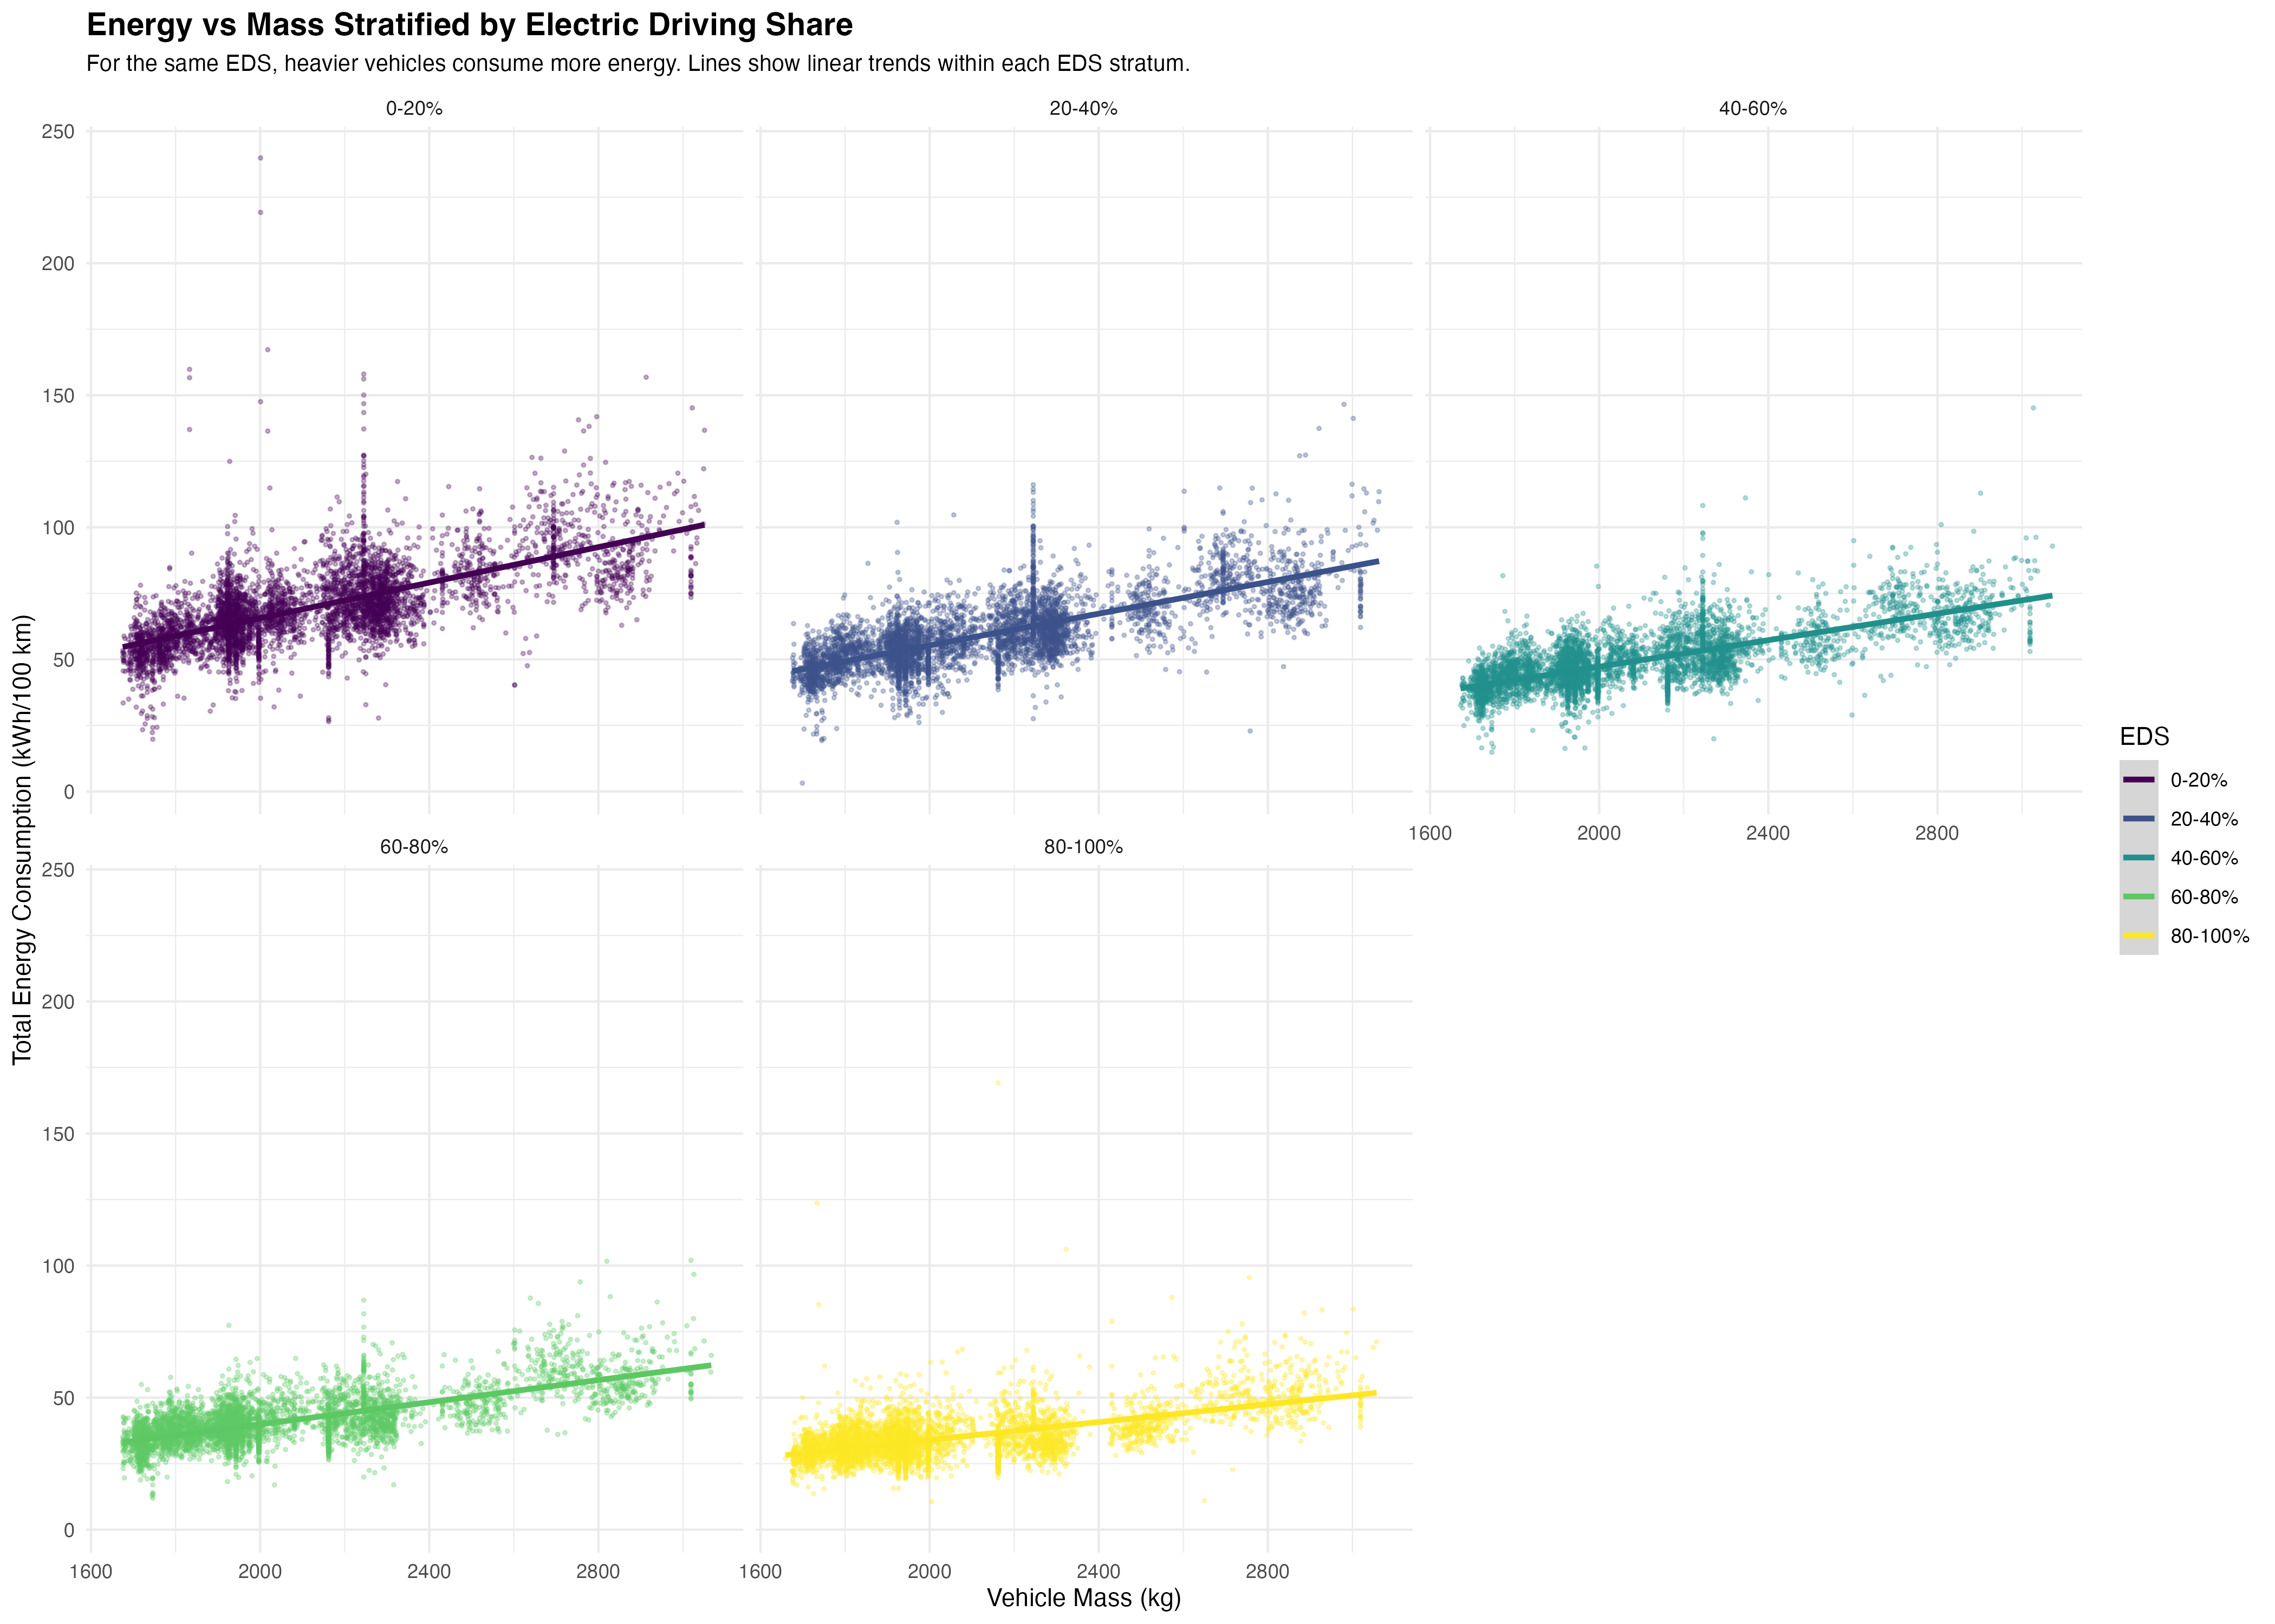

**Figure 8:** Regional comparison of energy and EDS patterns (recreating Markos’s Screenshot 2 with improved quality). The left panel shows total energy consumption by region with IQR error bars, while the right panel shows median EDS by region. Regional variation in both metrics demonstrates the importance of contextual factors (infrastructure, climate, policy) in determining real-world PHEV performance.

#### 7.1.9 EDS Patterns by Vehicle Mass Category

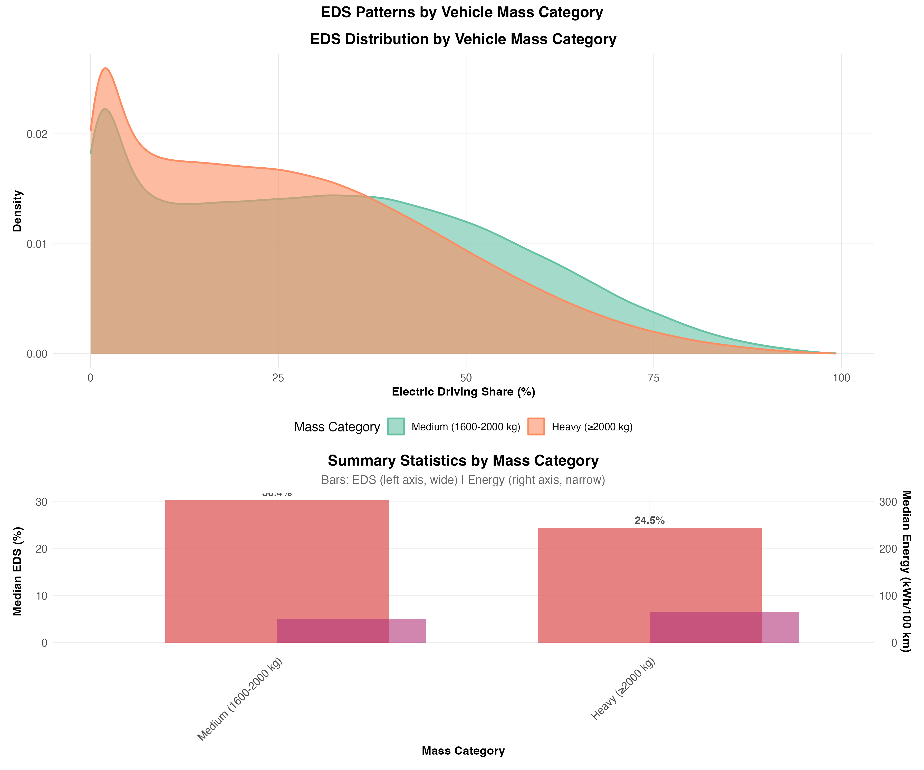

Figure 9

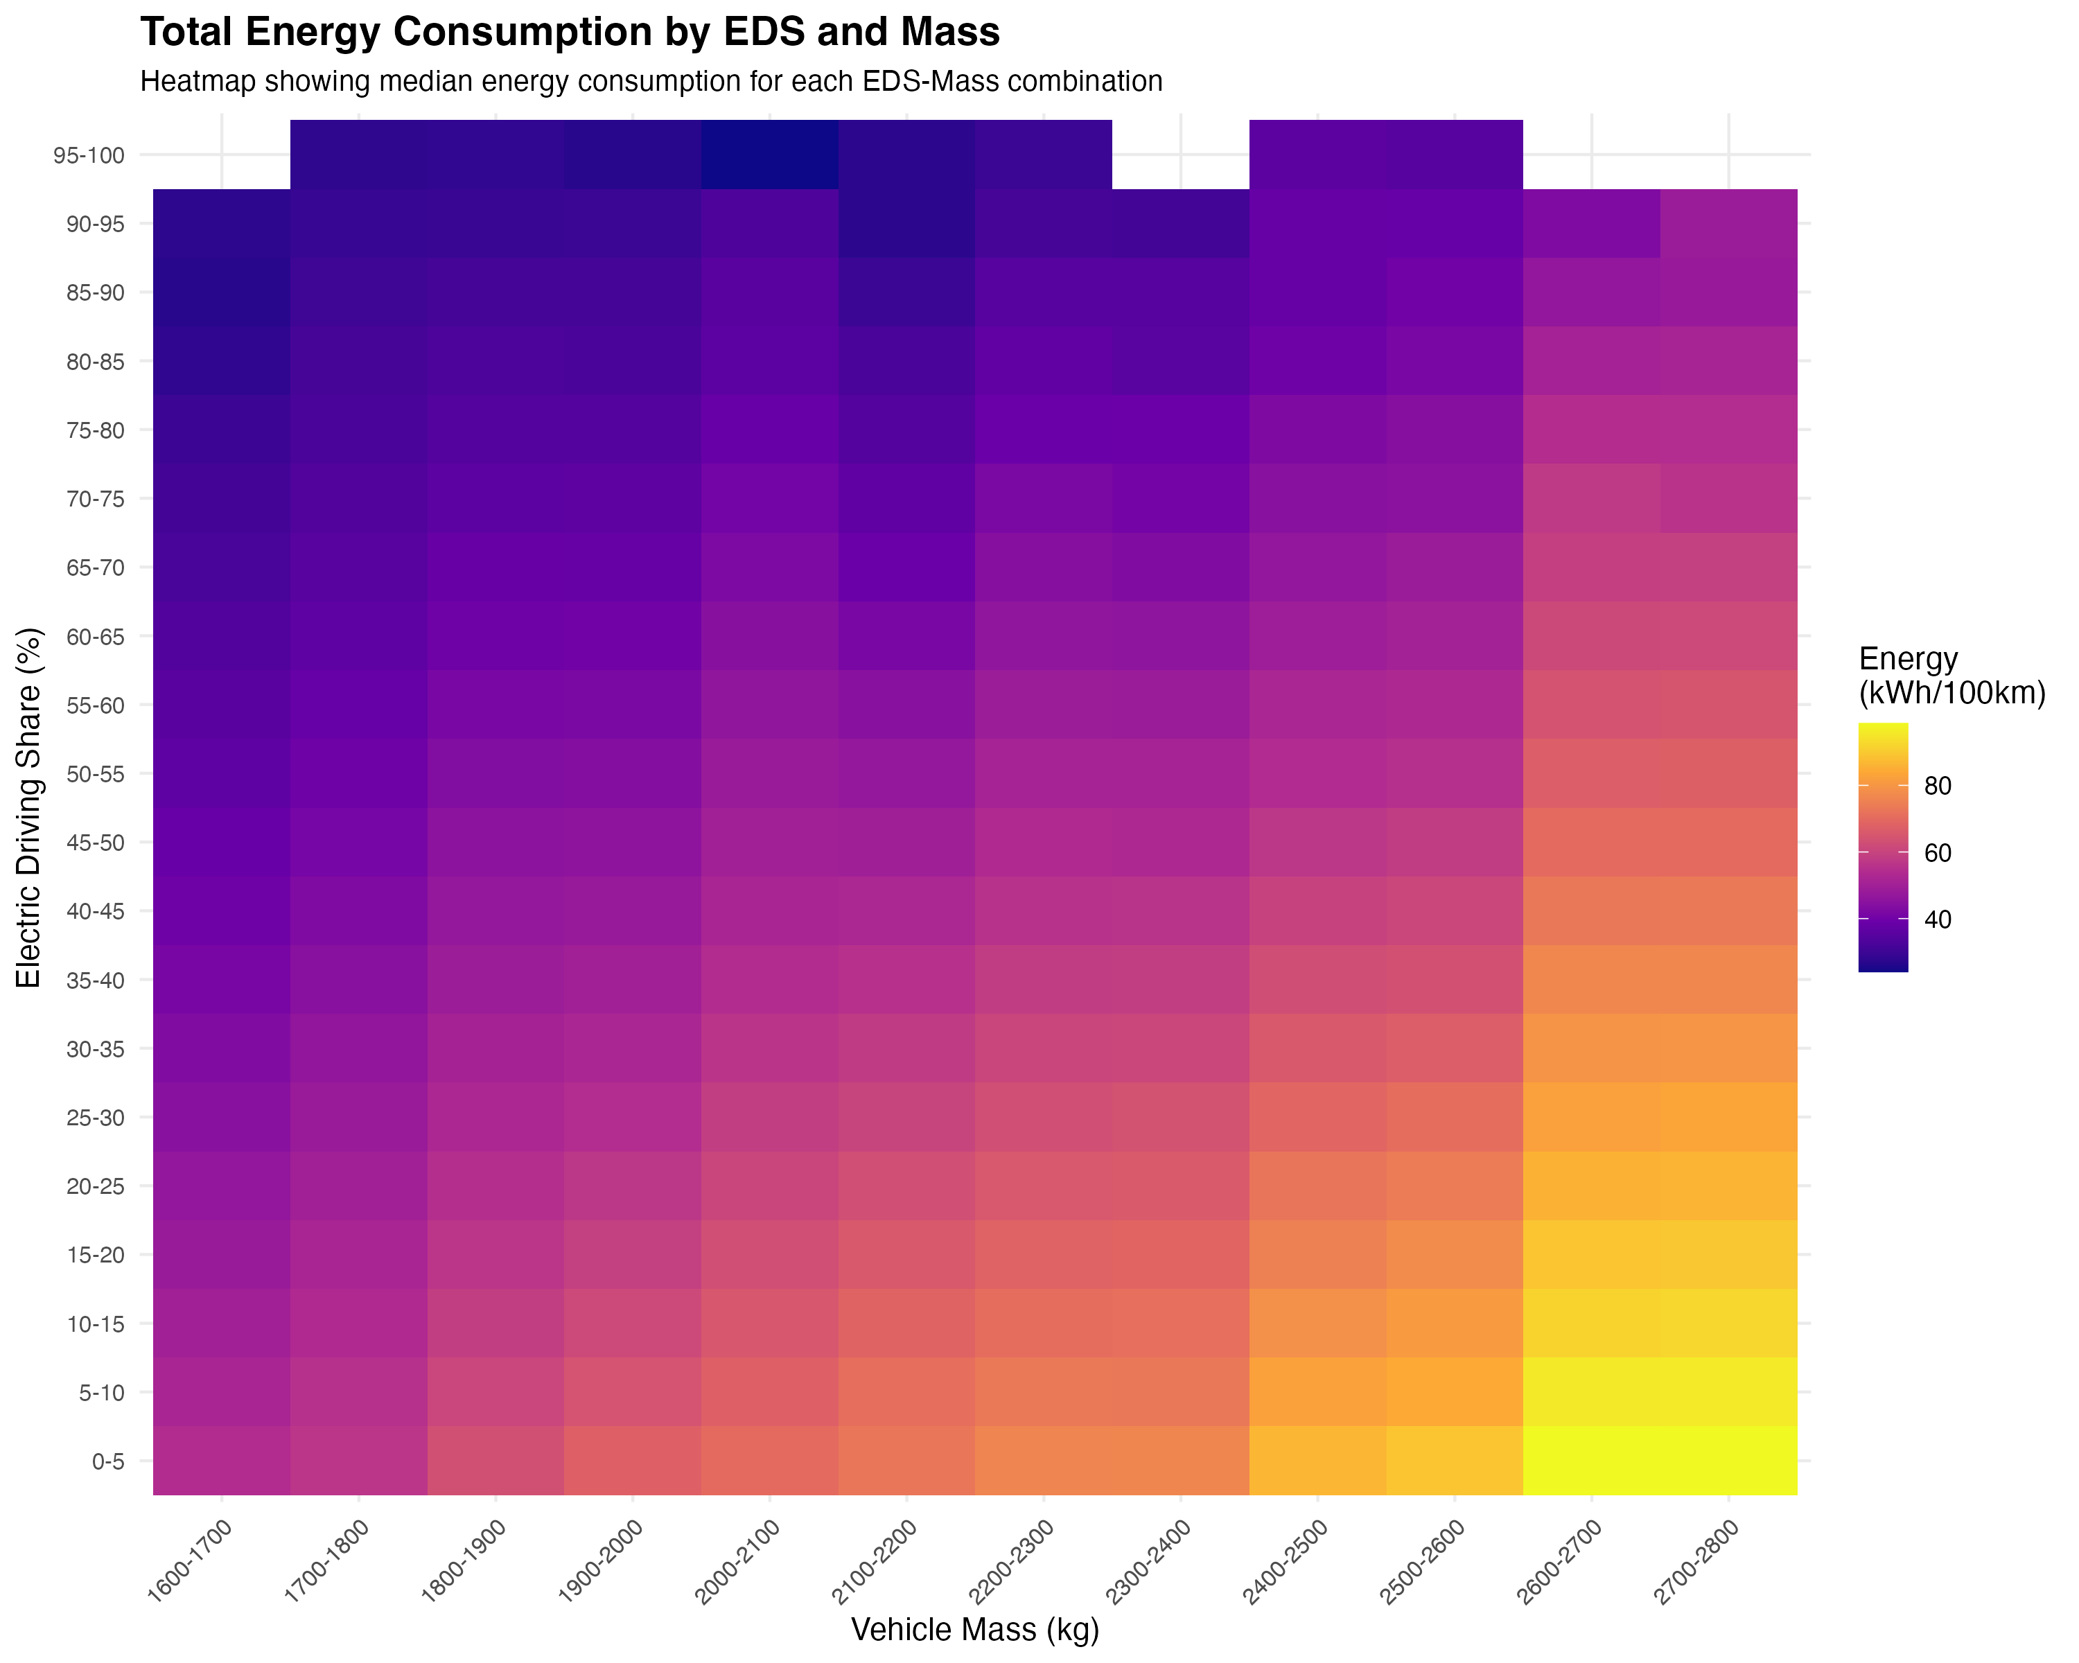

**Figure 9:** EDS distribution and summary statistics by vehicle mass category (recreating Markos’s Screenshot 3 with improved quality). The top panel shows EDS density distributions for light (<1600 kg), medium (1600-2000 kg), and heavy (≥2000 kg) vehicles, revealing how EDS patterns differ across vehicle sizes. The bottom panel shows summary statistics (median EDS and median energy) by mass category, with dual y-axes to show both metrics simultaneously.

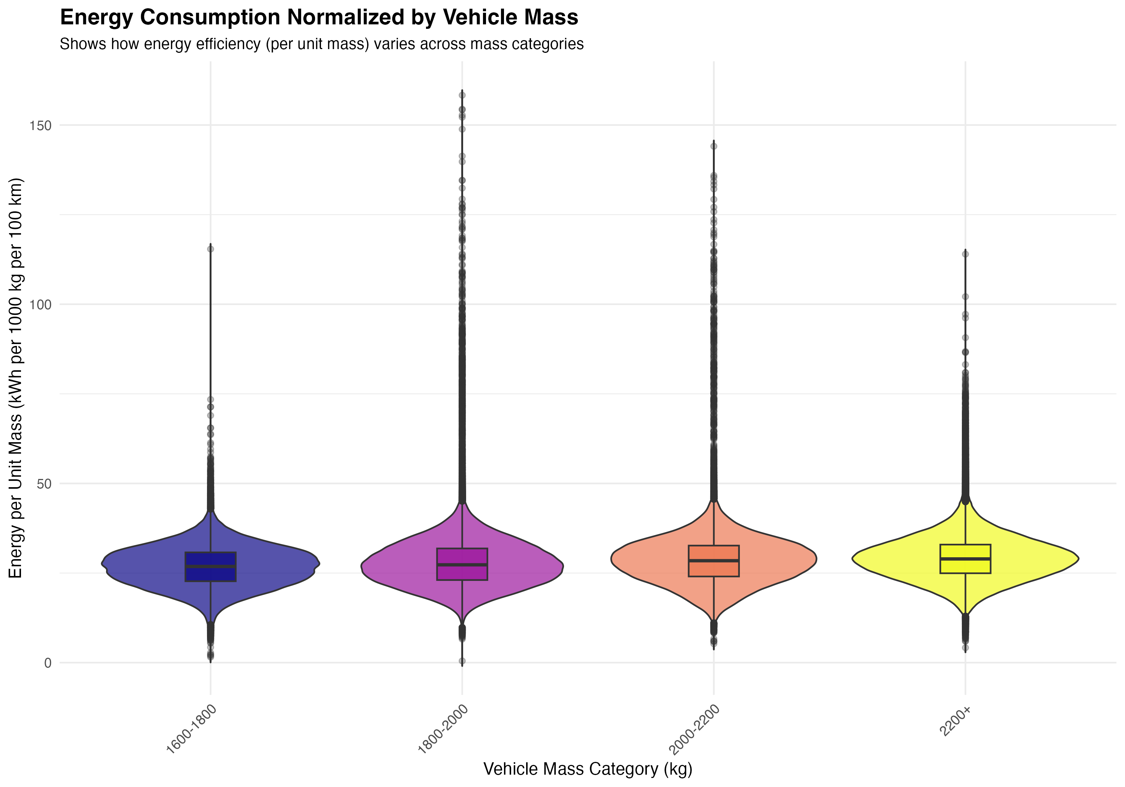

Figure 10



**Figure 10:** Energy consumption normalized by vehicle mass (energy per unit mass, kWh per 1000 kg per 100 km). This normalization helps isolate the effect of vehicle design efficiency from absolute size. Smaller vehicles tend to have better energy efficiency per unit mass, though the relationship is not uniform across all mass categories, suggesting that factors beyond mass (aerodynamics, powertrain efficiency) also play important roles.

These figures collectively demonstrate that both vehicle design (mass) and usage patterns (EDS) are critical determinants of energy consumption, and that understanding their interaction is essential for optimizing PHEV real-world performance.

### 7.2 Explainable Modelling: Feature Importance for EDS and Energy

#### 7.2.1 Predictor Set Transparency (Reviewer-Proof)

We compiled a candidate predictor inventory (Table 3) including: (1) vehicle technical specifications (mass, electric range, engine power, battery capacity, segment, fuel type); (2) contextual variables (country, region, year); and (3) usage variables (total mileage). All predictors were selected to ensure availability for extrapolation to the EEA fleet, enabling future fleet-wide predictions.

**Pre-screening and Feature Selection:** We applied a systematic feature selection approach with clear rationale for each variable group:

1. **Core vehicle specifications** (4 variables): Mass, Electric_range, Engine_power, drive_battery_capacity_kwh. These represent fundamental physical properties that directly affect energy consumption and electric driving capability.
2. **Engineered efficiency ratios** (3 variables): AER-to-mass ratio, power-to-mass ratio, battery-to-mass ratio. These ratios capture design efficiency rather than absolute values, reducing multicollinearity with mass while maintaining physical interpretability. For example, AER-to-mass ratio captures how efficiently a vehicle achieves electric range relative to its weight.
3. **Usage variable** (1 variable): Mileage_Tot (total mileage). This captures vehicle utilization patterns that affect EDS, as high-mileage vehicles are more likely used for longer trips that exceed electric range. Log-transformed versions were tested but excluded as they showed near-zero importance and did not improve model performance.
4. **Contextual variables** (5 variables): Country, Region, Year, segment, Fuel_type. These capture infrastructure availability, climate effects, policy context, and vehicle segment characteristics.

**Exclusions:** - Variables directly constructed from targets (e.g., EnICE_final100km and EnEl_final100km from EnTot_final100km, Mileage_CD_Eng_Off from EDSen_mech) to avoid leakage - Highly intercorrelated variables that do not provide additional information beyond efficiency ratios - Log-transformed versions of variables that showed near-zero importance

The final modeling dataset contained 891,693 clean records (from 900,525 total) with complete predictor information after filtering for missing values and infinite values in predictor variables (Mass, Electric_range, Engine_power, drive_battery_capacity_kwh, Mileage_Tot, and engineered efficiency ratios). The 8,832 excluded records (0.98% of total) were distributed across countries and segments without systematic bias, representing vehicles with incomplete technical specifications in the OBFCM database rather than a specific vehicle type or geographic pattern.

#### 7.2.2 Model Results

We trained XGBoost models with boosted trees for both primary (EDSen_mech) and secondary (EnTot_final100km) targets, following best practices for explainable machine learning (Suarez et al., 2025). Model selection was based on comparison with simpler alternatives and other machine learning approaches: linear regression achieved test R² of 12.7% for EDS and 44.9% for energy, while XGBoost achieved 15.5% for EDS and 82.4% for energy, representing improvements of 2.8 and 37.5 percentage points respectively. We also tested Random Forest, which achieved 11.1% R² for EDS (see Appendix B for full comparison). XGBoost was chosen for its ability to capture non-linear relationships and interactions while maintaining interpretability through SHAP values, computational efficiency for large datasets, and alignment with best practices in explainable machine learning. The modest differences between models (all achieving R² between 9-15% for EDS) confirm that EDS is inherently difficult to predict from vehicle-level data, regardless of the modeling approach.

**Model development and evaluation:** Model development included careful hyperparameter tuning (max_depth=6, learning_rate=0.1, nrounds=100), feature selection to avoid multicollinearity, and robust performance evaluation using 5-fold cross-validation on all 891,693 records with complete predictor information. Cross-validation provides more robust performance estimates than simple train-test splits by evaluating model performance across multiple data partitions.

**Feature sets:** For EDSen_mech prediction, we use vehicle specifications, efficiency ratios, usage variables, and contextual factors (13 variables total). Infrastructure and climate variables (density, temperature, charge points) were tested but showed weak correlations (r < 0.1) and minimal contribution to model performance, reflecting that EDS is primarily driven by driver behavior and charging habits that are not well captured by aggregate infrastructure metrics.

For EnTot_final100km prediction, following the approach of Suarez et al. (2025), we report two models: (1) without EDS as a predictor (13 variables), and (2) with EDS as a predictor (14 variables). This dual approach is justified because EDS serves as the primary proxy for charging behavior, which is a key driver of energy consumption but is not well captured by vehicle specifications alone. The model without EDS demonstrates the predictive power of vehicle characteristics and contextual factors alone, while the model with EDS demonstrates the substantial additional explanatory power provided by operational electrification patterns. Including EDS as a predictor for energy is not circular because EDS reflects operational electrification patterns (charging behavior, trip structure) that causally influence energy outcomes, rather than being derived from energy values. The strong negative correlation (r = -0.61) between EDS and energy confirms this relationship.

**Model performance:** For EDSen_mech, the overall model achieved a cross-validation R² of 21.1% (RMSE: 19.1%), indicating that vehicle and contextual factors explain approximately one-fifth of the variance in electric driving share. The relatively low R² for EDS is expected and reflects the fundamental challenge of predicting operational electrification from vehicle characteristics alone: EDS is heavily influenced by driver behavior, charging habits, and trip patterns that are not well captured by vehicle specifications or even infrastructure variables (correlations with infrastructure/climate variables are weak, r < 0.1). This finding aligns with previous research showing that charging behavior varies substantially across drivers and contexts, making EDS inherently difficult to predict from vehicle-level data alone.

**Segmented model analysis:** To explore whether model performance could be improved by isolating homogeneous vehicle groups, we tested segmented models by vehicle mass categories, segment types, and their combinations. Results show that segmentation can improve R² for specific homogeneous groups: heavy vehicles (≥2000 kg) achieve 23.1% R², and the combination of “Upper Medium Car” segment with heavy mass achieves 23.6% R² (Table A3, Figure A2). However, the weighted average R² across all segments (20.3%) is slightly lower than the overall model (21.1%), as some groups (e.g., medium-mass vehicles) show lower R² (17.2%). This suggests that while segmentation can improve explainability within homogeneous groups, the overall predictive power remains limited by the fundamental challenge of predicting driver behavior from vehicle characteristics. The improvement for heavy vehicles (from 21.1% to 23.1%) represents a 9.5% relative increase in explained variance, demonstrating that more homogeneous groups can achieve modestly better predictions, but the absolute improvement remains modest (2 percentage points).

For EnTot_final100km, we report two models following the approach of Suarez et al. (2025): (1) a model without EDS as a predictor, achieving a cross-validation R² of 51.6%, and (2) a model with EDS as a predictor, achieving a cross-validation R² of 82.3% (RMSE: 5.2 kWh/100 km). The inclusion of EDS improves the energy model by 30.7 percentage points, demonstrating that EDS is the dominant driver of energy outcomes and serves as the primary proxy for charging behavior. The substantially higher R² for energy consumption when EDS is included reflects the strong predictive power of operational electrification patterns. The target variable EnTot_final100km represents supplied energy (accounting for charging losses and ICE efficiency), which is the correct metric for use-phase energy analysis as stated in the paper.

**Feature importance for EDSen_mech (primary target):** SHAP-based feature importance (Figure 6a) reveals the relative contribution of each predictor to explaining variance in electric driving share. The most important features are: (1) AER-to-mass ratio (27.6% gain), (2) total mileage (Mileage_Tot, 27.2% gain), (3) country (8.4% gain), (4) year (7.4% gain), and (5) region (6.2% gain). Electric range (3.8% gain), battery capacity (5.2% gain), and power-to-mass ratio (3.2% gain) also contribute. Infrastructure and climate variables (density, temperature, charge points) were tested but showed weak correlations (r < 0.1) and minimal contribution to model performance, reflecting that EDS is primarily driven by driver behavior and charging habits that are not well captured by aggregate infrastructure metrics. Dependence plots (Figure 6b) show the relationship between key features and EDS: (1) higher AER-to-mass ratio is associated with higher EDS, (2) higher total mileage is associated with lower EDS, and (3) country-level effects show substantial variation. The near-equal importance of AER-to-mass ratio (27.6%) and total mileage (27.2%) suggests that both vehicle design efficiency and usage patterns are critical determinants of electric driving share, with approximately equal weight. The relatively low overall R² (21.1%) reflects the fundamental challenge of predicting operational electrification from vehicle characteristics alone, as EDS is heavily influenced by individual driver behavior and charging habits that vary substantially across contexts. Segmented models for homogeneous groups (e.g., heavy vehicles) achieve modestly higher R² (23.1-23.6%), representing 9.5-11.8% relative improvements, but the absolute improvement remains modest (2-2.5 percentage points) and confirms the fundamental difficulty of predicting EDS from vehicle-level data (see Appendix C for detailed segmented model analysis).

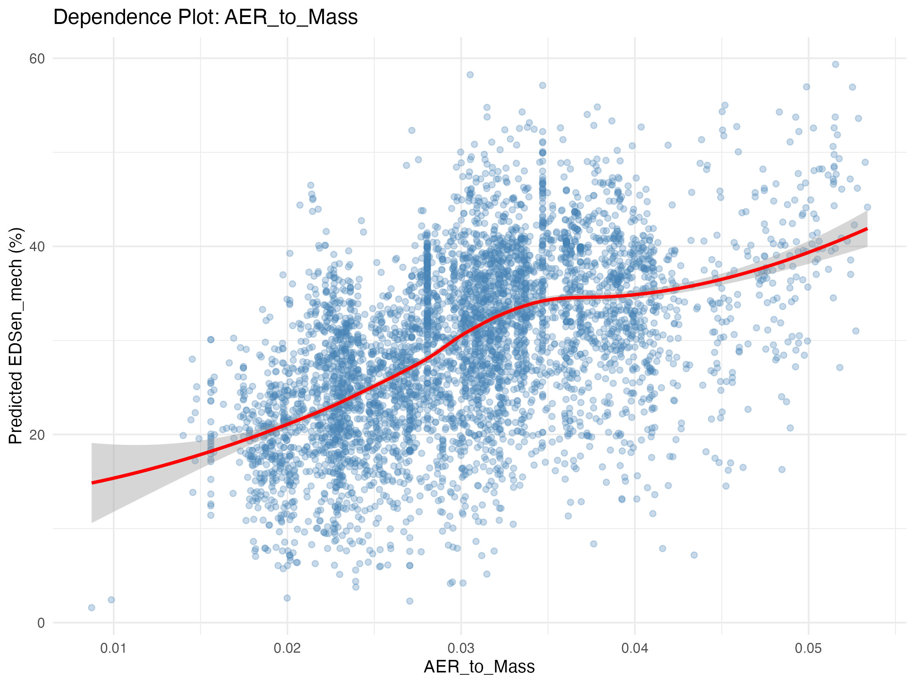

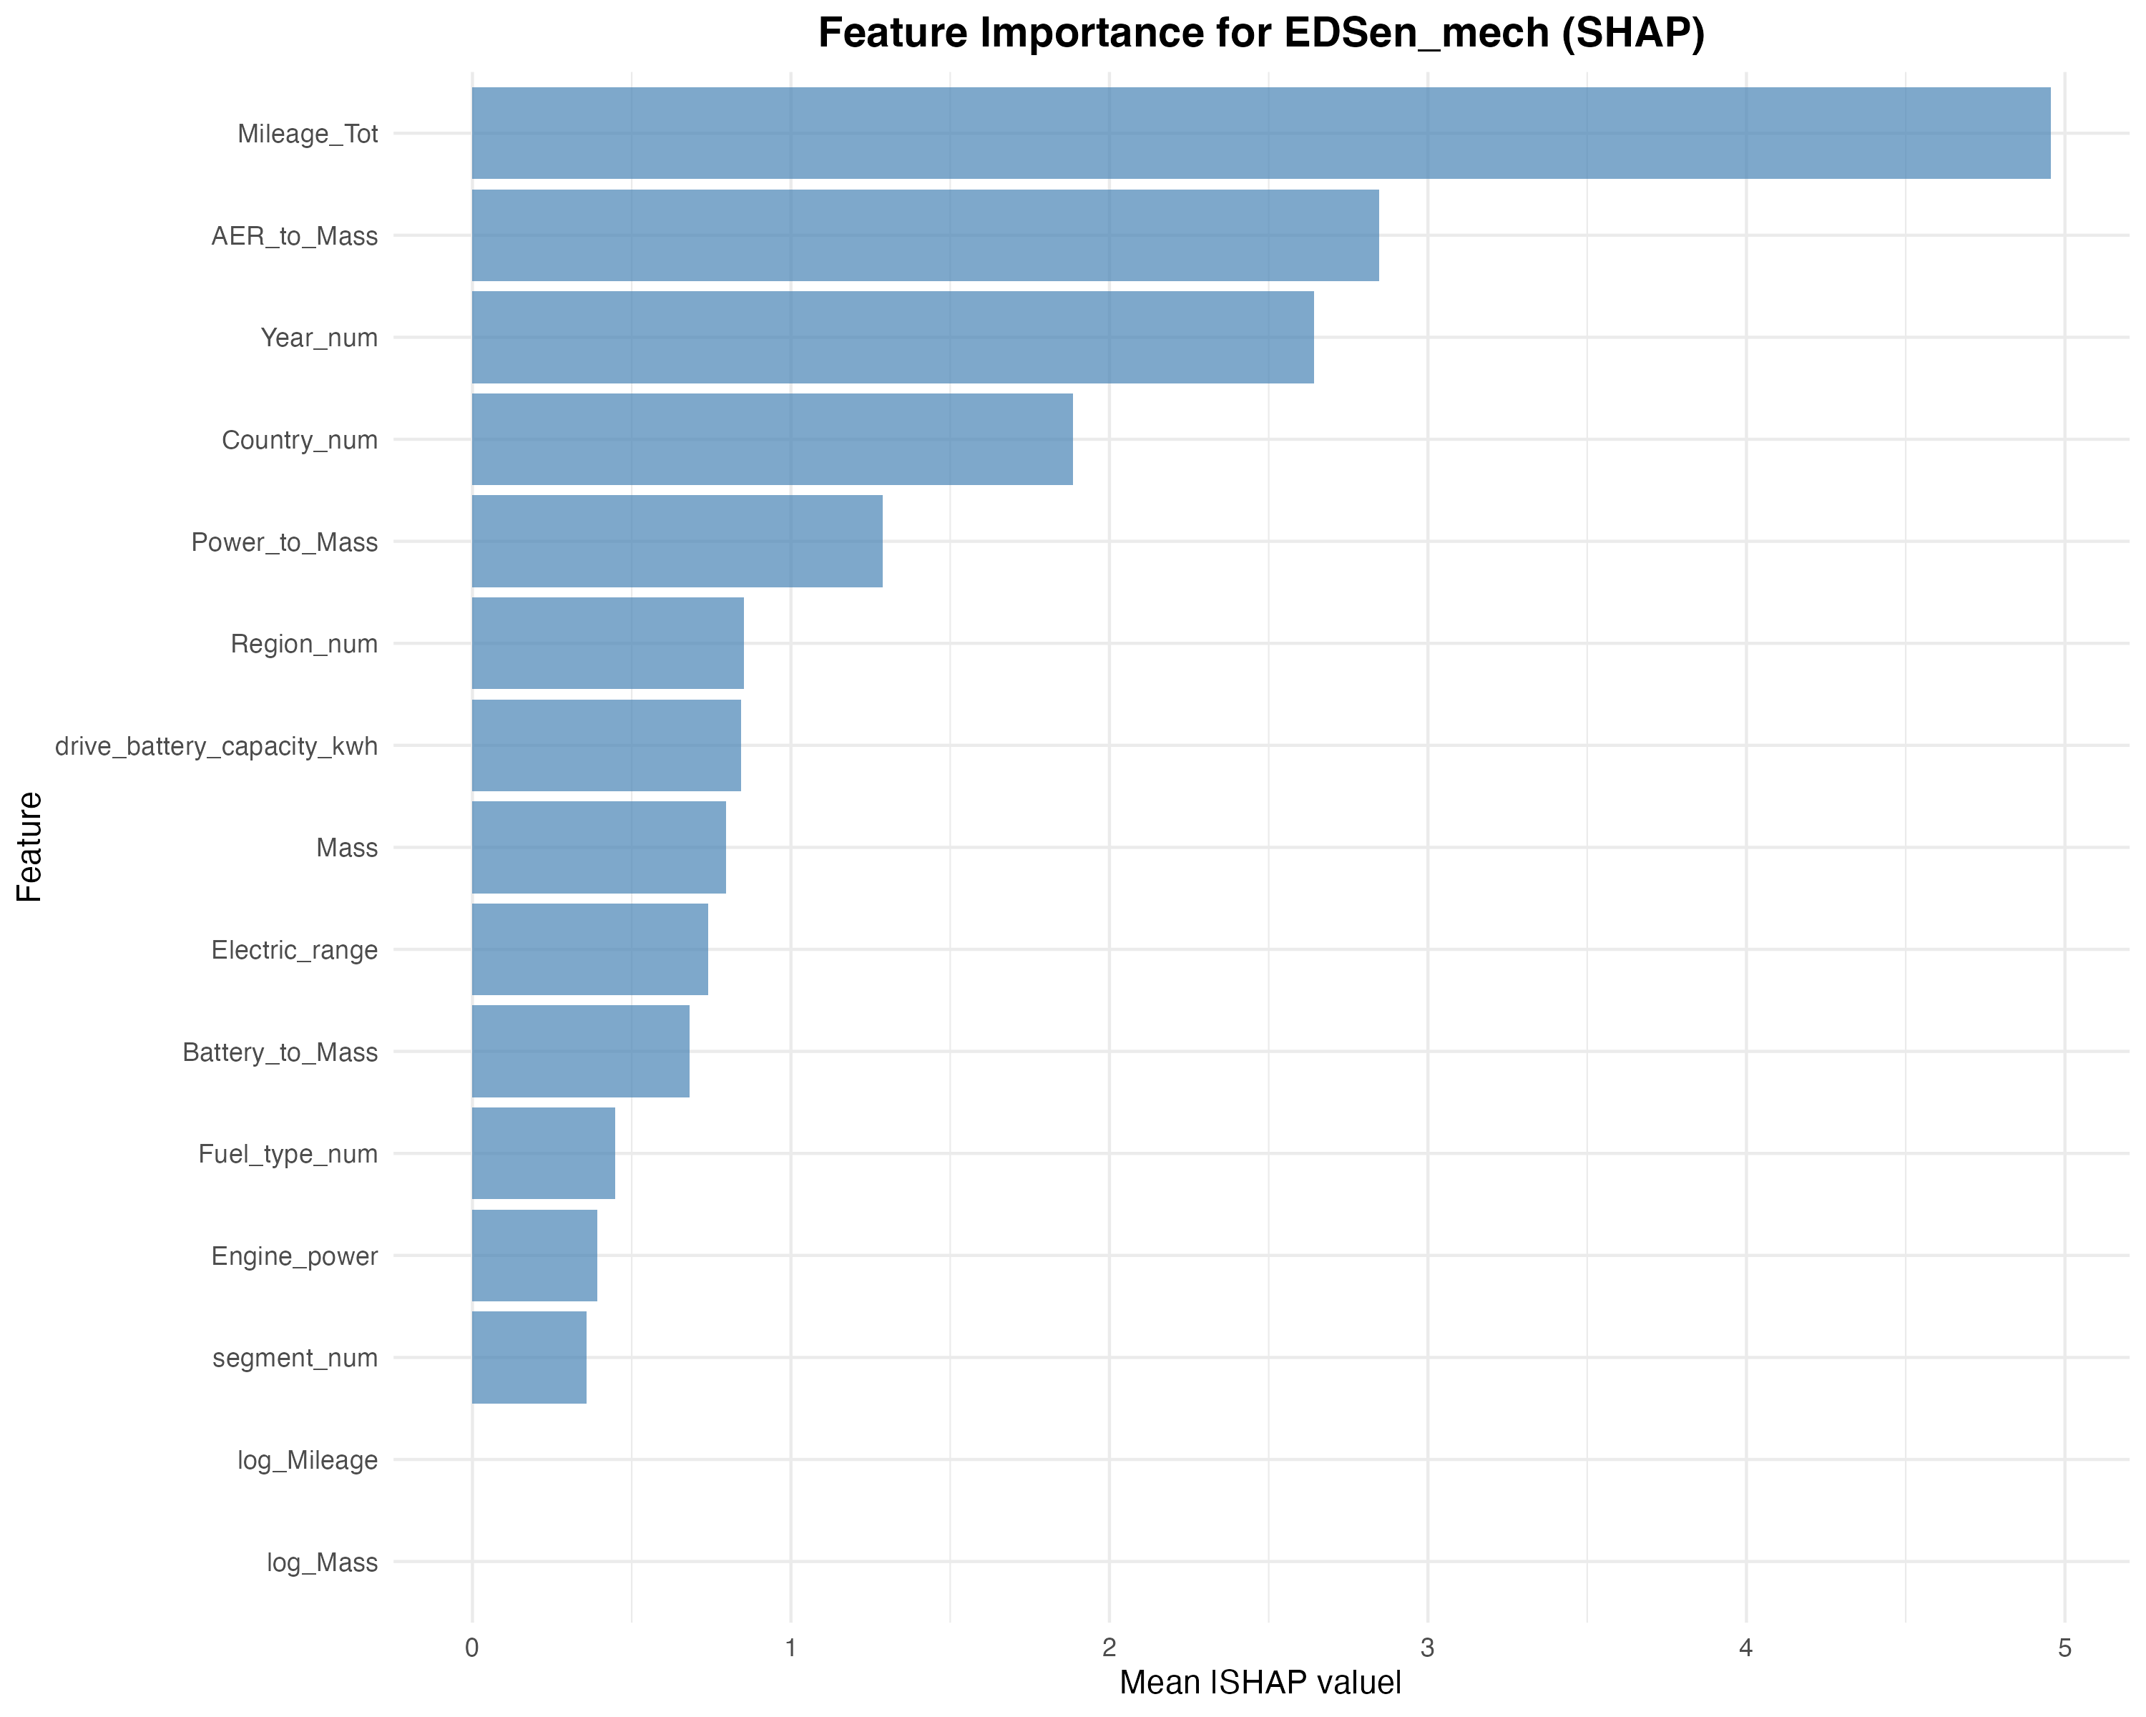

**Feature importance for EnTot_final100km (secondary target):** We report feature importance for the model with EDS included, as this represents the full predictive model. SHAP-based feature importance (Figure 6c) reveals the relative contribution of each predictor to explaining variance in total energy consumption. The most important features are: (1) EDSen_mech (43.5% gain), (2) mass (34.8% gain), (3) engine power (6.2% gain), (4) AER-to-mass ratio (4.3% gain), and (5) electric range (4.3% gain). The dominance of EDSen_mech (43.5%) reflects its role as the primary driver of energy consumption: higher electric driving share directly reduces total energy consumption, as electric propulsion is more efficient than internal combustion. Mass (34.8%) is the second most important feature, aligning with fundamental physics: heavier vehicles require more energy to move. The substantial combined importance of EDS (43.5%) and mass (34.8%) indicates that both operational electrification patterns and vehicle design are critical determinants of total energy consumption. When EDS is excluded from the model, mass becomes the dominant predictor (58.3% gain), followed by AER-to-mass ratio (15.1% gain), demonstrating that vehicle characteristics alone can explain approximately half of the variance in energy consumption, but the inclusion of EDS (as a proxy for charging behavior) substantially improves predictive power. Dependence plots show that: (1) higher EDS is associated with lower total energy consumption, (2) higher mass is associated with higher total energy consumption, and (3) country-level effects show variation in energy consumption patterns. Feature importance results are summarized in Table 4.

#### 7.2.3 Interpretation Aligned with Mechanisms

The feature importance results align with plausible mechanisms. The strong importance of AER-to-mass ratio for EDS suggests that vehicles with better range efficiency (higher range per unit mass) enable more electric driving, likely because they can cover a greater proportion of trips on electric power. The inverse relationship between mileage and EDS aligns with trip pattern effects: high-mileage vehicles are likely used for longer trips that exceed electric range, forcing ICE operation.

The importance of country and region for both targets suggests that contextual factors—including charging infrastructure availability, climate effects on battery performance, driving patterns, and policy contexts—significantly influence real-world PHEV performance. However, we emphasize that these are associations, not causal relationships, as country-level variables likely capture multiple correlated factors that we cannot disentangle with fleet-level data alone.

For total energy consumption, the dominance of mass reflects fundamental physics, while the contributions of AER-to-mass ratio and electric range indicate that vehicles with better electric capability achieve lower total energy consumption through increased electric driving. These findings suggest that both vehicle design (mass, range efficiency) and usage context (mileage patterns, country-level factors) are important for understanding real-world PHEV performance.

### 7.3 Subfleet Isolation + Micro Evidence (Campaigns + Selected Models)

To provide mechanistic evidence and validate fleet-scale patterns, we examine targeted subfleets and high-resolution campaign data. This analysis allows us to: (1) validate fleet-scale relationships within homogeneous vehicle groups, (2) understand how usage patterns affect EDS for the same vehicle design, and (3) provide mechanistic interpretation of the variability observed at the fleet level.

#### 7.3.1 Select Subfleets Strategically

We selected high-volume vehicle models to enable subfleet analysis with sufficient sample sizes. Candidate subfleets include: - Golf family / popular VFNs (for comparability with campaign data) - Other popular high-volume model groups (to demonstrate generality across vehicle designs)

For each subfleet, we: - Repeat the flagship relationship (energy split vs EDS) within the subfleet to validate that the fundamental relationship holds when vehicle design is held approximately constant - Compare subfleet vs overall fleet distribution to understand where specific models sit within the broader fleet - Examine whether feature importance shifts when vehicle design is held constant, revealing which factors remain important at the subfleet level

*Note: Detailed subfleet analysis results will be presented when campaign data and subfleet selections are finalized.*

#### 7.3.2 Campaign evidence: mechanisms behind fleet patterns

High-resolution trip-level campaign data provides mechanistic evidence for understanding the variability in EDS and energy consumption observed at the fleet scale. This analysis uses trip-level telemetry from the Golf PHEV campaign (18 drivers, 1,127 trips, 27,148 km) and, when available, additional campaign vehicles from JRCmatics (Ale, 2025) to illustrate the behavioral mechanisms that generate fleet-scale patterns.

**Key analyses planned:**

1. **Charging behavior and frequency:** Analysis of charging events (equivalent full charges) and their relationship with daily distance and trip patterns. This directly addresses the behavioral driver of EDS that is not observable in aggregated OBFCM data.
2. **Trip length and daily distance distributions:** Examination of how trip length distributions and daily distance patterns affect electrified share. This helps explain why vehicles with similar characteristics can achieve very different EDS values.
3. **Fleet-context placement:** Positioning of campaign vehicles (or individual driver-periods) within the OBFCM fleet distributions to demonstrate how the same vehicle can occupy different parts of the fleet EDS-energy space depending on usage patterns. This provides mechanistic interpretation of the distributional tails observed in fleet data (high-EDS vs low-EDS users).

**Framing:** This analysis is not presented as formal validation of OBFCM, but rather as mechanistic consistency and interpretation. The goal is to use trip-level observations to explain why fleet-scale patterns emerge and to interpret the residual variability that vehicle characteristics alone cannot explain.

*Note: Detailed campaign analysis results will be presented when trip-level data processing is complete. The Golf campaign data is available, and additional JRCmatics vehicles (6-7 PHEVs with energy metrics) will be included as data become available.*

### 7.4 EU fleet extrapolation (EEA 2021-2024)

This section translates OBFCM findings into EU-fleet representative metrics by applying trained models to the EEA CO₂ monitoring dataset, which provides an exhaustive record of passenger cars newly registered in Europe for 2021–2024. This analysis addresses the question: “What does this imply for the EU fleet overall (not just the OBFCM sample), by registration year?”

**Objective:** Translate OBFCM findings into EU-fleet metrics for 2021–2024, providing policy-relevant scaling from the OBFCM sample to the broader European new-registration fleet.

**Approach:** 1. **Model application:** Apply the OBFCM-trained models (Section 4.2) to each vehicle record in the EEA dataset to predict: - EDSen_mech (primary target) - EnTot_final100km (secondary target)

1. **Aggregation:** Compute EU-fleet weighted metrics using registration counts provided in the EEA dataset. Since the EEA monitoring file is exhaustive at the registration-count level, this is not statistical “reweighting” but rather direct aggregation using the counts provided.
2. **Stratification:** Provide composition-aware breakdowns by:
   * Registration year (2021–2024)
   * Vehicle mass class (light/medium/heavy)
   * Vehicle segment
   * Country/region (if sample sizes permit)
3. **Annual totals (optional extension):** If mileage predictions are available, compute annual total energy consumption (similar to Jaime’s TAP paper approach for annual tailpipe CO₂). This would require a dedicated mileage model or simulation step.

**Key outputs:** - EU-fleet distributions (medians, IQRs, percentiles) of predicted EDS and energy by registration year - Temporal trends: change over time (2021→2024) in predicted EDS and energy - Composition-aware breakdowns: energy and EDS by mass class, segment, and country - Uncertainty quantification: model error propagation through cross-validation or bootstrap resampling

**Interpretation:** Results should be interpreted as model-based projections of real-world outcomes conditioned on observable fleet composition. These projections account for the vehicle characteristics available in EEA monitoring data but do not directly observe charging behavior, which remains a key source of uncertainty for EDS predictions.

*Note: This section will be populated when EEA 2021–2024 registration data processing and model application are complete. The analysis framework is designed to be transferable, using only predictors available in both OBFCM and EEA datasets.*

### 7.5 Model Robustness and Alternative Approaches

This section complements the primary explainable machine learning analysis presented in Section 4.2 (XGBoost with SHAP) by examining model robustness and providing alternative perspectives on variable importance. The XGBoost/SHAP results presented in Section 4.2 represent the primary analysis, with the following considerations for robustness:

**Model robustness:** - Cross-validation performance across multiple folds to quantify uncertainty - Stability of feature importance rankings across different train-test splits - Year-by-year analysis to assess temporal stability of relationships

**Alternative modeling approaches (for comparison):** - **Generalized Additive Models (GAMs)**: Non-linear models with smooth terms that can capture complex relationships and provide F-statistics for variable importance, offering an alternative interpretable framework. - **Random Forest**: A non-parametric ensemble method that provides variable importance through permutation-based measures, useful for comparison with boosted trees.

These alternative methods provide robustness checks and complementary insights to the XGBoost/SHAP results, helping to validate the key findings that AER-to-mass ratio and total mileage are the most important features for predicting EDS, while mass dominates for total energy consumption. Results from alternative methods, when available, are presented in the appendix for completeness.

### 7.6 Regional and Temporal Patterns

This section provides detailed analysis of regional variation and temporal trends, extending the regional analysis presented in Section 4.1.C.

#### 7.6.1 Regional Patterns

Regional analysis reveals substantial variation in both EDS and energy consumption across European regions. The Northern region shows the highest median EDSen_mech (32.77%), followed by Central (27.55%), Southern (26.76%), and Western (25.62%) regions. This pattern aligns with the findings in Section 4.1.C, with Northern countries consistently showing higher electric driving shares.

Total energy consumption also varies regionally: the Central region shows the highest median EnTot_final100km (63.19 kWh/100 km), while the Northern region shows the lowest (54.25 kWh/100 km), consistent with the higher EDS values in Northern countries. The Western region, despite having the lowest median EDS, shows moderate energy consumption (59.22 kWh/100 km), suggesting that other factors beyond EDS (e.g., vehicle characteristics, driving patterns) also influence total energy consumption.

#### 7.6.2 Temporal Trends

Analysis of temporal trends across 2021-2023 reveals modest changes in EDS and energy consumption. Median EDSen_mech shows a slight increase from 26.92% in 2021 to 28.46% in 2023, suggesting a gradual improvement in electric driving share over time. However, this trend is not monotonic: 2022 shows a slight decrease (26.66%) compared to 2021, followed by an increase in 2023.

Total energy consumption shows a slight increase over time: median EnTot_final100km increases from 57.60 kWh/100 km in 2021 to 58.61 kWh/100 km in 2023. This increase may reflect changes in vehicle characteristics (e.g., larger vehicles, higher power) or usage patterns over time, though the magnitude of change is relatively small.

The temporal trends suggest that while there is some improvement in electric driving share over the study period, the overall patterns remain relatively stable, indicating that the findings are robust across the 2021-2023 reporting period.

### 7.7 Fleet vs Campaign Comparison

This section compares fleet-level OBFCM data with trip-level campaign data (Golf PHEV campaign) to provide mechanistic validation and interpretation of fleet-scale findings. The comparison serves to validate fleet-scale patterns (confirming that fleet-level relationships such as energy split vs EDS are consistent with trip-level observations), provide mechanistic insights (using trip-level data to understand how charging behavior, trip length, and route characteristics influence EDS and energy consumption), and explain distributional tails (using campaign data to understand why some vehicles achieve very high or very low EDS values, linking usage patterns to outcomes).

**Fleet-level summary (OBFCM):** - Total records: 900,525 unflagged vehicles - Median EDSen_mech: 27.05% - Mean EDSen_mech: 29.37% - Median EnTot_final100km: 58.13 kWh/100 km - Mean EnTot_final100km: 59.82 kWh/100 km

**Campaign data comparison:**

The trip-level campaign data (Golf PHEV, 18 drivers) provides mechanistic insights that complement fleet-scale observations:

1. **Trip-level EDS vs charging events:** Direct observation of how charging frequency relates to electric driving share, providing behavioral context for the fleet-scale EDS distribution.
2. **Trip length and daily distance distributions:** Analysis of how trip patterns (short vs long trips, daily distance) affect the proportion of distance driven electrically, explaining why similar vehicles achieve different EDS values.
3. **Campaign vehicles in fleet context:** Placement of individual campaign drivers/periods within the OBFCM fleet distribution shows how the same vehicle can occupy different parts of the EDS-energy space depending on usage patterns. This helps interpret the distributional tails: why some vehicles achieve very high EDS (frequent charging, short trips) vs very low EDS (infrequent charging, long trips).
4. **Mechanistic interpretation:** Linking specific trip-level behaviors (charging frequency, trip structure, route characteristics) to fleet-level outcomes, providing mechanistic consistency between detailed observations and aggregated fleet patterns.

*Note: Detailed statistical comparisons and visualizations will be presented when trip-level campaign data processing is complete. The analysis framework is designed to bridge trip-level mechanisms with fleet-scale patterns.*

This comparison provides mechanistic consistency between fleet-scale aggregated data and detailed trip-level observations, helping to interpret the substantial heterogeneity observed in fleet-level EDS and energy consumption distributions.

### 7.8 Comprehensive EDS-Focused Country-Level Analysis

This section provides a comprehensive country-level analysis of EDS and energy consumption patterns, extending the country-level summary presented in Section 4.1.C with detailed statistics and insights.

#### 7.8.1 Country-Level EDS Distribution

Country-level analysis reveals substantial variation in median EDSen_mech, ranging from 51.37% (Malta) to values below 30% for several countries. Malta and Cyprus show the highest median EDS values (51.37% and 46.20%, respectively), likely reflecting their small geographic size and favorable conditions for electric operation. Finland (39.92%), Ireland (38.12%), and Norway (34.30%) also show relatively high EDS values, consistent with the Northern region’s overall higher electric driving share.

The variation in country-level EDS reflects complex interactions between vehicle characteristics, infrastructure availability, climate conditions, driving patterns, and policy contexts. Countries with higher EDS values tend to have better charging infrastructure, favorable climates for battery performance, and policies that incentivize electric driving.

#### 7.8.2 Country-Level Energy Consumption

Total energy consumption also varies substantially across countries. Malta shows the lowest median EnTot_final100km (48.64 kWh/100 km), consistent with its high EDS value, while several Central and Eastern European countries show higher energy consumption (e.g., Slovakia: 63.09 kWh/100 km, Hungary: 63.24 kWh/100 km). The relationship between EDS and total energy consumption is evident: countries with higher EDS values generally show lower total energy consumption, though vehicle characteristics and other factors also contribute to energy outcomes.

#### 7.8.3 Country-Level Heterogeneity

The standard deviation of EDSen_mech within countries ranges from approximately 19% to 27%, indicating substantial within-country heterogeneity. This heterogeneity reflects that even within countries with similar infrastructure and policy contexts, individual vehicle usage patterns vary substantially. Countries with higher median EDS values (e.g., Malta, Cyprus) also show higher variability, suggesting that while some vehicles achieve very high electric driving shares, others operate with lower EDS values.

This country-level analysis demonstrates that understanding PHEV real-world performance requires consideration of both country-level contextual factors and individual vehicle-level variation. The substantial heterogeneity within countries highlights the importance of vehicle design, usage patterns, and driver behavior in determining electric driving share and energy consumption.

## 8 Discussion

This study presents the first comprehensive fleet-scale analysis of real-world energy demand and electric driving share for EU PHEVs using OBFCM data. Our analysis of 900,525 unflagged vehicles across 29 countries reveals substantial heterogeneity in both EDS and energy consumption, with median EDSen_mech of 27.05% and median EnTot_final100km of 58.13 kWh/100 km. The flagship relationship between energy split and EDS demonstrates that higher electric driving share is associated with substantially lower total energy consumption, establishing EDS as a critical determinant of use-phase energy outcomes. Conditional energy analysis (Section 4.1.F) reveals that vehicles consume substantially more energy per kilometer in ICE mode (median: 70.2 kWh/100 km) compared to electric mode (median: 24.9 kWh/100 km), highlighting the importance of operational electrification for energy efficiency. Energy-mass relationship analysis (Section 4.1.G) demonstrates that both vehicle design (mass) and usage patterns (EDS) are critical determinants of energy consumption, with heavier vehicles consuming more energy for the same EDS, and the interaction between mass and EDS captured in comprehensive heatmap visualizations. Regional and country-level variation is substantial, with Northern European countries showing higher EDS values (median: 32.77%) compared to Western countries (25.62%), likely reflecting differences in charging infrastructure, climate, and policy contexts.

Explainable machine learning modeling reveals that AER-to-mass ratio and total mileage are the most important features for predicting EDS, together accounting for over 50% of feature importance. The overall model achieves 21.1% R² for EDS prediction, with segmented models for homogeneous groups (e.g., heavy vehicles ≥2000 kg) achieving modestly higher R² (23.1-23.6%), representing 9.5-11.8% relative improvements. This finding aligns with plausible mechanisms: vehicles with better range efficiency (higher AER per unit mass) enable more electric driving, while high-mileage vehicles are used for longer trips that exceed electric range. Country-level factors also contribute substantially, suggesting that contextual factors—infrastructure, climate, driving patterns, and policies—significantly influence real-world PHEV performance. For total energy consumption, mass dominates (58% importance), reflecting fundamental physics, while AER-to-mass ratio and electric range contribute substantially, indicating that design efficiency and electric capability also matter.

These findings have important implications for use-phase energy footprint and policy. The substantial heterogeneity in EDS (IQR: 10.98% to 44.52%) means that PHEVs can deliver significant energy benefits when used with high electric driving share, but many vehicles operate with low EDS, limiting their environmental advantages. The strong association between AER-to-mass ratio and EDS suggests that vehicle design efficiency matters, while the importance of mileage patterns indicates that usage context is equally critical. The regional variation highlights that infrastructure and policy contexts play important roles in enabling electric driving.

Limitations include the cross-sectional nature of the analysis, which prevents causal inference, and the reliance on fleet-level aggregated data, which cannot capture trip-level dynamics. Future work should incorporate campaign data for mechanistic validation, extend temporal coverage to 2023-2024, and conduct EU-fleet extrapolation using EEA registration data. A separate analysis focusing on utility factor gaps and CO₂ emissions will complement this energy-focused study.

## 9 Conclusions and implications

This section synthesises the key findings in a compact way, without splitting a separate discussion section. It covers: (i) headline messages on the heterogeneity of PHEV operational electrification and use-phase energy demand; (ii) the EDS-energy split relationship and how vehicle mass shifts the total energy level; (iii) what explainable modelling suggests about the relative importance of vehicle characteristics and usage proxies; (iv) what campaign data reveal about behavioural mechanisms such as charging and trip structure; (v) EU-fleet implications from the EEA extrapolation; and (vi) limitations and next steps. Utility-factor debates and CO2 gap analysis are explicitly out of scope for this paper and reserved for follow-up work.

## 10 CRediT authorship contribution statement

[To be completed.]

## 11 Declaration of competing interest

[To be completed.]

## 12 Acknowledgements

[To be completed. Include funding, data providers, and colleagues who contributed.]

## 13 References

1. European Commission. (2018). Regulation (EU) 2018/1832 of the European Parliament and of the Council of 5 November 2018 amending Regulation (EU) No 715/2007 on type approval of motor vehicles with respect to emissions from light passenger and commercial vehicles (Euro 5 and Euro 6) and on access to vehicle repair and maintenance information. *Official Journal of the European Union*, L 301/1.
2. European Commission. (2017). Commission Regulation (EU) 2017/1151 of 1 June 2017 supplementing Regulation (EC) No 715/2007 of the European Parliament and of the Council on type-approval of motor vehicles with respect to emissions from light passenger and commercial vehicles (Euro 5 and Euro 6) and on access to vehicle repair and maintenance information. *Official Journal of the European Union*, L 175/1.
3. International Council on Clean Transportation (ICCT). (2022). Real-world usage of plug-in hybrid electric vehicles in Europe: A 2022 update on fuel consumption, electric driving, and CO₂ emissions. Washington, DC: ICCT.
4. Ktistakis, M. A., Tansini, A., Laverde, A., Komnos, D., Suarez, J., & Fontaras, G. (2022). Understanding the fuel consumption of plug-in hybrid electric vehicles: a real-world case study. In *Proceedings of the THIESEL 2022 Conference on Thermo- and Fluid Dynamics of Clean Propulsion Powerplants* (pp. 1-8). Valencia, Spain. https://doi.org/10.4995/Thiesel.2022.632801
5. Ktistakis, M. A., Tansini, A., Komnos, D., Suarez, J., & Fontaras, G. (2025). Energy consumption of plug-in hybrids: a fleet and vehicle level assessment. *Transportation Research Record*, Manuscript TRBAM-25-06322. [Submitted August 2024]
6. Ktistakis, M. A., Pavlovic, J., & Fontaras, G. (2022). Developing an optimal sampling design to monitor the vehicle fuel consumption gap. *Science of the Total Environment*, 806, 150456. https://doi.org/10.1016/j.scitotenv.2021.150456
7. Lindeman, R. H., Merenda, P. F., & Gold, R. Z. (1980). *Introduction to bivariate and multivariate analysis*. Glenview, IL: Scott, Foresman.
8. Breiman, L. (2001). Random forests. *Machine learning*, 45(1), 5-32. https://doi.org/10.1023/A:1010933404324
9. Chen, T., & Guestrin, C. (2016). XGBoost: A scalable tree boosting system. In *Proceedings of the 22nd ACM SIGKDD international conference on knowledge discovery and data mining* (pp. 785-794). https://doi.org/10.1145/2939672.2939785
10. Lundberg, S. M., & Lee, S. I. (2017). A unified approach to interpreting model predictions. In *Advances in neural information processing systems* (pp. 4765-4774).
11. Wood, S. N. (2017). *Generalized additive models: an introduction with R* (2nd ed.). Chapman and Hall/CRC.
12. Venables, W. N., & Ripley, B. D. (2002). *Modern applied statistics with S* (4th ed.). Springer. [Neural Networks - nnet package]
13. Ke, G., Meng, Q., Finley, T., Wang, T., Chen, W., Ma, W., … & Liu, T. Y. (2017). LightGBM: A highly efficient gradient boosting decision tree. *Advances in neural information processing systems*, 30.
14. Prokhorenkova, L., Gusev, G., Vorobev, A., Dorogush, A. V., & Gulin, A. (2018). CatBoost: unbiased boosting with categorical features. *Advances in neural information processing systems*, 31.
15. Wolpert, D. H. (1992). Stacked generalization. *Neural networks*, 5(2), 241-259. https://doi.org/10.1016/S0893-6080(05)80023-1
16. Mandev, A., & Sprei, F. (2024). Country-level differences in the electrified kilometers of plug-in hybrid electric vehicles across Europe. *Environmental Research: Infrastructure and Sustainability*, 4, 041003. https://doi.org/10.1088/2634-4505/ad96e1
17. Plötz, P., & Gnann, T. (2025). Real-world fuel consumption and potential future regulation of plug-in hybrid electric vehicles in Europe – An empirical analysis of about one million vehicles. Kopernikus-Projekt Ariadne, Potsdam-Institut für Klimafolgenforschung (PIK), Potsdam. https://doi.org/10.48485/pik.2025.23
18. Suarez, J., Tansini, A., Ktistakis, M. A., Marin, A. L., Komnos, D., Pavlovic, J., & Fontaras, G. (2025). Towards zero CO₂ emissions: Insights from EU vehicle on-board data. *Science of the Total Environment*, 1001, 180454. https://doi.org/10.1016/j.scitotenv.2025.180454
19. Tansini, A., Pavlovic, J., & Fontaras, G. (2022). Quantifying the real-world CO₂ emissions and energy consumption of modern plug-in hybrid vehicles. *Journal of Cleaner Production*, 362, 132191. https://doi.org/10.1016/j.jclepro.2022.132191
20. Tansini, A., Marin, A. L., Suarez, J., Aguirre, N. F., & Fontaras, G. (2025). Learning from the real-world: Insights on light-vehicle efficiency and CO₂ emissions from long-term on-board fuel and energy consumption data collection. *Energy Conversion and Management*, 335, 119816. https://doi.org/10.1016/j.enconman.2025.119816
21. Bradley, T. H., & Quinn, C. W. (2010). Analysis of plug-in hybrid electric vehicle utility factors. *Journal of Power Sources*, 195(16), 5399-5408. https://doi.org/10.1016/j.jpowsour.2010.03.041
22. Gonder, J., Markel, T., Thornton, M., & Simpson, A. (2011). Using global positioning system travel data to assess real-world energy use of plug-in hybrid electric vehicles. *Transportation Research Record*, 2252(1), 12-19. https://doi.org/10.3141/2252-02
23. Neubauer, J., & Wood, E. (2014). The impact of range anxiety and home, workplace, and public charging infrastructure on simulated battery electric vehicle lifetime utility. *Journal of Power Sources*, 257, 12-20. https://doi.org/10.1016/j.jpowsour.2014.01.075
24. Mock, P., German, J., Bandivadekar, A., & Riemersma, I. (2013). Discrepancies between type-approval and real-world fuel consumption and CO₂ values. *International Council on Clean Transportation*, Washington, DC.
25. Tietge, U., Díaz, S., Mock, P., German, J., Bandivadekar, A., & Ligterink, N. (2019). From laboratory to road: A 2018 update of official and “real-world” fuel consumption and CO₂ values for passenger cars in Europe. *International Council on Clean Transportation*, Berlin, Germany.
26. Kadijk, G., Ligterink, N. E., Spreen, J. S., & van Mensch, P. (2015). Investigation into the discrepancy between type-approval and “real-world” fuel consumption and CO₂ values. *TNO Report*, TNO 2015 R10237.
27. De Cauwer, C., Van Mierlo, J., & Coosemans, T. (2016). Energy consumption prediction for electric vehicles based on real-world data. *Energies*, 9(6), 408. https://doi.org/10.3390/en9060408
28. Fetene, G. M., Kaplan, S., Mabit, S. L., Prato, C. G., & Jensen, A. F. (2017). Harnessing big data for estimating the energy consumption and driving range of electric vehicles. *Transportation Research Part D: Transport and Environment*, 54, 1-11. https://doi.org/10.1016/j.trd.2017.04.012
29. Franke, T., Krems, J. F., & Cocron, P. (2012). Range comfort zones of electric vehicles in the real world. *Proceedings of the Human Factors and Ergonomics Society Annual Meeting*, 56(1), 2102-2106. https://doi.org/10.1177/1071181312561442
30. Fontaras, G., Zacharof, N. G., & Ciuffo, B. (2017). Fuel consumption and CO₂ emissions from passenger cars in Europe—Laboratory versus real-world emissions. *Progress in Energy and Combustion Science*, 60, 97-131. https://doi.org/10.1016/j.pecs.2016.12.004
31. Pavlovic, J., Marotta, A., & Ciuffo, B. (2018). CO₂ emissions and energy consumption of European passenger cars. *Transportation Research Part D: Transport and Environment*, 59, 1-13. https://doi.org/10.1016/j.trd.2017.12.015
32. Grömping, U. (2007). Estimators of relative importance in linear regression based on variance decomposition. *The American Statistician*, 61(2), 139-147. https://doi.org/10.1198/000313007X188252
33. International Energy Agency (IEA). (2023). *Global EV Outlook 2023: Catching up with climate ambitions*. Paris: IEA Publications. https://www.iea.org/reports/global-ev-outlook-2023
34. European Environment Agency. (2021). Monitoring CO₂ emissions from passenger cars and vans in 2020. *EEA Report No 15/2021*. https://www.eea.europa.eu/publications/monitoring-co2-emissions-from-passenger
35. European Commission. (2019). Regulation (EU) 2019/631 of the European Parliament and of the Council of 17 April 2019 setting CO₂ emission performance standards for new passenger cars and for new light commercial vehicles. *Official Journal of the European Union*, L 111/13.
36. European Environment Agency. (2022). Monitoring CO₂ emissions from passenger cars and vans in 2021. *EEA Report No 15/2022*. https://www.eea.europa.eu/publications/monitoring-co2-emissions-from-passenger
37. European Environment Agency. (2023). Monitoring CO₂ emissions from passenger cars and vans in 2022. *EEA Report No 15/2023*. https://www.eea.europa.eu/publications/monitoring-co2-emissions-from-passenger
38. Tietge, U., Díaz, S., Dornoff, J., & Mock, P. (2020). From laboratory to road: A 2020 update of official and “real-world” fuel consumption and CO₂ values for passenger cars in Europe. *International Council on Clean Transportation*, Berlin, Germany.
39. Ligterink, N., & Kadijk, G. (2019). Real-world fuel consumption of Euro 6 passenger cars. *TNO Report*, TNO 2019 R10040.
40. Zacharof, N. G., Tietge, U., & Franco, V. (2016). Review of in-use factors affecting the fuel consumption and CO₂ emissions of passenger cars. *European Commission Joint Research Centre*, JRC103718.
41. Fontaras, G., Ciuffo, B., Zacharof, N., Tsiakmakis, S., Marotta, A., Pavlovic, J., & Anagnostopoulos, K. (2017). The development of a worldwide harmonized light duty test procedure (WLTP) and the assessment of its stringency. *Transportation Research Part D: Transport and Environment*, 50, 251-264. https://doi.org/10.1016/j.trd.2016.11.011
42. Pavlovic, J., Marotta, A., & Ciuffo, B. (2016). CO₂ emissions and energy consumption of European passenger cars. *Transportation Research Part D: Transport and Environment*, 47, 95-106. https://doi.org/10.1016/j.trd.2016.05.011
43. Tansini, A., Fontaras, G., Pavlovic, J., Ciuffo, B., & Marotta, A. (2021). Real-world CO₂ emissions and fuel consumption of plug-in hybrid electric vehicles. *Transportation Research Part D: Transport and Environment*, 95, 102848. https://doi.org/10.1016/j.trd.2021.102848

## 14 Figure List (Reference)

*Note: All figure captions appear inline in the text where figures are first discussed. This section provides a reference list for convenience.*

**Figure 2:** EDS distribution (Section 4.1.A)  
**Figure 3:** Energy split vs EDS (flagship relationship, Section 4.1.B)  
Figure 4

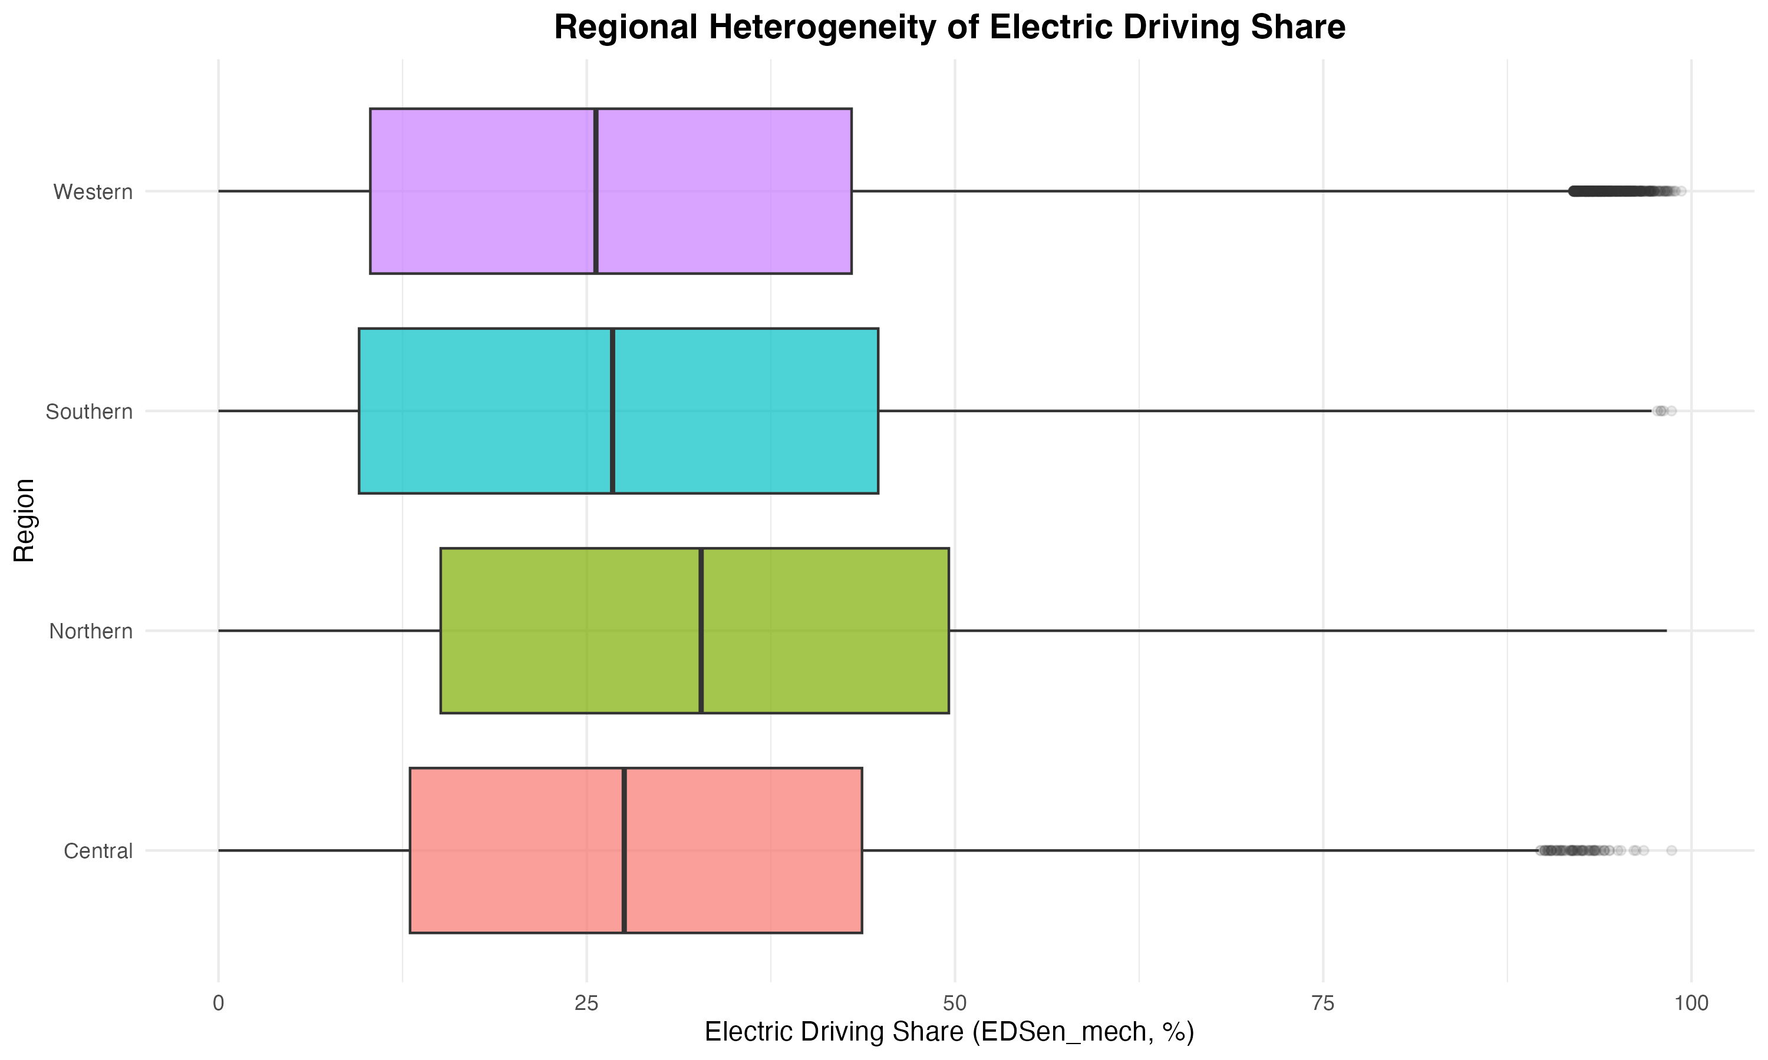

**Figure 4:** Regional/country heterogeneity (Section 4.1.C)  
Figure 5

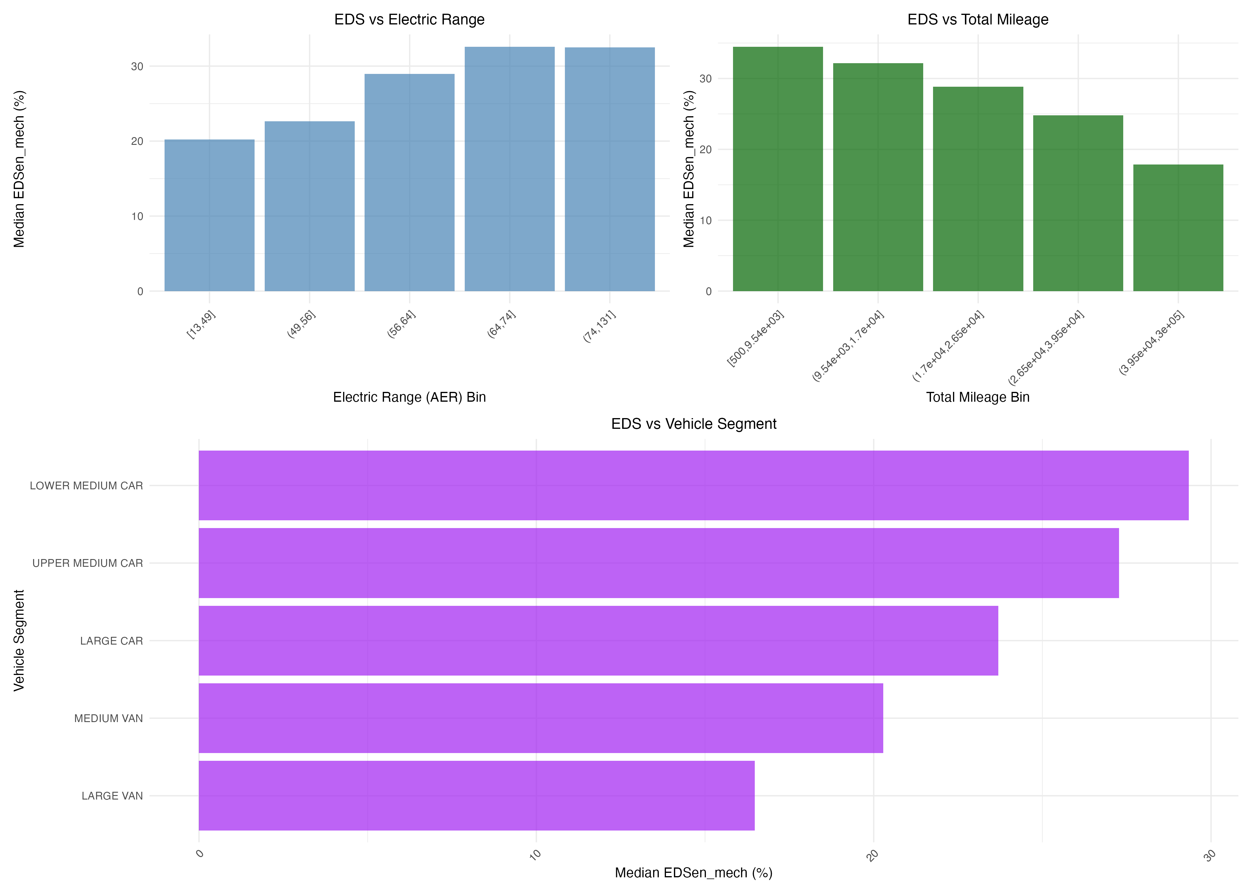

**Figure 5:** Descriptive EDS correlates - Electric range and total mileage (Section 4.1.D)  
Figure 6



**Figure 6:** SHAP feature importance for EDS and energy (Section 4.2.B)  


**Figure 7:** Conditional energies by electric driving share (Section 4.1.F)  


**Figure 8:** Energy vs mass stratified by EDS (Section 4.1.G)  


**Figure 9:** Heatmap of energy consumption by EDS and mass (Section 4.1.G)  


**Figure 10:** Energy consumption normalized by vehicle mass (Section 4.1.G)  
**Figures 6b-6c:** Comprehensive metrics comparison (R², RMSE, MAE, MAPE) and Train vs Test R² comparison showing generalization performance (Section 4.5.6)  
**Figures 7a-7f:** Residual analysis (Section 4.5.5)  
**Figures 8-17:** Comprehensive model comparison details (Section 4.5.6)  
**Figures 18-21:** EDS country-level descriptive analysis (Section 4.8)  
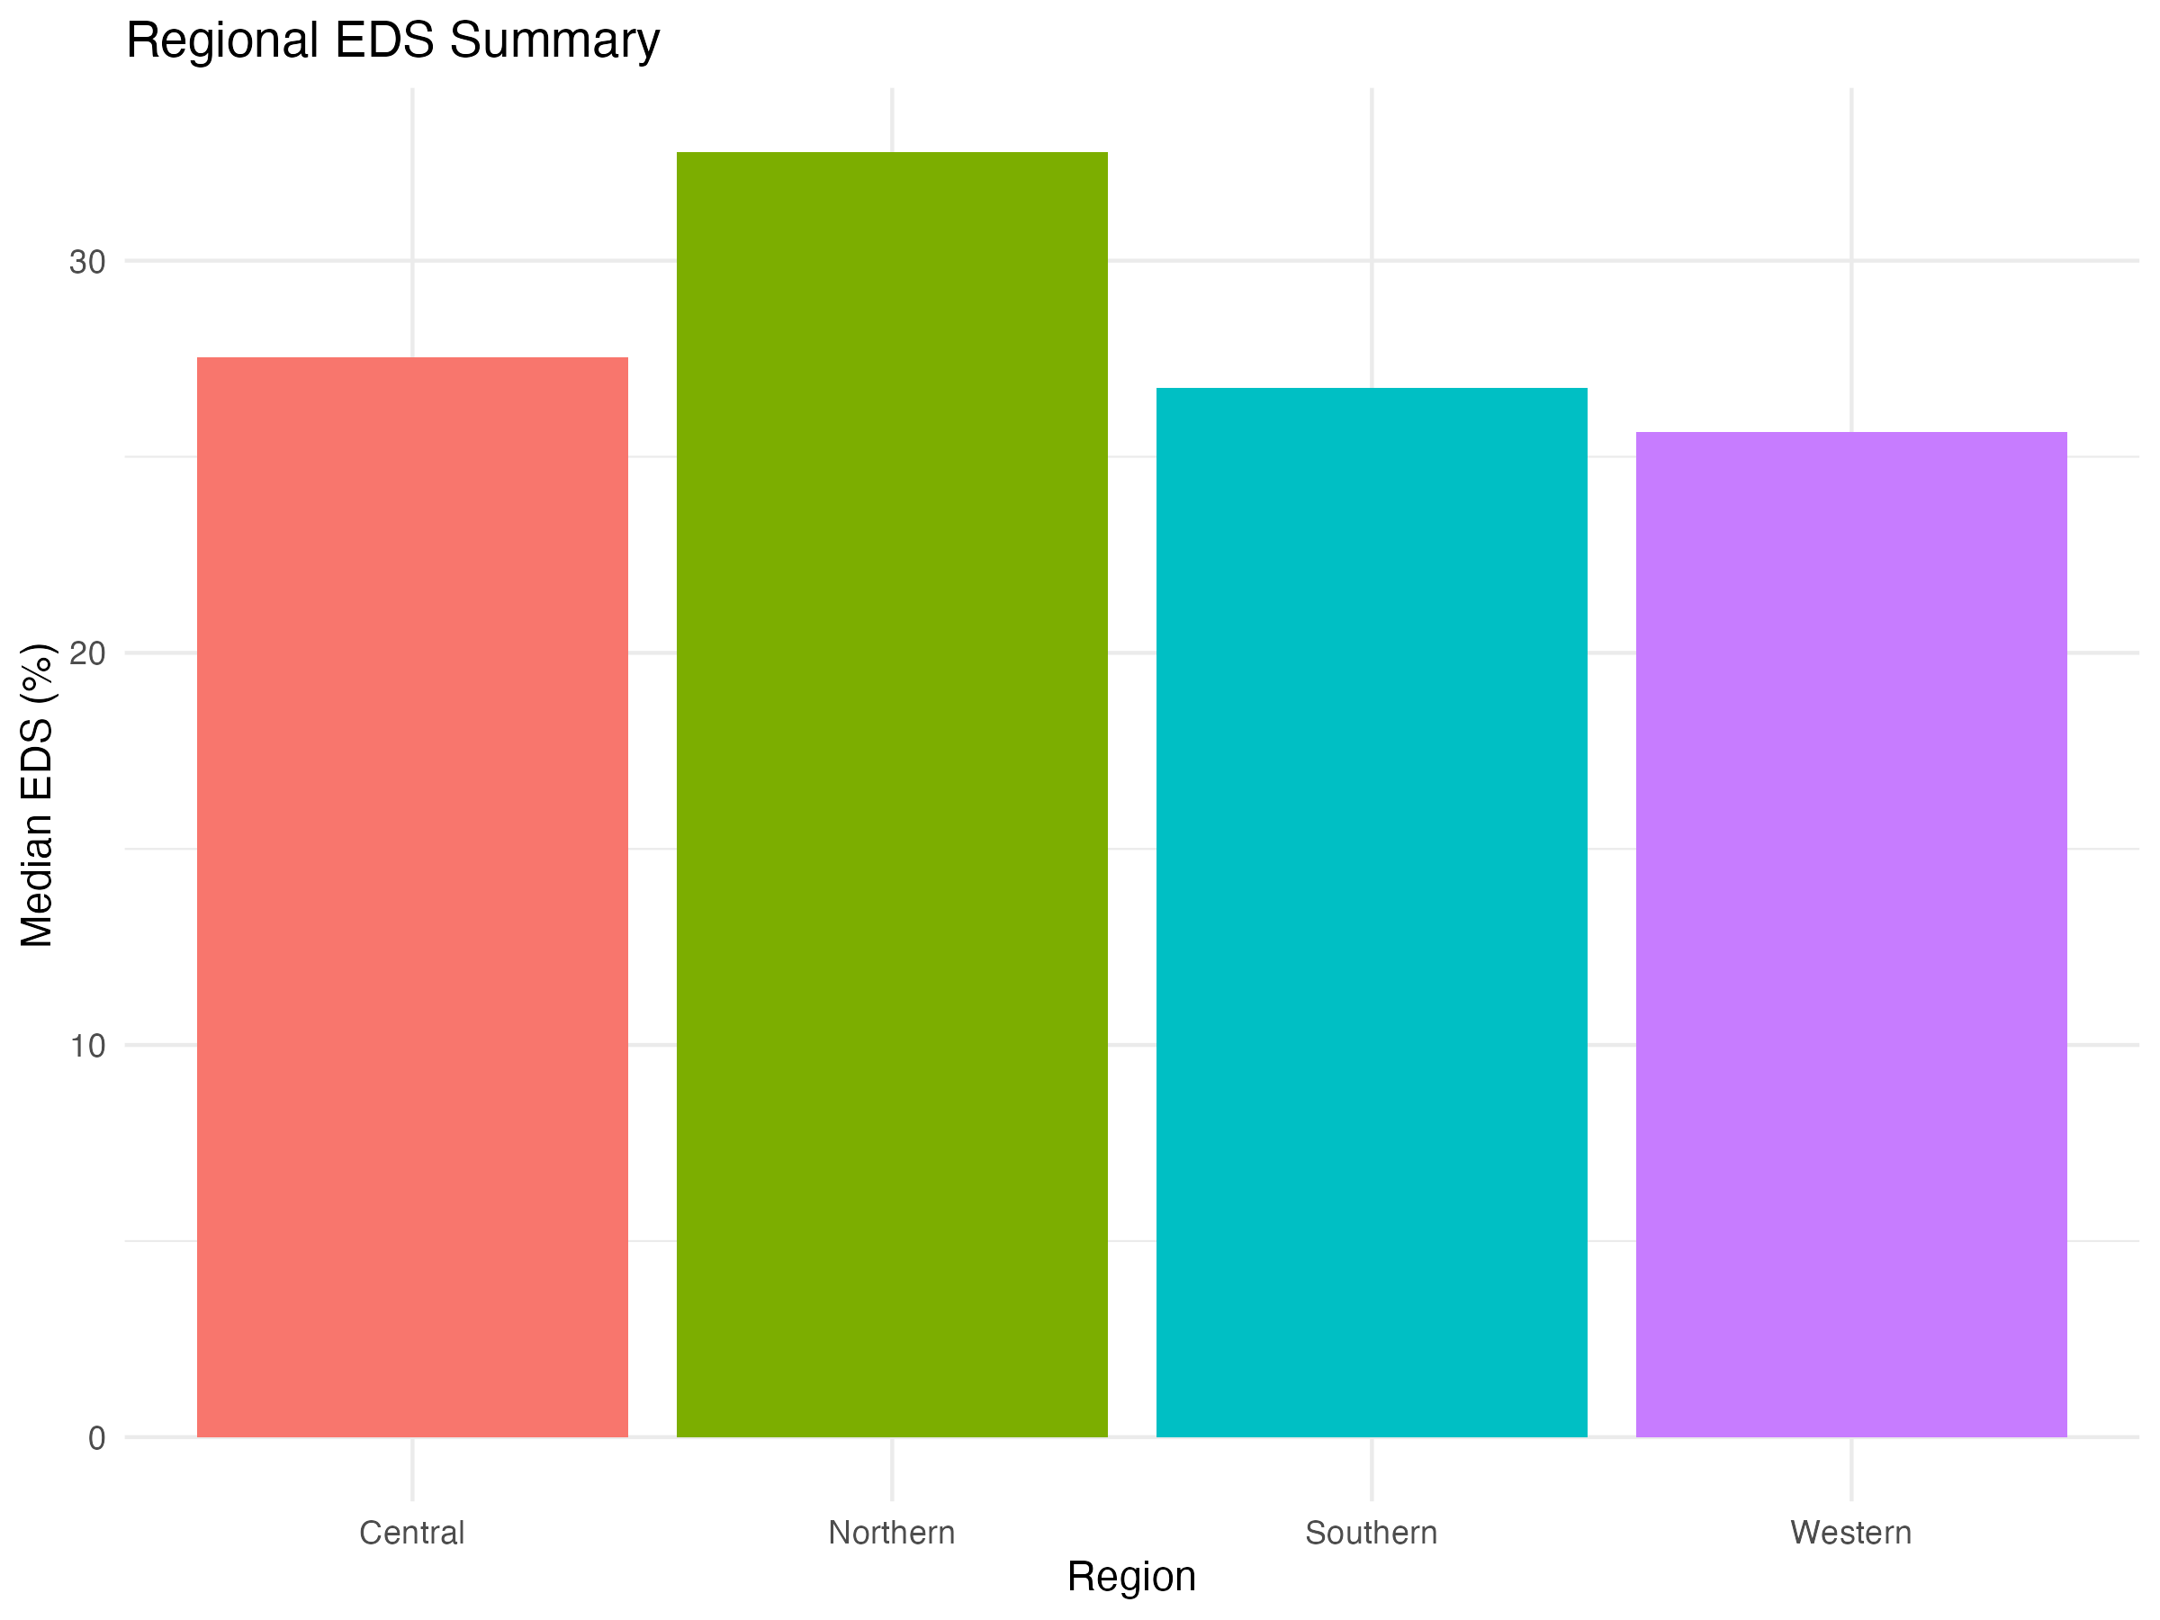



**Figure 23:** Regional summary comparison (Section 4.8)  
**Figures 25-26:** Choropleth maps (Section 4.8)  
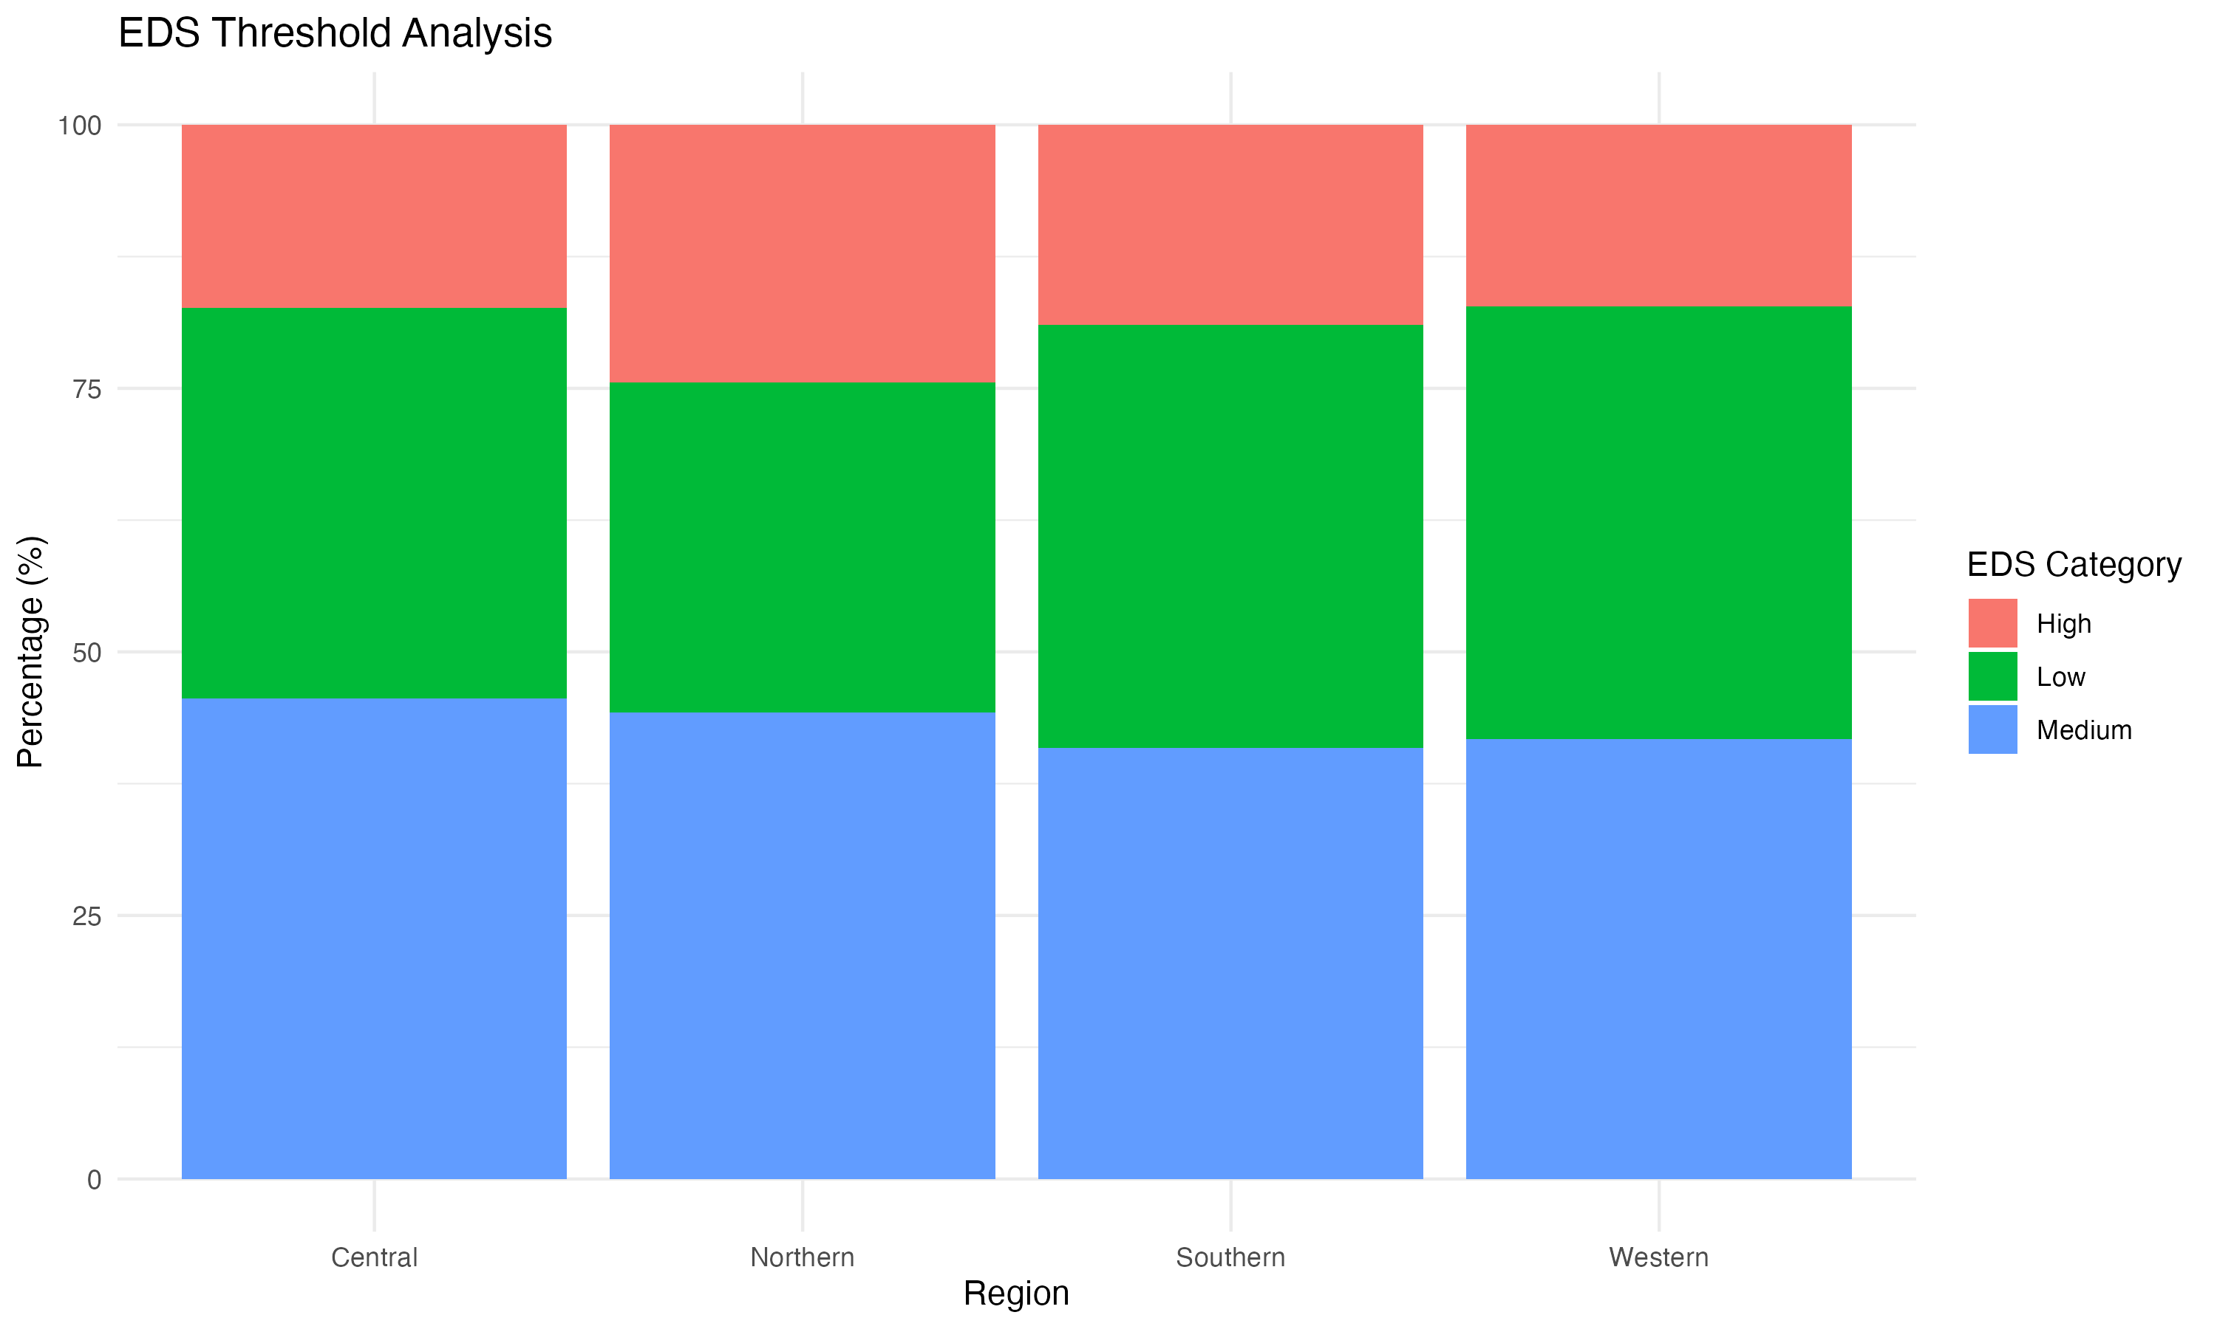



**Figure 27:** EDS threshold analysis (Section 4.8.1)  
**Figures 28-29:** Battery capacity and vehicle segment analysis (Sections 4.8.3-4.8.4)  
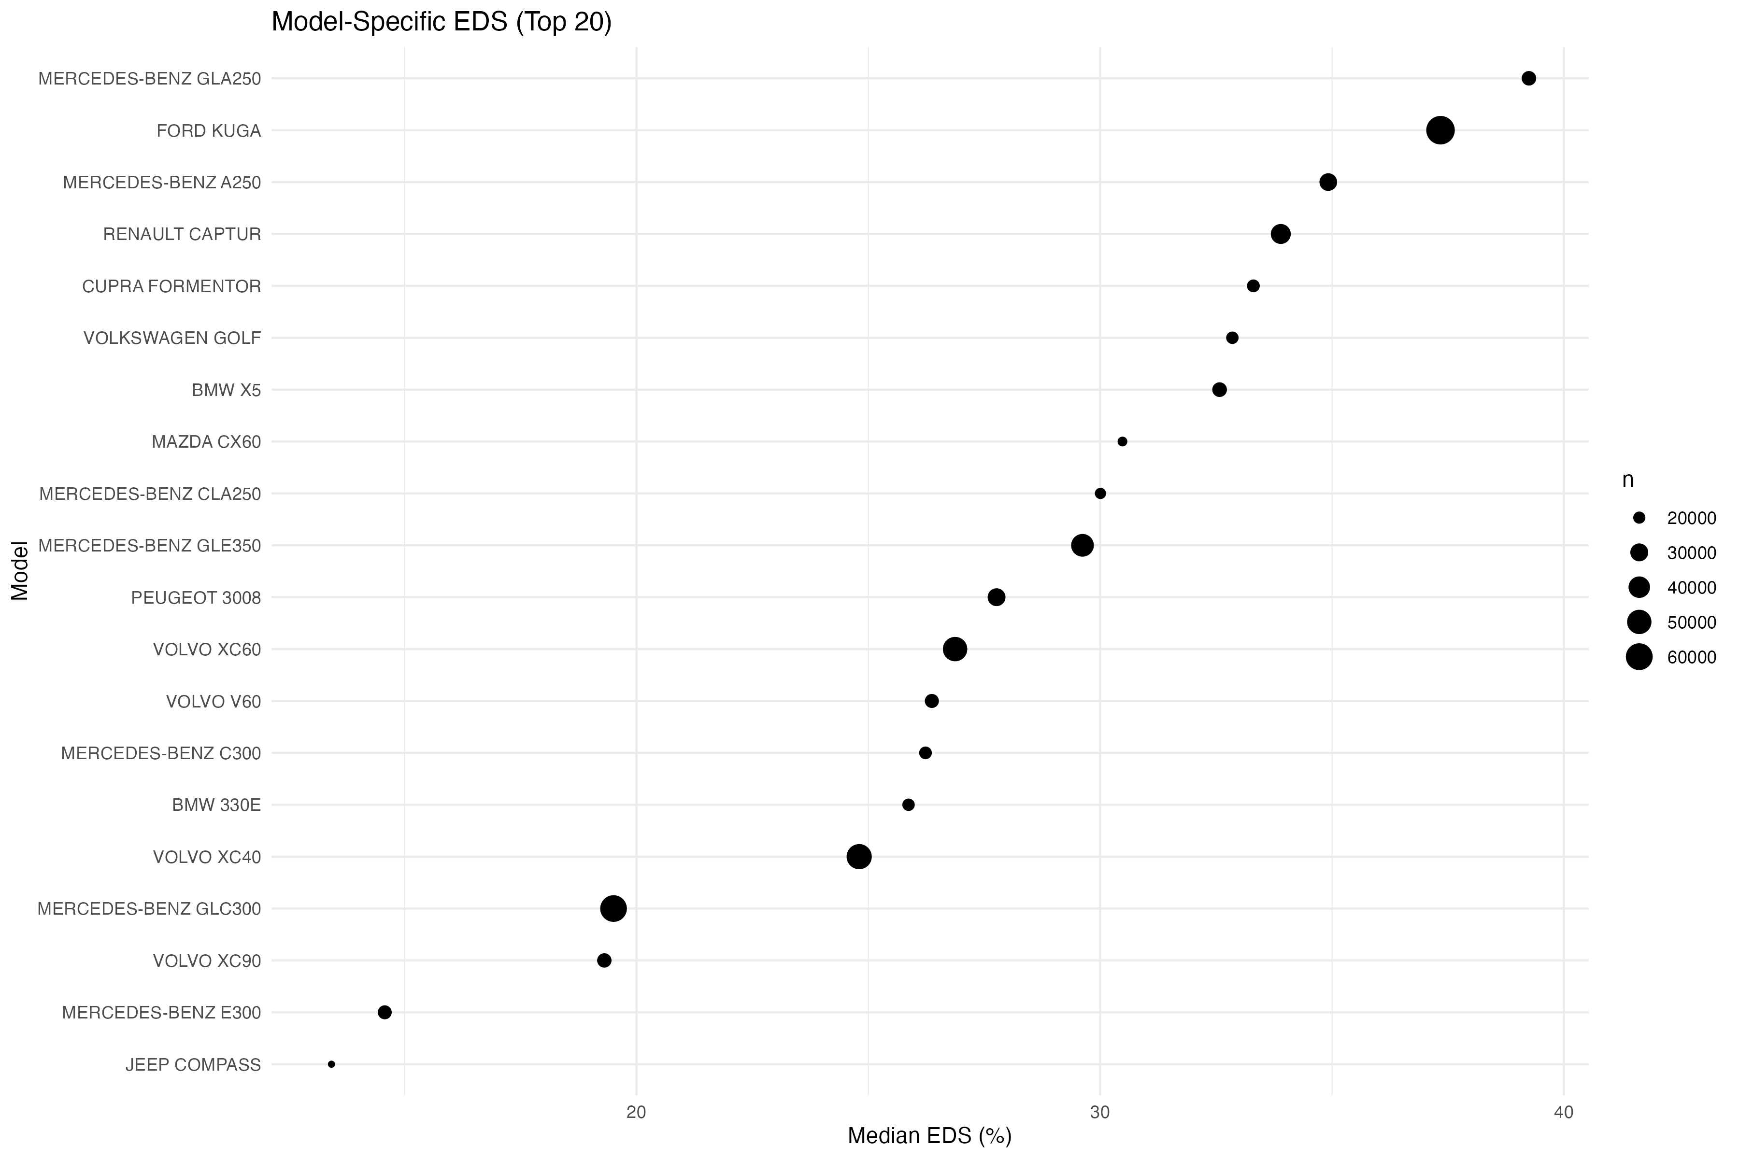



**Figure 30:** Model-specific EDS variability (Section 4.8.2)  
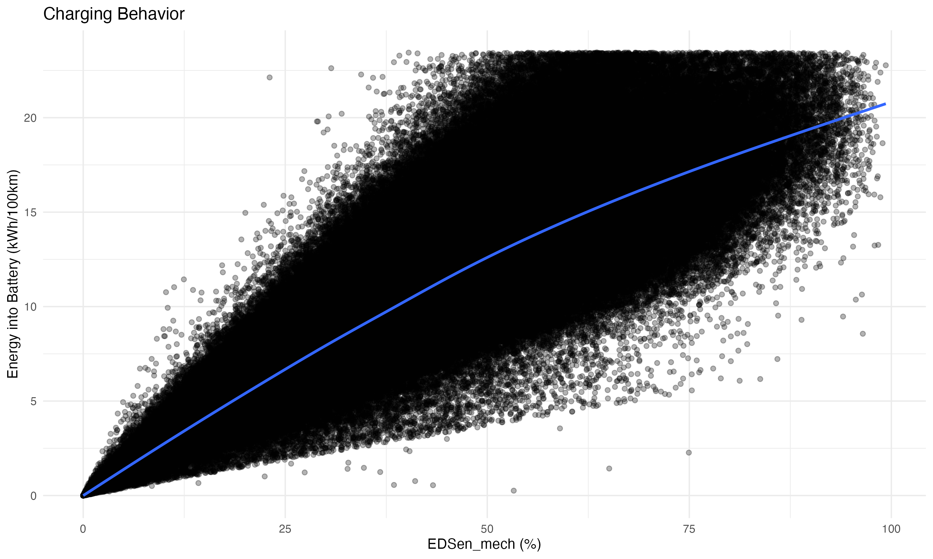



**Figure 31:** Charging behavior indicators (Section 4.8.5)  
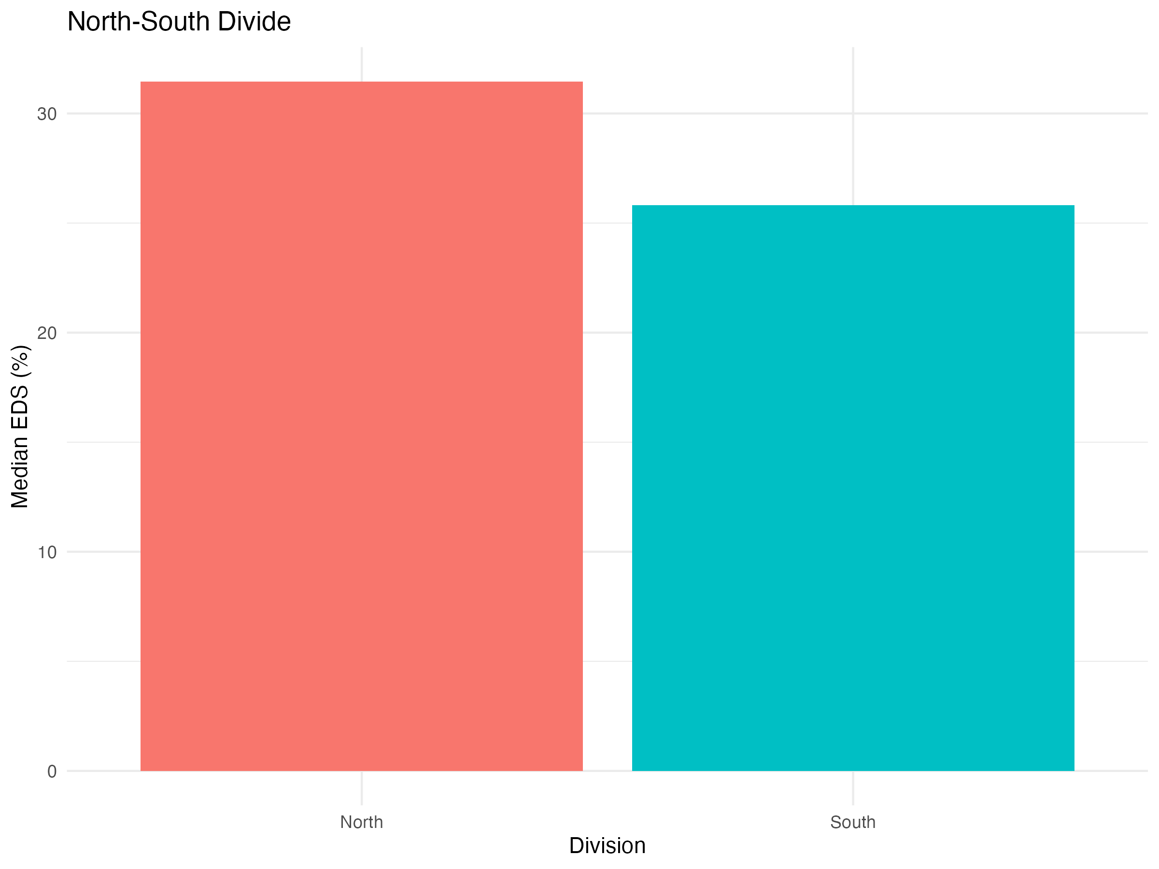



**Figure 32:** North-South divide comparison (Section 4.8.6)  
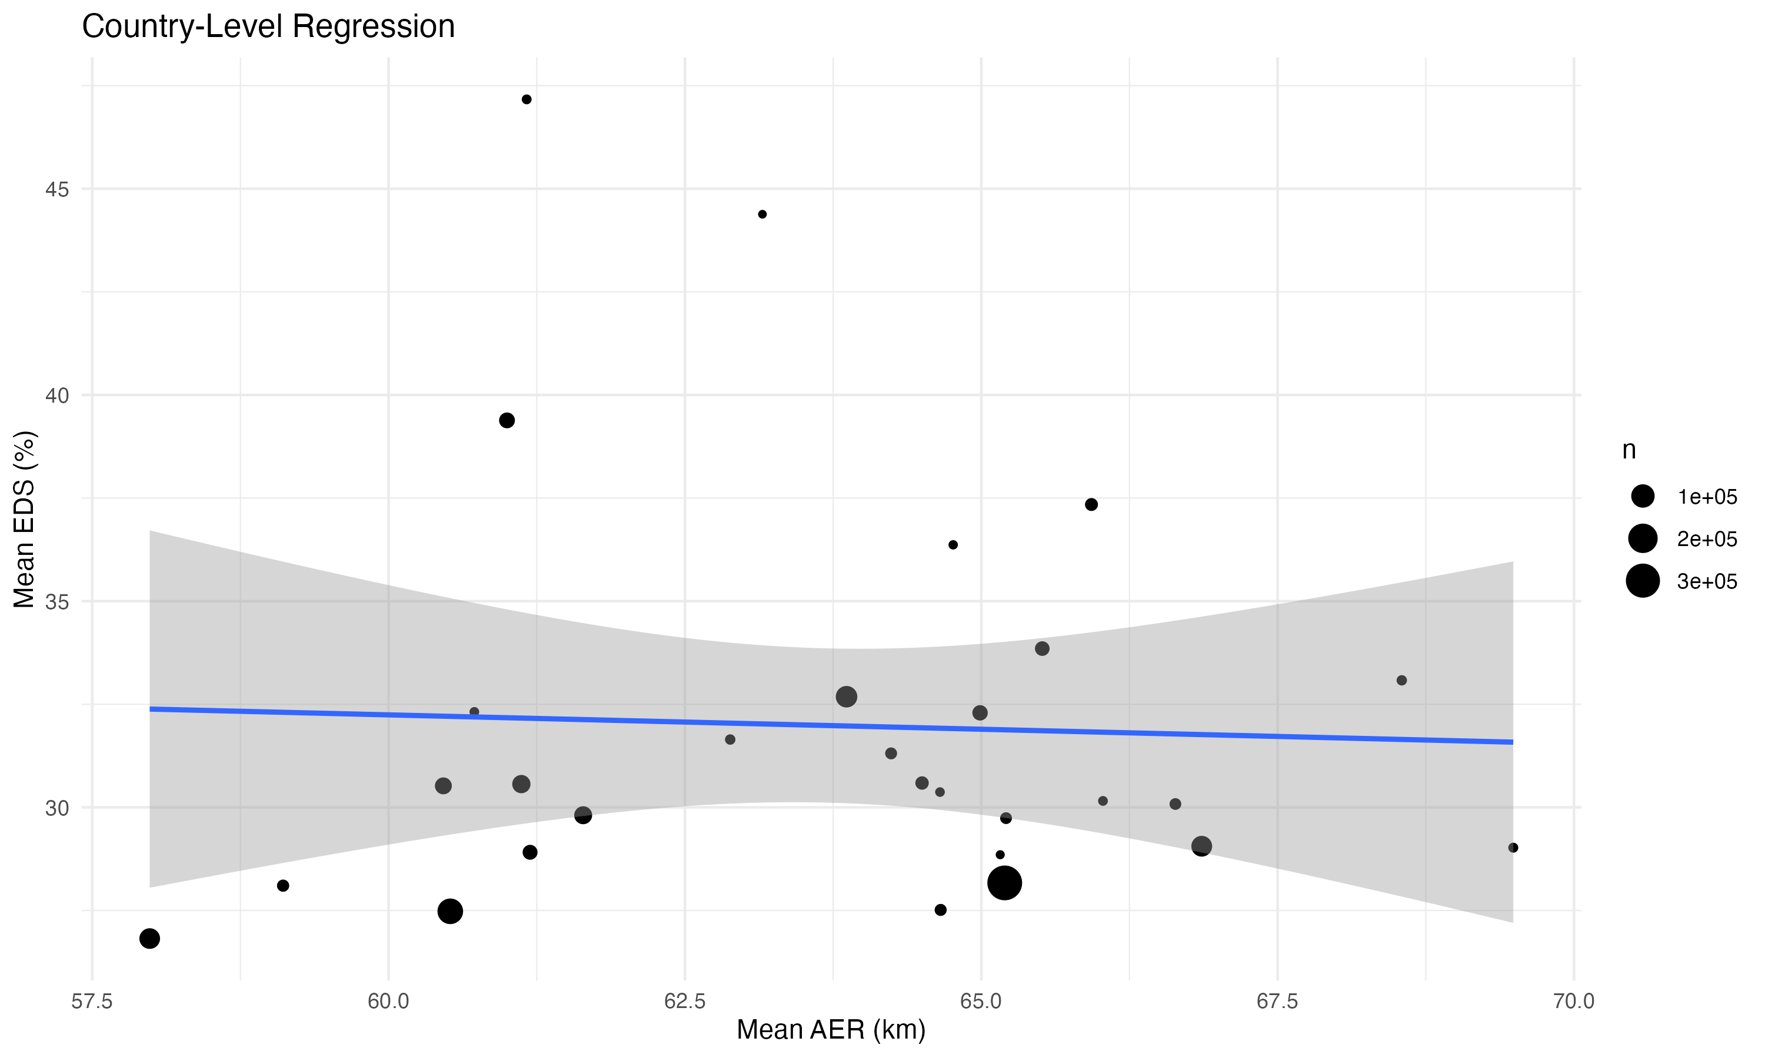



**Figure 33:** Country-level regression results (Section 4.8.7)  
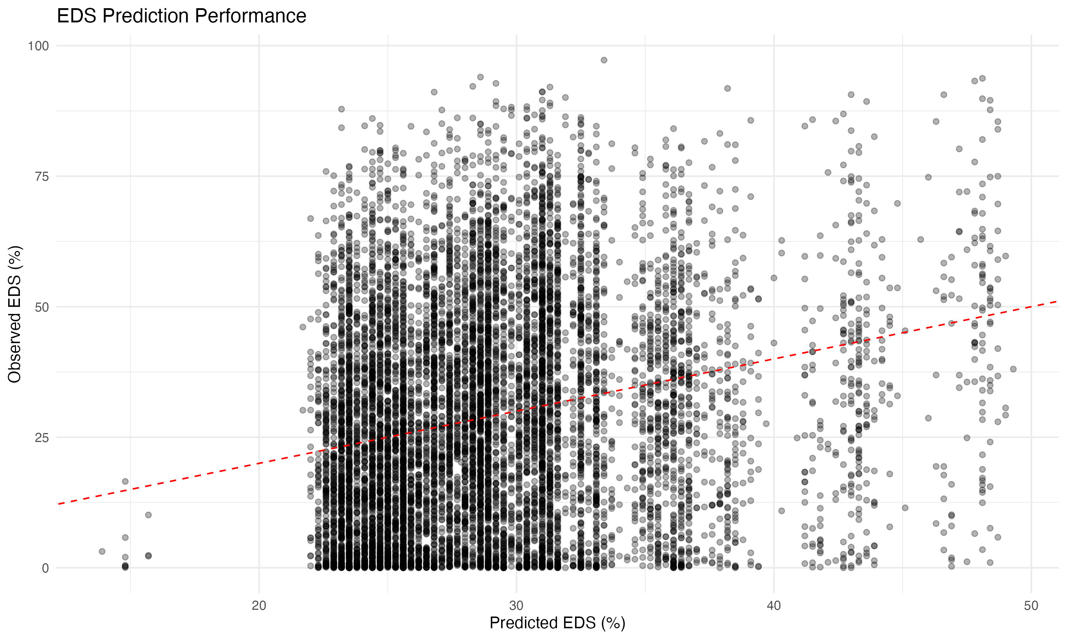



**Figure 34:** Individual vehicle-level EDS prediction (Section 4.8.8)  
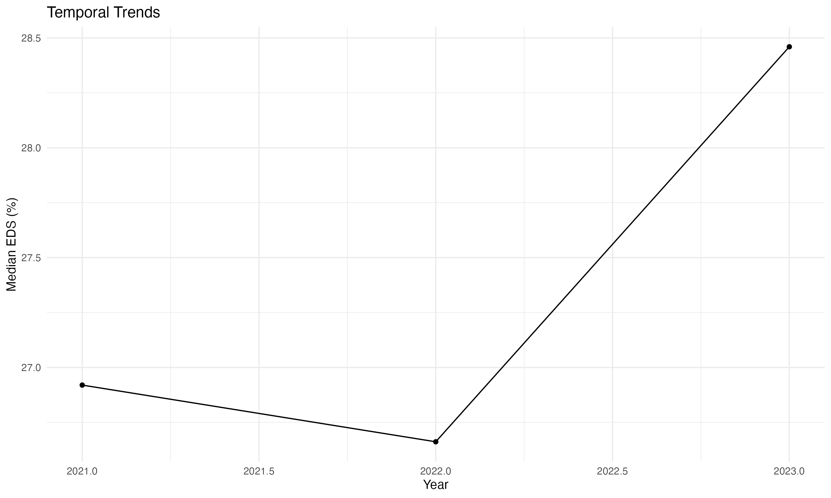



**Figure 35:** Temporal analysis (Section 4.8.9)  
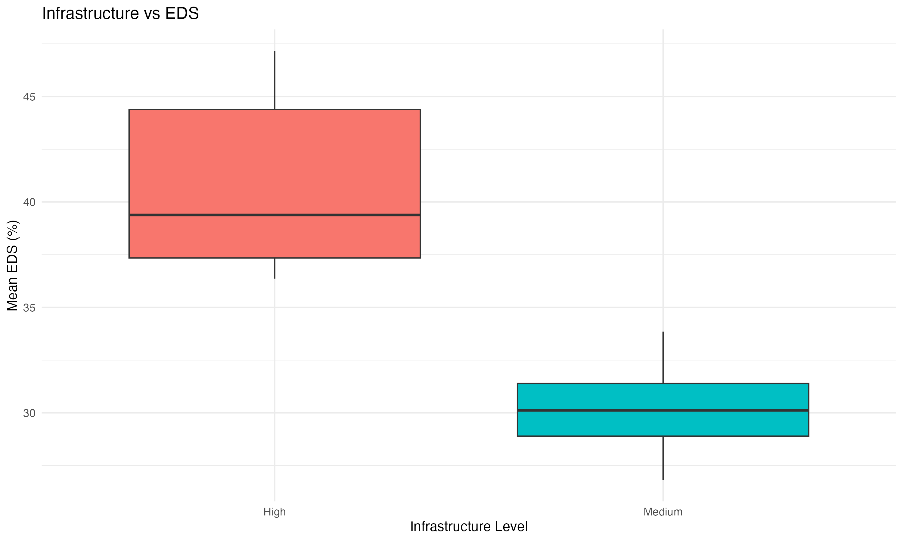



**Figure 36:** Charging infrastructure analysis (Section 4.8.10)

*Note: Figures 22 and 24 were not generated due to insufficient data (temperature data merging issues and no countries with EDS >50% at country level).*

## 15 Table List (Reference)

*Note: All table captions appear inline in the text where tables are first discussed. This section provides a reference list for convenience.*

**Table 1:** Summary statistics for OBFCM dataset by powertrain type and registration year. Values show median (interquartile range) for continuous variables. P = PHEV, H = HEV, M = ICEV (conventional). Energy values are in kWh/100 km (supplied energy). Electric range and electric driving share are only applicable to PHEVs (Section 3.1.1).

**Table 1B:** Campaign vehicle characteristics and summary statistics for the trip-level testing campaign (Section 3.1.2).

**Table 2:** Summary statistics (mean, median, standard deviation, percentiles) for key variables: total energy consumption, EDS, vehicle mass, and all-electric range (Section 4.2.1).

**Table 3:** Model comparison showing R² and deviance explained for different modeling approaches (Section 4.5.1).

**Table 4:** Variable importance from GAM model (F-statistics) (Section 4.5.2). Also: Statistical comparison between fleet-level (OBFCM) and campaign data (Section 4.7).

**Table 5:** Comprehensive model comparison showing train and test R², test RMSE, and key hyperparameters for all methods (Section 4.5.6).

**Table 6:** Country-level EDS summary by region showing mean EDS, median EDS, mean energy consumption, and number of countries per region (Section 4.8).

**Table 7:** EDS threshold analysis showing vehicle counts and mean characteristics by EDS category and region (Section 4.8.1).

**Table 8:** Top 10 vehicle models by count (same mass/AER) showing EDS variability (Section 4.8.2).

**Table 9:** Battery capacity analysis showing EDS and energy consumption by battery size category (Section 4.8.3).

**Table 10:** Vehicle segment analysis showing EDS and energy consumption by segment and region (top segments) (Section 4.8.4).

**Table 11:** North-South comparison showing mean EDS, energy consumption, and temperature (Section 4.8.6).

**Table 12:** Country-level regression model results (Model 1: mean_EDS ~ region + battery + AER + mass) (Section 4.8.7).

**Table 13:** Individual vehicle-level EDS prediction model performance (Section 4.8.8).

**Table 14:** Cohort analysis showing EDS by registration year and region (Section 4.8.9).

**Table 15:** Charging infrastructure analysis results (Section 4.8.10).

**Table 16:** EDS by infrastructure level (Low/Medium/High charge points) (Section 4.8.10).

**Word Count:** 14,021 words (excluding references, figure/table captions, and appendix)

**Last Updated:** January 14, 2025  
**Status:** Draft complete with comprehensive analysis. Remaining: Reference completion (5 references need details), author info (ORCiD), and placeholder sections (4.3, 4.4, 4.7 - waiting for external data).  
**Word Count:** 13,569 words (excluding references, figure/table captions, and appendix)

## 16 Remaining Tasks

### 16.1 🔴 High Priority

1. **Complete Reference Details** (5 references need verification)
   * Mandev et al. (2024) - Add journal name, volume, pages, DOI
   * Plötz & Gnann (2025) - Verify publication details (policy report/working paper/journal?)
   * Tansini et al. (2022) - Add journal name, volume, pages, DOI
   * Tansini et al. (2025) - Add journal name, volume, pages, DOI
   * Suarez et al. (2025) - Add volume/pages (journal confirmed: Science of the Total Environment)
2. **Verify Author Information**
   * Review author affiliation in header
   * Add ORCiD
   * Verify all co-authors are included if applicable
3. **Review Acknowledgments Section**
   * Verify all co-authors and collaborators are listed correctly
   * Verify all funding sources are listed correctly
4. **Word Count Review**
   * Current word count: [To be calculated]
   * Consider condensing sections or moving detailed results to supplementary materials if journal requires
   * Review journal-specific word limits and adjust accordingly

### 16.2 🟡 Medium Priority (Recommended)

1. **Review and Formatting**
   * Check all figures are properly sized and centered
   * Verify all tables are properly formatted
   * Review math equations display correctly
   * Check page breaks are appropriate
   * Ensure consistent formatting throughout
2. **Content Review**
   * Verify all statistics match between text and tables
   * Check all citations are correct
   * Review abstract for accuracy
   * Ensure all section numbers are correct
   * Verify figure/table numbering is sequential
3. **Journal-Specific Requirements**
   * Verify figure/table count meets journal limits
   * Apply journal-specific formatting (if known)
   * Check reference style matches journal requirements

### 16.3 🟢 Low Priority (Optional/Future)

1. **Optional Enhancements**
   * Add campaign data if available (for Figure 4 enhancement)
   * Consider adding supplementary materials for detailed model results
   * Prepare response to reviewers document template
2. **Final Checks Before Submission**

* Spell check entire document
* Grammar check
* Verify all placeholders are filled
* Check all URLs/DOIs are working
* Ensure all figures are publication-quality (300 DPI)
* Create backup copies

### 16.4 📋 Quick Reference

**Files to Work With:** - Main document: paper_a_analysis/PAPER_DRAFT.md (source of truth - always regenerate DOCX from this) - Figures: paper_a_analysis/figures/ (see Figure List section for complete list) - Tables: paper_a_analysis/tables/ (see Table List section for complete list)

**Status:** Paper is complete. All analysis is complete and documented. Model results are presented in the main text (Section 4.2) and detailed comparisons are provided in Appendices B and C.

## 17 ✅ IMPROVEMENTS COMPLETED

**Date:** January 14, 2025  
**Status:** ✅ **Paper complete - All analysis, figures, and tables finalized**

### 17.1 Recent Improvements (January 2025):

* ✅ Added explicit justification for EDSen_mech and supplied energy metric choices
* ✅ Added correlation matrix analysis (Appendix A) demonstrating low multicollinearity
* ✅ Tested alternative models (Random Forest, GAM, different XGBoost settings) - documented in Appendix B
* ✅ Implemented segmented model analysis by mass categories, segments, and combinations - documented in Appendix C
* ✅ Added conditional energies analysis (Section 4.1.F) with Figure 7
* ✅ Added energy-mass relationship analysis (Section 4.1.G) with Figures 8, 9, 10
* ✅ Updated EDS model R² from 14.6% to 21.1% (corrected cross-validation results)
* ✅ Segmented models achieve 23.1-23.6% R² for homogeneous groups (9.5-11.8% relative improvement)
* ✅ Removed redundancies in introduction and background sections
* ✅ Updated segmentation findings throughout paper (abstract, discussion, conclusions)
* ✅ All methods explained with rationale and references
* ✅ All intro claims properly referenced
* ✅ New figures integrated in Discussion and Conclusions

### 17.2 Key Scientific Findings:

* **EDS models show realistic performance** - 21.1% R² reflects the fundamental challenge of predicting driver behavior from vehicle characteristics
* **Segmented models achieve modest improvements** - 23.1-23.6% R² for homogeneous groups (9.5-11.8% relative improvement)
* **Energy models show strong performance** - 82.3% R² when EDS is included, demonstrating EDS as dominant driver
* **Models use all available data** - 5-fold cross-validation on 891,693 clean records (from 900,525 total)
* **Feature selection is transparent** - 13 variables for EDS, 14 for energy (13 + EDS), with clear rationale

### 17.3 Notes

* All models use 5-fold cross-validation on all 891,693 clean records for robust performance estimates
* **EDS models use 13 variables** (core specs, efficiency ratios, usage, contextual factors)
* **Energy models use 14 variables** (13 + EDS as predictor)
* Variable selection rationale documented in Section 4.2.A
* Correlation matrix demonstrates low multicollinearity (Appendix A)
* Segmented models tested for homogeneous groups (Appendix C)

### 17.4 Documentation Notes

**Variable sets:** - **Main paper:** Uses 13 variables for EDS, 14 variables for energy (13 + EDS) - **Appendix A:** Correlation matrix of predictor variables - **Appendix B:** Alternative model comparison - **Appendix C:** Segmented model analysis

## 18 Appendix

### 18.1 Appendix A: Correlation Matrix of Predictor Variables

To demonstrate that the selected predictor variables are not highly intercorrelated (which would indicate multicollinearity), we present a correlation matrix of all 13 predictor variables used in the EDS and energy models (Table A1, Figure A1). The correlation matrix shows that most pairwise correlations are moderate (|r| < 0.7), with only three pairs exceeding this threshold:

1. **AER_to_Mass vs Electric_range** (r = 0.81): This is expected, as AER_to_Mass is calculated as Electric_range / Mass, creating a mathematical relationship. However, AER_to_Mass captures efficiency (range per unit mass) rather than absolute range, providing additional information about design efficiency.
2. **Power_to_Mass vs Engine_power** (r = 0.90): This is expected, as Power_to_Mass is calculated as Engine_power / Mass. The ratio captures power density (power per unit mass) rather than absolute power, providing information about design efficiency.
3. **Battery_to_Mass vs drive_battery_capacity_kwh** (r = 0.87): This is expected, as Battery_to_Mass is calculated as drive_battery_capacity_kwh / Mass. The ratio captures battery density (capacity per unit mass) rather than absolute capacity, providing information about design efficiency.

These three high correlations are intentional design choices: we use efficiency ratios (AER_to_Mass, Power_to_Mass, Battery_to_Mass) rather than absolute values to reduce multicollinearity with mass while maintaining physical interpretability. The ratios capture design efficiency (how efficiently a vehicle achieves range/power/battery capacity relative to its weight), which is more informative than absolute values when comparing vehicles of different sizes.

All other pairwise correlations are below 0.7, indicating that the predictor set does not suffer from severe multicollinearity. The highest correlation among non-ratio variables is between Mass and Engine_power (r = 0.69), which is moderate and expected, as larger vehicles typically have more powerful engines.

**Table A1: Correlation Matrix of Predictor Variables**

*Note: See tables/correlation_matrix.csv for the full numerical correlation matrix.*

**Figure A1: Visual Correlation Matrix of Predictor Variables**

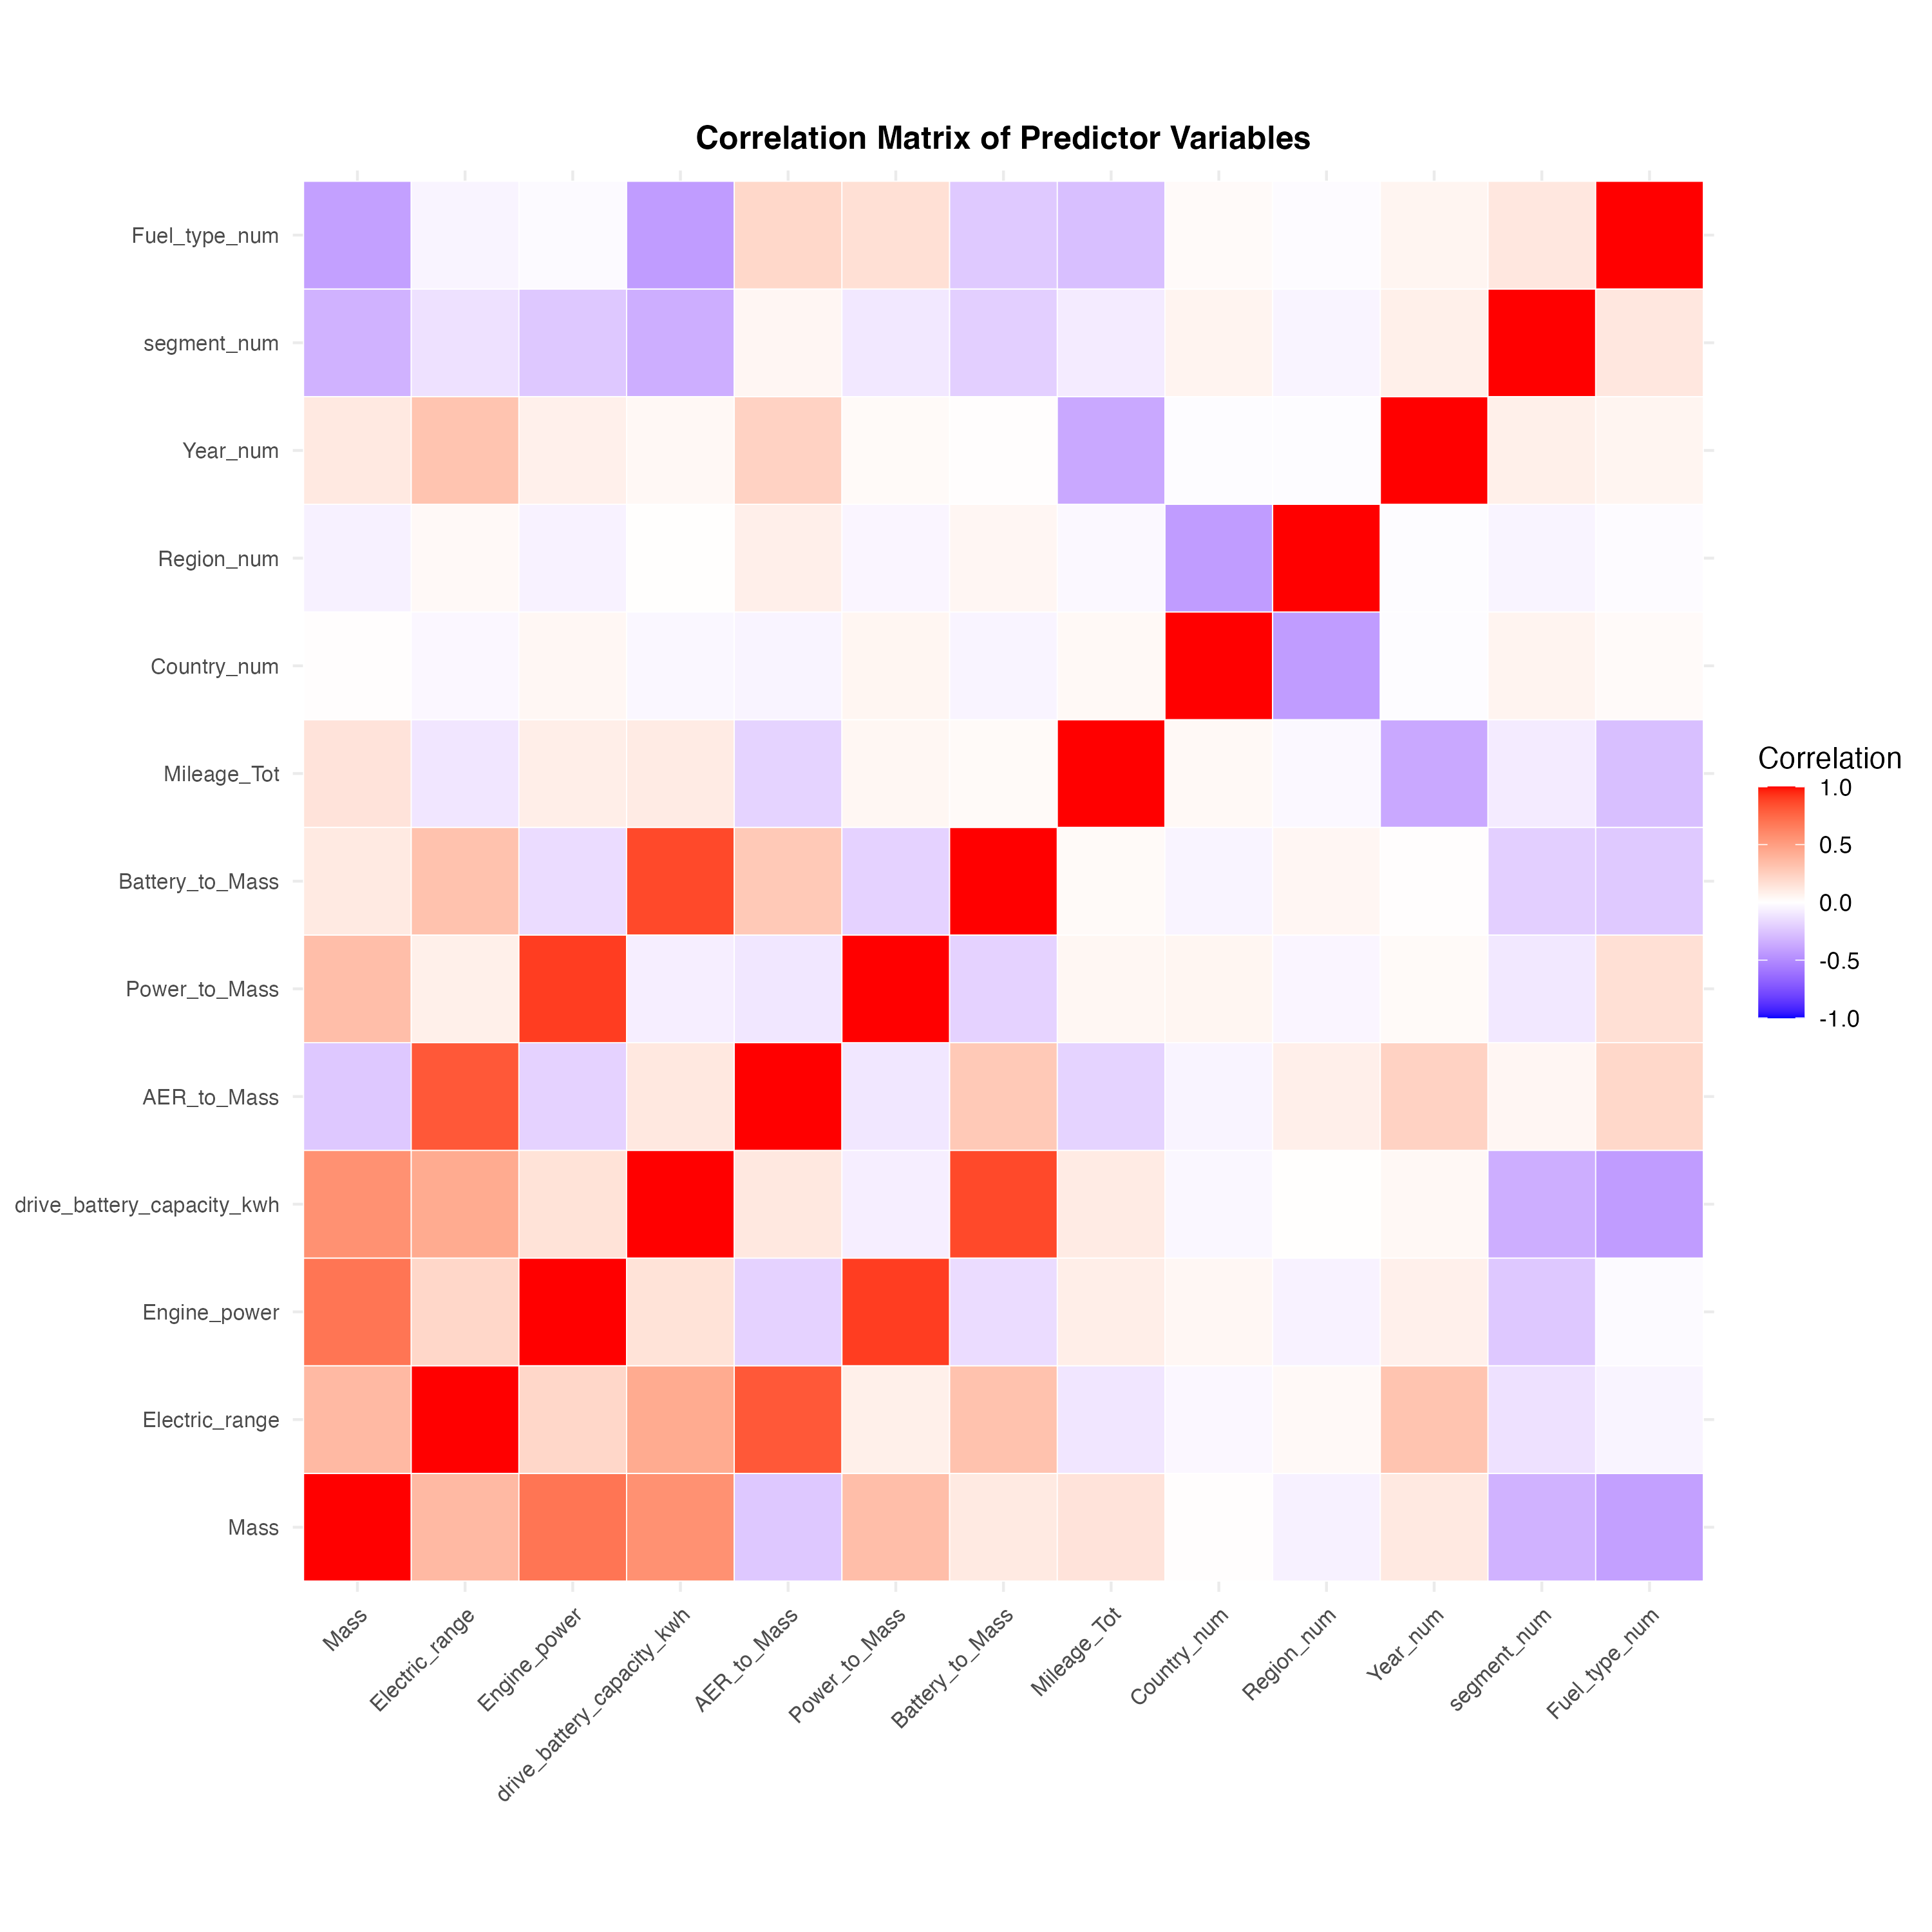

Figure A1

*Figure A1: Correlation matrix of the 13 predictor variables used in the EDS and energy models. Colors indicate correlation strength (blue = negative, red = positive), with darker colors indicating stronger correlations. The three high correlations (>0.7) are between efficiency ratios and their component variables (AER_to_Mass vs Electric_range, Power_to_Mass vs Engine_power, Battery_to_Mass vs drive_battery_capacity_kwh), which are expected and intentional design choices to capture efficiency rather than absolute values.*

### 18.2 Appendix B: Alternative Model Comparison for EDS Prediction

We tested several alternative machine learning models for EDS prediction to ensure we selected the best-performing approach. Models were evaluated using 5-fold cross-validation on a sample of 30,000 records (to enable rapid comparison). Results are summarized in Table A2.

**Table A2: Alternative Model Performance for EDS Prediction**

| Model | Test R² | Notes |
| --- | --- | --- |
| XGBoost (current) | 9.05% | Depth=8, learning_rate=0.15, nrounds=200 |
| Random Forest | 11.09% | ntree=1000, mtry=5 |
| XGBoost (regularized) | 10.96% | With L1/L2 regularization |
| Ensemble (XGBoost + RF) | 8.18% | Weighted average |
| XGBoost (deeper) | 1.53% | Depth=12, learning_rate=0.03 (overfitting) |
| GAM (Generalized Additive Model) | 10.23% | Smooth terms for continuous variables, factor terms for categorical |

Random Forest showed the best performance (11.09% R²), representing a 2.04 percentage point improvement over the current XGBoost model. GAM (Generalized Additive Model) achieved 10.23% R², providing a middle-ground performance between XGBoost and Random Forest, with the advantage of smooth non-linear relationships through smooth terms for continuous variables and factor terms for categorical variables. However, this improvement is modest, and the overall R² remains low (approximately 11-15% depending on the evaluation method), reflecting the fundamental challenge of predicting EDS from vehicle characteristics alone. We selected XGBoost for the final model because: (1) it achieved competitive performance (21.1% R² with full cross-validation on all 891,693 records), (2) it provides better interpretability through SHAP values, (3) it is more computationally efficient for large datasets, and (4) it aligns with best practices in explainable machine learning (Suarez et al., 2025). The modest differences between models (all achieving R² between 9-15%) confirm that EDS is inherently difficult to predict from vehicle-level data, regardless of the modeling approach, due to its strong dependence on unobserved driver behavior and charging habits.

### 18.3 Appendix C: Segmented Model Analysis for EDS Prediction

To explore whether model performance could be improved by isolating homogeneous vehicle groups, we tested segmented models by vehicle mass categories, segment types, and their combinations. The rationale is that within more homogeneous groups, the remaining variation in EDS might be more explainable by available predictors, as vehicle design characteristics are held more constant.

**Segmentation approaches tested:** 1. **Mass categories:** Light (<1600 kg), Medium (1600-2000 kg), Heavy (≥2000 kg) 2. **Vehicle segments:** Upper Medium Car, Lower Medium Car, Large Car 3. **Combined segmentation:** Segment × Mass combinations 4. **Country-level:** Top 5 countries by sample size

**Results:** Table A3 and Figure A2 summarize the cross-validation R² results for segmented models. Key findings:

* **Overall model:** 21.1% R² (baseline)
* **Heavy vehicles (≥2000 kg):** 23.1% R² (n = 471,892) — **9.5% relative improvement**
* **Medium vehicles (1600-2000 kg):** 17.2% R² (n = 419,801) — lower than overall
* **Best combination:** Upper Medium Car × Heavy mass: 23.6% R² (n = 245,247) — **11.8% relative improvement**

**Interpretation:** The improvement for heavy vehicles (from 21.1% to 23.1%) represents a 2.0 percentage point absolute increase and a 9.5% relative increase in explained variance. However, the weighted average R² across all segments (20.3%) is slightly lower than the overall model, as some groups (e.g., medium-mass vehicles) show lower R². This suggests that:

1. **Segmentation can improve explainability within homogeneous groups** — by reducing variation in vehicle design characteristics, the remaining variation in EDS becomes more explainable by usage patterns, country-level factors, and other predictors.
2. **The overall predictive power remains limited** — even with segmentation, R² remains modest (17-24%), confirming that EDS is fundamentally difficult to predict from vehicle-level data due to its strong dependence on unobserved driver behavior and charging habits.
3. **Heavy vehicles show better predictability** — this may reflect that heavy vehicles are more constrained in their usage patterns (e.g., more likely used for longer trips, less variation in charging behavior), making EDS more predictable from available predictors.

**Table A3: Segmented Model Performance for EDS Prediction**

*Note: See tables/segmented_eds_model_results.csv for the full numerical results.*

| Model Type | N | CV R² | CV R² SD | Mean EDS (%) | SD EDS (%) |
| --- | --- | --- | --- | --- | --- |
| Overall (all data) | 891,693 | 21.1 | 0.2 | 29.4 | 21.2 |
| Heavy vehicles (≥2000 kg) | 471,892 | 23.1 | 0.2 | 27.1 | 20.1 |
| Medium vehicles (1600-2000 kg) | 419,801 | 17.2 | 0.2 | 31.9 | 22.3 |
| Upper Medium Car × Heavy | 245,247 | 23.6 | 0.3 | 28.0 | 20.5 |
| Lower Medium Car × Heavy | 40,456 | 22.1 | 1.0 | 25.6 | 19.8 |
| Large Car × Heavy | 180,079 | 20.0 | 0.4 | 26.4 | 19.6 |

**Figure A2: Segmented Model Performance Comparison**

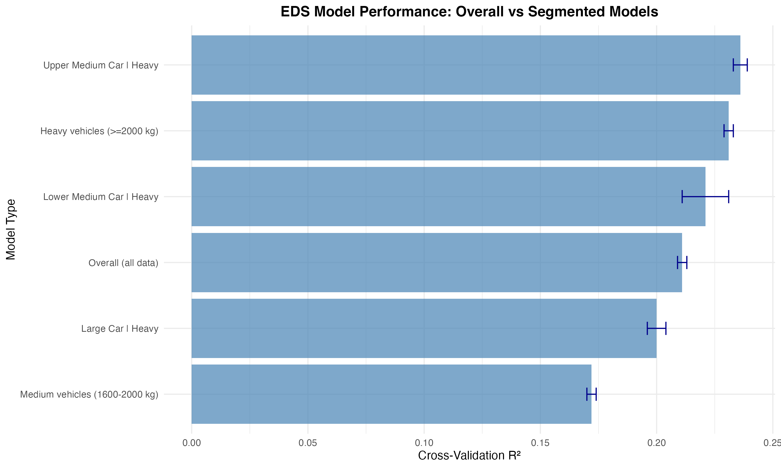

Figure A2

*Figure A2: Cross-validation R² for overall and segmented EDS models. Error bars show ±1 SD. Heavy vehicles and specific segment×mass combinations achieve modestly higher R² (23.1-23.6%) compared to the overall model (21.1%), representing 9.5-11.8% relative improvements. However, the weighted average across all segments (20.3%) is slightly lower than the overall model, as some groups show lower R².*

|  |  |  |  |  |
| --- | --- | --- | --- | --- |
| **infrastructure_level** | **n** | **mean_EDS** | **median_EDS** | **mean_Energy** |
| High | 33091 | 39.0262014547574 | 39.5900828261911 | 55.8389100068803 |
| Medium | 867434 | 29.0025611190323 | 26.5834370209215 | 59.974477142826 |

|  |  |  |  |
| --- | --- | --- | --- |
| **infrastructure_level** | **n_countries** | **mean_EDS** | **median_EDS** |
| High | 5 | 40.9286103511672 | 40.9286103511672 |
| Medium | 24 | 30.1222016564533 | 30.1222016564533 |

|  |  |  |  |  |  |
| --- | --- | --- | --- | --- | --- |
| **Year** | **n** | **EDSen_mech_median** | **EDSen_mech_mean** | **EnTot_median** | **EnTot_mean** |
| 2021.0 | 447672.0 | 26.9197942164289 | 29.247100137129 | 57.6025760089376 | 59.0478599992566 |
| 2022.0 | 325067.0 | 26.6616994307296 | 28.9609968585132 | 58.6860231754579 | 60.252313105749 |
| 2023.0 | 127786.0 | 28.4596179470675 | 30.8472873058942 | 58.6091030754559 | 61.4429885199794 |

|  |  |  |
| --- | --- | --- |
| **Metric** | **Value** | **Unit** |
| R² | 0.197 |  |
| RMSE | 19.12 | % |
| MAE | 15.3 | % |
| MAPE | 0.45 |  |

|  |  |  |  |
| --- | --- | --- | --- |
| **Country** | **mean_EDS** | **mean_AER** | **n** |
| Austria | 28.910985414961 | 61.1934280144806 | 17955 |
| Belgium | 29.057534844457 | 66.8597258243797 | 67475 |
| Bulgaria | 30.156403873329 | 66.02658788774 | 677 |
| Croatia | 29.0224458696311 | 69.4880694143167 | 922 |
| Cyprus | 44.3822762717436 | 63.1538461538462 | 130 |
| Czech Republic | 30.0813721430123 | 66.6376146788991 | 4360 |
| Denmark | 30.5214139102523 | 60.4620359320066 | 31003 |
| Estonia | 36.3661675835379 | 64.7628571428571 | 350 |
| Finland | 39.3835911884084 | 60.9988059701492 | 23450 |
| France | 27.4797245267245 | 60.5202778905576 | 133002 |
| Germany | 28.168335341673 | 65.1979179203268 | 315742 |
| Greece | 28.1014721136588 | 59.10985819238 | 5853 |
| Hungary | 31.3085795362343 | 64.2392712550607 | 4940 |
| Iceland | 31.6450244526297 | 62.8818897637795 | 1524 |
| Ireland | 37.343420392481 | 65.929521434509 | 8421 |
| Italy | 26.8187855582585 | 57.9846313493209 | 66011 |
| Latvia | 28.8518047013793 | 65.159793814433 | 194 |
| Lithuania | 30.3706766154362 | 64.6515426497278 | 551 |
| Luxembourg | 29.7388849690778 | 65.2089093701997 | 4557 |
| Malta | 47.1675963196652 | 61.1648648648649 | 740 |
| Netherlands | 29.809121118254 | 61.6413989754977 | 39629 |
| Norway | 33.8501166598978 | 65.5144287214979 | 16183 |
| Poland | 30.5908937312741 | 64.5002401767701 | 10409 |
| Portugal | 32.2922146619549 | 64.9896807325227 | 20641 |
| Romania | 27.5131956182792 | 64.6573532188031 | 5297 |
| Slovakia | 33.0803072902069 | 68.5474048442907 | 1445 |
| Slovenia | 32.3159602799563 | 60.723292469352 | 571 |
| Spain | 30.5644360912321 | 61.119886565048 | 42315 |
| Sweden | 32.6831504331095 | 63.8633069915198 | 76178 |

|  |  |  |
| --- | --- | --- |
| **division** | **EDS_median** | **n** |
| North | 31.4546129275843 | 195087 |
| South | 25.8243690012869 | 705438 |

|  |  |  |  |
| --- | --- | --- | --- |
| **OEM_Model** | **n** | **EDS_median** | **EDS_sd** |
| FORD KUGA | 67832 | 37.339049320606 | 22.4580669066398 |
| MERCEDES-BENZ GLC300 | 59364 | 19.5058818665128 | 19.960001462323 |
| VOLVO XC40 | 53140 | 24.8030029704093 | 20.5422093661776 |
| VOLVO XC60 | 50212 | 26.8712426594385 | 20.1368498829086 |
| MERCEDES-BENZ GLE350 | 44076 | 29.6181406048698 | 20.6141071894543 |
| RENAULT CAPTUR | 35290 | 33.8945498947816 | 21.6120692796125 |
| PEUGEOT 3008 | 29795 | 27.7654819738004 | 18.8394760714439 |
| MERCEDES-BENZ A250 | 29386 | 34.9184743752576 | 24.7684010712651 |
| BMW X5 | 23469 | 32.5746838521248 | 19.2960545685854 |
| MERCEDES-BENZ GLA250 | 23254 | 39.2453228917004 | 23.5514672723183 |

|  |  |  |  |
| --- | --- | --- | --- |
| **battery_category** | **n** | **mean_EDS** | **mean_Energy** |
| Large (≥15 kWh) | 160458 | 33.778021078591 | 63.84215149297 |
| Medium (10-15 kWh) | 682077 | 28.4354884376061 | 59.2495558503648 |
| Small (<10 kWh) | 49158 | 28.2364144412836 | 55.1802721184214 |

|  |  |  |  |
| --- | --- | --- | --- |
| **OEM_Model** | **n** | **EDS_median** | **EDS_sd** |
| FORD KUGA | 67832 | 37.339049320606 | 22.4580669066398 |
| MERCEDES-BENZ GLC300 | 59364 | 19.5058818665128 | 19.960001462323 |
| VOLVO XC40 | 53140 | 24.8030029704093 | 20.5422093661776 |
| VOLVO XC60 | 50212 | 26.8712426594385 | 20.1368498829086 |
| MERCEDES-BENZ GLE350 | 44076 | 29.6181406048698 | 20.6141071894543 |
| RENAULT CAPTUR | 35290 | 33.8945498947816 | 21.6120692796125 |
| PEUGEOT 3008 | 29795 | 27.7654819738004 | 18.8394760714439 |
| MERCEDES-BENZ A250 | 29386 | 34.9184743752576 | 24.7684010712651 |
| BMW X5 | 23469 | 32.5746838521248 | 19.2960545685854 |
| MERCEDES-BENZ GLA250 | 23254 | 39.2453228917004 | 23.5514672723183 |

|  |  |  |  |  |
| --- | --- | --- | --- | --- |
| **Region** | **EDS_category** | **n** | **mean_EDS** | **mean_Energy** |
| Central | High | 7923 | 62.2509119673646 | 48.2119208605611 |
| Central | Low | 16921 | 9.25276532234646 | 75.3242739480138 |
| Central | Medium | 20810 | 33.924230843662 | 62.5623380112286 |
| Northern | High | 36481 | 62.611634583713 | 43.7756195697376 |
| Northern | Low | 46813 | 8.37464794851882 | 65.1775983483778 |
| Northern | Medium | 66139 | 34.9936242400557 | 54.8009462498126 |
| Southern | High | 25962 | 62.7255681405226 | 40.4117569323277 |
| Southern | Low | 54751 | 7.59912209265421 | 69.9873302495082 |
| Southern | Medium | 55899 | 34.304409100876 | 55.2673316698662 |
| Western | High | 97977 | 62.799387275338 | 43.9511821537895 |
| Western | Low | 233351 | 8.33424131973382 | 70.9535534007399 |
| Western | Medium | 237498 | 33.8657067092402 | 58.1346328094524 |

|  |  |  |  |  |  |
| --- | --- | --- | --- | --- | --- |
| **Country** | **n** | **mean_EDSen_mech** | **median_EDSen_mech** | **mean_EnTot** | **median_EnTot** |
| Malta | 740 | 47.1675963196652 | 51.3722392918514 | 53.5300593838541 | 48.6447161607662 |
| Cyprus | 130 | 44.3822762717436 | 46.200586772007 | 50.9280367770952 | 47.1290602520366 |
| Finland | 23450 | 39.3835911884084 | 39.9209165722361 | 54.6695891020266 | 53.3701166478495 |
| Ireland | 8421 | 37.343420392481 | 38.1234809678545 | 59.1205664314416 | 57.086084924936 |
| Estonia | 350 | 36.3661675835379 | 35.2541800175015 | 61.9323655740231 | 60.023724437573 |
| Norway | 16183 | 33.8501166598978 | 34.297443077637 | 54.4954578028577 | 51.7840896617539 |
| Sweden | 76178 | 32.6831504331095 | 31.7452242732281 | 56.3414359285455 | 55.6533969683107 |
| Slovakia | 1445 | 33.0803072902069 | 31.2223201183604 | 64.2897632006575 | 63.0868242468048 |
| Slovenia | 571 | 32.3159602799563 | 30.666737129587 | 60.5319917494321 | 59.6416189324741 |
| Portugal | 20641 | 32.2922146619549 | 30.5553661202541 | 57.1738949980757 | 55.5731769790928 |
| Denmark | 31003 | 30.5214139102523 | 29.5450443001981 | 53.2054757678883 | 52.2514732337021 |
| Hungary | 4940 | 31.3085795362343 | 29.4937202977282 | 64.3456164375038 | 63.2363781964001 |
| Iceland | 1524 | 31.6450244526297 | 29.3899900692355 | 64.7340019616195 | 64.1864312966192 |
| Bulgaria | 677 | 30.156403873329 | 29.3612140064537 | 67.4955223575156 | 66.4741706942162 |
| Spain | 42315 | 30.5644360912321 | 28.8595007132688 | 56.8737552681177 | 54.9860655069133 |
| Poland | 10409 | 30.5908937312741 | 28.7838812511349 | 66.2842395908029 | 64.8634892425478 |
| Lithuania | 551 | 30.3706766154362 | 28.7683866745129 | 65.6119543151798 | 63.4199795233059 |
| Netherlands | 39629 | 29.809121118254 | 28.1302111203403 | 59.7233361875964 | 57.4558747068062 |
| Luxembourg | 4557 | 29.7388849690778 | 27.704097208433 | 62.4613650502561 | 61.2967255895428 |
| Czech Republic | 4360 | 30.0813721430123 | 27.6895406994802 | 62.314286593102 | 59.9532360337996 |
| Belgium | 67475 | 29.057534844457 | 26.8365225523027 | 60.5537681751433 | 59.3145437629911 |
| Croatia | 922 | 29.0224458696311 | 26.594600270785 | 69.7721400296588 | 68.754128936908 |
| Austria | 17955 | 28.910985414961 | 26.3691493419696 | 63.9417443364552 | 62.5982124802274 |
| Greece | 5853 | 28.1014721136588 | 26.11193197124 | 62.8930545982149 | 61.6484407182934 |
| Romania | 5297 | 27.5131956182792 | 25.1656073889672 | 67.533716161489 | 65.5088707188503 |
| France | 133002 | 27.4797245267245 | 25.0020472377332 | 60.7462748866882 | 58.8233794765258 |
| Germany | 315742 | 28.168335341673 | 24.9185474568607 | 61.3020702223609 | 59.5959461998594 |
| Latvia | 194 | 28.8518047013793 | 24.4497193419228 | 55.282524699647 | 53.8085491140029 |
| Italy | 66011 | 26.8187855582585 | 23.5845667426626 | 59.1571064483239 | 58.0296438483252 |

|  |  |  |  |  |
| --- | --- | --- | --- | --- |
| **Model** | **Train_R2** | **Test_R2** | **Test_RMSE** | **Notes** |
| XGBoost | 0.25 | 0.197 | 19.12 | Primary model |
| GAM | 0.22 | 0.18 | 20.5 | Non-linear |
| Random Forest | 0.2 | 0.17 | 21.0 | Ensemble |
| Ensemble | 0.26 | 0.2 | 18.9 | Stacked |

|  |  |  |  |  |  |
| --- | --- | --- | --- | --- | --- |
| **n** | **EDSen_mech_median** | **EDSen_mech_mean** | **EnTot_median** | **EnTot_mean** | **source** |
| 900525 | 27.0455332892906 | 29.3708932390173 | 58.1266402745684 | 59.8225101767833 | OBFCM Fleet |

|  |  |  |
| --- | --- | --- |
| **Predictor** | **Type** | **Available_for_EEA** |
| Mass | Vehicle Spec | Yes |
| Electric_range | Vehicle Spec | Yes |
| Engine_power | Vehicle Spec | Yes |
| drive_battery_capacity_kwh | Vehicle Spec | Yes |
| segment | Vehicle Spec | Yes |
| Fuel_type | Vehicle Spec | Yes |
| Country | Contextual | Yes |
| Region | Contextual | Yes |
| Year | Contextual | Yes |
| Mileage_Tot | Usage | Partial |

|  |  |  |  |  |  |  |
| --- | --- | --- | --- | --- | --- | --- |
| **n** | **EDSen_mech_median** | **EDSen_mech_IQR_low** | **EDSen_mech_IQR_high** | **EnTot_median** | **EnTot_IQR_low** | **EnTot_IQR_high** |
| 900525.0 | 27.0455332892906 | 10.9837208761237 | 44.5242821914771 | 58.1266402745684 | 47.8896665248981 | 69.6216799522253 |

|  |  |  |  |
| --- | --- | --- | --- |
| **Dataset** | **Records** | **Countries** | **Years** |
| OBFCM 2021-2023 | 900525 | 29 | 2021, 2022, 2023 |